Make the base salary edit link open a usable driver salary editor
  - QA-084 | P2 | Bug | TODO
Environment: Staging https://vantai.tingting.vip
Reviewed: 14 September 2026
Role: ADMIN · desktop 1440 × 900
Page: /salary → /users → Chỉnh sửa lái xe Dương Văn Thực

Existing behaviour
Dương Văn Thực's Lương cứng is 0. Sửa lương cứng opens all 66 accounts in /users, losing driver context. After searching dvthuc, his complete editor offers personal details, roles/status, payroll-unit membership and password reset, but no salary amount or salary-edit action. Admin cannot complete the advertised correction through this path.

Target behaviour
Open the authorized salary editor for the selected driver, with amount, effective date and return navigation. If this role cannot edit salary, explain the restriction and route the user to the responsible role.

Impact
Base-salary setup is blocked. Positive payment testing remains unverified; the guard correctly rejects 50,000 VND against this driver's zero outstanding balance.

Cause and investigation
The destination's capabilities do not match the action label. A salary editor may exist elsewhere; global feature or API absence is not established.

Steps to reproduce
1. Select Dương Văn Thực in /salary; activate Sửa lương cứng beside Lương cứng 0.
2. In /users, search dvthuc and open his driver editor.
3. Inspect the complete drawer: payroll-unit controls exist, but salary cannot be edited.

Acceptance criteria
1. Open an actual salary workflow with the correct driver selected and explicit role permissions.
2. Validate amount/effective date and explain period restrictions; preserve historical and locked payroll according to policy.
3. After saving, reload the relevant profile/payroll to verify the effective value; retain payment limits.
4. Verify desktop, tablet and phone, including cancel and return to the selected payroll record.

Requirement reference
The payroll action is labelled Sửa lương cứng. The administration hub also describes user/driver management as including lương cơ bản.

Evidence 1
  - Make the base salary edit link open a usable driver salary editor
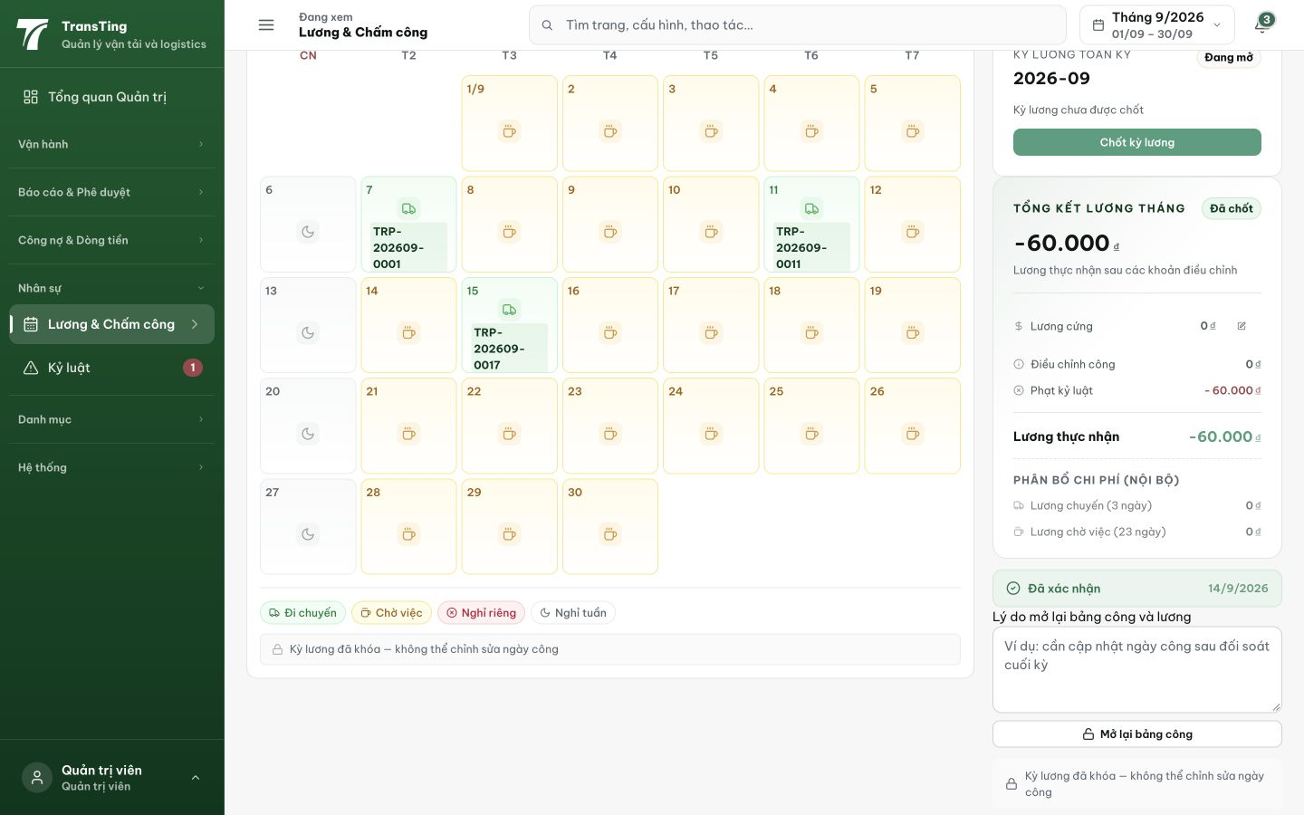
Figure 1. Source action: the edit icon beside Lương cứng 0 has the accessible label Sửa lương cứng and points to /users. This earlier capture predates cancellation of the separate deduction.

Evidence 2
  - Make the base salary edit link open a usable driver salary editor
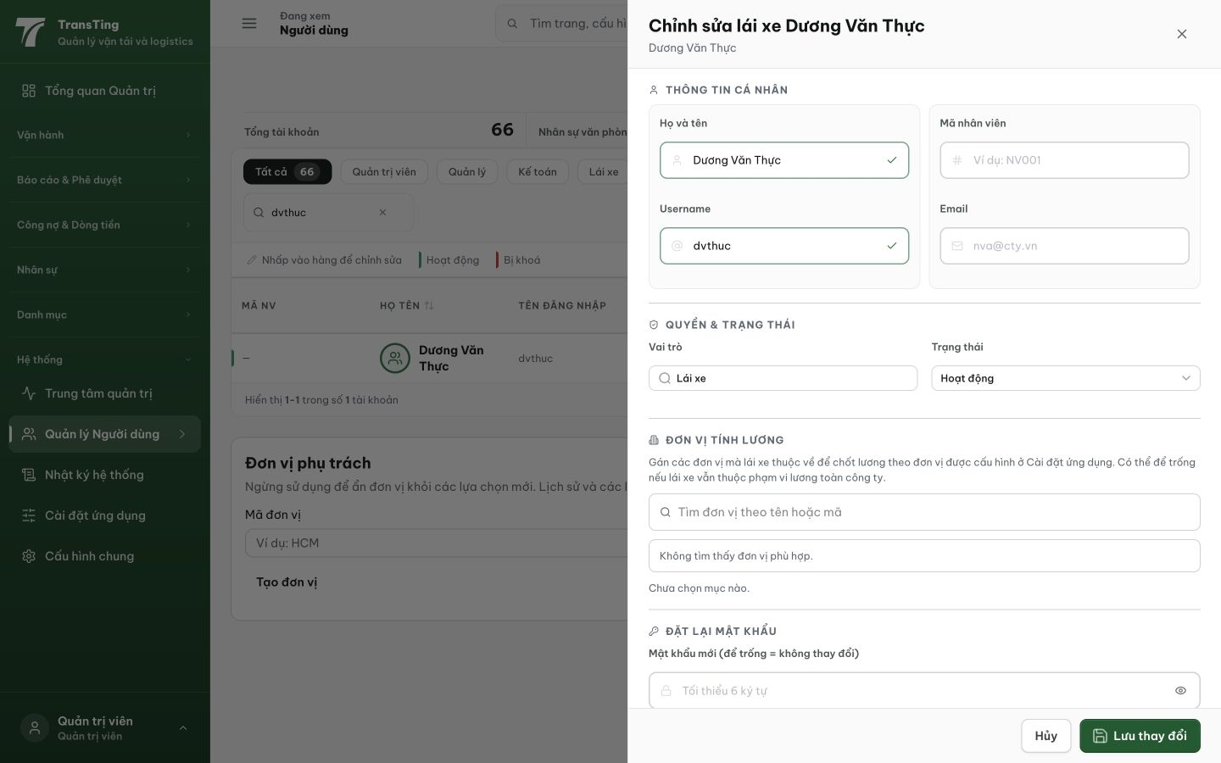
Figure 2. Destination: after searching dvthuc, the complete driver editor offers payroll-unit membership but no salary amount or salary-edit action.
Trạng thái: ĐANG XỬ LÝ — chờ staging verify (lead revert từ QA_PASSED)

[2026-09-14] DEV COMPLETED — UI DRIVEN: admin @ /salary → Dương Văn Thực → Sửa lương cứng → editor opens in-context (Lương cứng textbox with 5,000,000₫ value). URL stays /salary (no redirect to /users). Code: faa143ad. Evidence: qa/2026-09-14_qa084-salary-editor/
Hướng dẫn xác minh: 1. Login admin @ /salary 2. Click Dương Văn Thực 3. Click Sửa lương cứng 4. Verify Lương cứng editor opens inline (not /users redirect)
[2026-09-14] LEAD REVERT — moved by bulk sweep ahead of its staging verify (fix 0ca348e4 not yet in any cut (cut #11 carries only the path half); staging re-verify on cut #12). Returned to IN_PROGRESS; local evidence stands; re-passes on staging verification.

