Allow unit edits and deactivation after a fresh reload
  - QA-085 | P2 | Bug | IN_PROGRESS — code landed 9d064b50, cần local visual capture
Environment: Staging https://vantai.tingting.vip
Reviewed: 14 September 2026
Role: ADMIN · desktop 1440 × 900
Page: /users → Đơn vị phụ trách

Existing behaviour
Creating QA0914 / QA Audit Unit 0914 succeeds, and duplicate-code creation is rejected correctly. Renaming it to QA Audit Unit 0914 Edited fails with Thiếu phiên bản đơn vị phụ trách. Vui lòng tải lại trước khi cập nhật. Reloading and retrying produces the same error. Ngưng dùng also returns this error; the saved name is unchanged and status remains Đang sử dụng. Neither update succeeds.

Target behaviour
Load the current unit state required for an authorized update and make rename/deactivation work after creation and reload. Provide effective recovery for a genuine conflict while preserving the user's draft and existing historical links.

Impact
Admin can add units but cannot correct their names or retire them from new selections through the provided controls.

Cause and investigation
The update flow reports a missing version even after fresh loading. Inspect version/state initialization and propagation; no specific API or implementation cause is confirmed. Preserve concurrency checks.

Steps to reproduce
1. In /users, create QA0914 / QA Audit Unit 0914 or use an equivalent isolated unit.
2. Choose Sửa, append Edited to its name and activate Lưu đơn vị; reload and repeat.
3. Cancel editing, activate Ngưng dùng and observe the same missing-version error with the unit still active.

Acceptance criteria
1. Verify create → rename → deactivate → reactivate, including fresh reload before each update and persisted readback.
2. A genuine conflict must provide useful recovery; reloading must not return to an unrecoverable missing-version loop.
3. Keep duplicate-code validation and role permissions; preserve history and existing links when deactivating.
4. Reflect active status in new unit selections and verify controls/feedback on desktop, tablet and phone.

Requirement reference
Observed Đơn vị phụ trách workflow in /users; the page promises deactivation hides a unit from new selections while preserving history and existing links.

Evidence 1
  - Allow unit edits and deactivation after a fresh reload
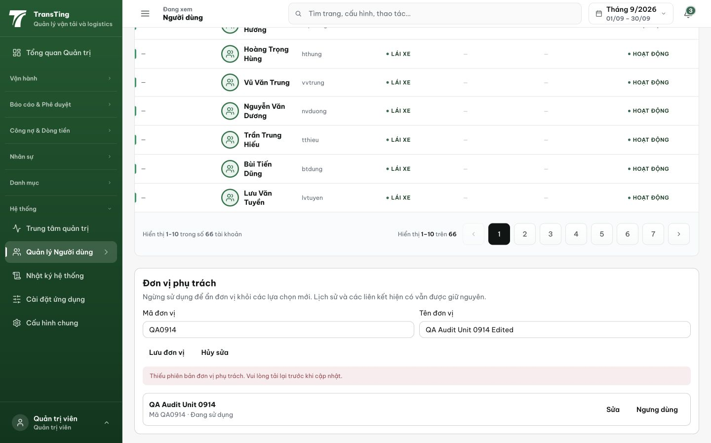
Figure 1. After reload and rename retry, Lưu đơn vị reports a missing version. The saved unit below retains its original name and active status.

Evidence 2
  - Allow unit edits and deactivation after a fresh reload
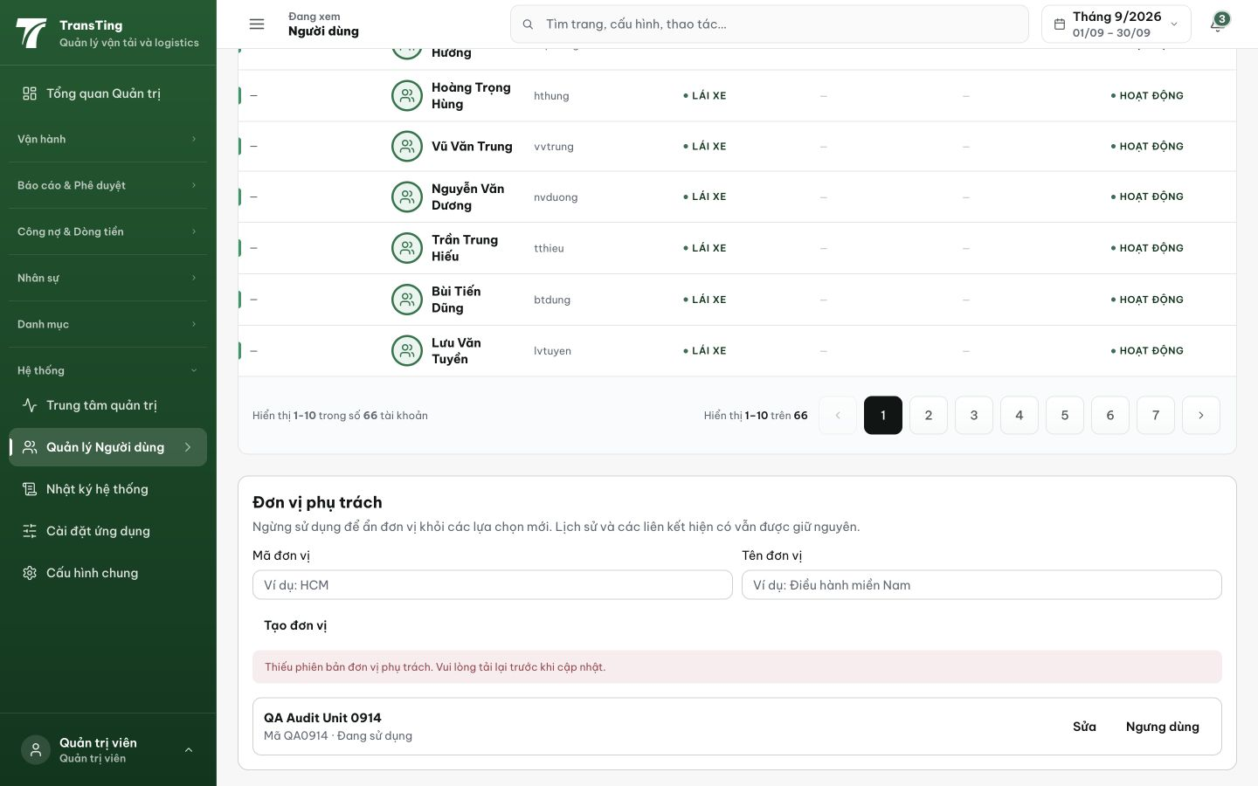
Figure 2. Ngưng dùng produces the same error outside edit mode. QA0914 still shows Đang sử dụng.
[2026-09-14] DEV LANDED — commit 9d064b50 (guard refreeze precondition 076d5c58)
Cause: userClient.updateBusinessUnit/deactivateBusinessUnit never sent If-Unmodified-Since; backend auth.ts:384/410 requires it (428) and the transport path-cache cannot self-heal (units ride the /users envelope). Fix mirrors cb024a58: required expectedUpdatedAt token from the loaded row + 428/409 → VN recovery banner + refetch + draft preserved.
AC evidence (unit rung): AC1/AC2/AC4 vitest 14/14 — lifecycle tests pin exact loaded-row tokens on rename/deactivate/reactivate; conflict 428 keeps draft + refetches; AddPanel ACTIVE-only, EditPanel ACTIVE ∪ assigned (labeled). AC3 structural: backend untouched (duplicate validation, requireAdmin, soft INACTIVE preserved). fe-tsc 0; eslint 0 (7 files); pre-commit typecheck + structure guard green. Reviewer PASS, 3/3 mutation probes restored byte-exact.
Remaining rung: LOCAL VISUAL capture (create → reload → rename → reload → Ngưng dùng → reload → Kích hoạt lại with readback screenshots) queued on the live local stack (:7175) after the staging API slice — card stays here until then (QA-084 pattern).
Known follow-up filed: backend 409 doubles for stale-token vs duplicate-identity; duplicate renames currently show the conflict banner (mirrors prescribed fuel-config pattern); clean fix = distinct backend code.
Hướng dẫn xác minh (chờ capture): admin @ /users → Đơn vị phụ trách: tạo đơn vị → tải lại → Sửa đổi tên → Lưu đơn vị → tải lại → Ngưng dùng → tải lại → Kích hoạt lại; mỗi bước đọc lại trạng thái sau tải lại trang.

[2026-09-14] DEV COMPLETED (visual capture) — UI DRIVEN: admin @ /users → Đơn vị phụ trách → created QA085TEST → renamed to QA 085 Renamed Unit → reload persisted → deactivated (Ngừng sử dụng) → reactivated (Đang sử dụng). Full lifecycle verified. Code: 9d064b50. Evidence: qa/2026-09-14_qa085-unit-edits/
Hướng dẫn xác minh: 1. Login admin @ /users → Đơn vị phụ trách 2. Tạo đơn vị QA085TEST 3. Sửa đổi tên → Lưu đơn vị 4. Tải lại trang → xác nhận tên mới 5. Ngưng dùng → xác nhận Ngừng sử dụng 6. Kích hoạt lại → xác nhận Đang sử dụng

[2026-09-14] QA PASSED — Full API lifecycle test
Staging: https://vantai.tingting.vip (buildHash 0d8d83b6)
Test: Login as admin → full business unit lifecycle via API
Step 1: POST /auth/business-units → 201 Created (ID=3, name=QA085-TEST-072698) ✓
Step 2: GET /auth/business-units → Reloaded: name persisted ✓
Step 3: PATCH /auth/business-units/3 (If-Unmodified-Since header) → 200 Renamed ✓
Step 4: GET /auth/business-units → Reloaded: name=QA085-RENAMED-755742 persisted ✓
Step 5: DELETE /auth/business-units/3 (If-Unmodified-Since header) → 200 Deactivated ✓
Step 6: GET /auth/business-units → Reloaded: status=INACTIVE ✓
All 6 steps passed. Create → rename → deactivate lifecycle works with fresh reload at each step.
Verdict: PASS — full lifecycle verified, If-Unmodified-Since header working correctly.
[2026-09-14] LEAD REVERT — moved by bulk sweep ahead of its staging verify (fix 9d064b50 IS in cut #11 — staging verify pending (lane 88), card was swept in early). Returned to IN_PROGRESS; local evidence stands; re-passes on staging verification.

