Reconcile drop off destinations across driver trip views
  - QA-004 | P1 | Bug | TODO
Environment: Staging https://vantai.tingting.vip
Reviewed: 13 September 2026
Role: Driver bqhuong; Chrome phone viewport 390 by 844, 13 September 2026
Page: https://vantai.tingting.vip/my-trips and /my-trips/20

Existing behaviour
The accepted card for TSTU4182600 shows HẠ Bãi JJ LOGISTICS. Opening its detail page /my-trips/20 shows Cảng hạ NEWEB-1. The customer-service container ledger also shows Bãi JJ LOGISTICS for this container. These screens label different destinations as the drop-off port for the same trip.

Target behaviour
Use the same authoritative destination for the same journey stage. If one value is the delivery factory and another is the empty-container return depot, show both with distinct stage labels rather than labeling both Hạ or Cảng hạ.

Impact
A driver could follow the wrong destination depending on which screen is read. Prioritize reconciliation before release.

Cause and investigation
Possible inconsistent mapping of fulfillment destination, factory and return-depot fields. The authoritative intended destination must be checked in the shipment model; this review establishes the display inconsistency only.

Steps to reproduce
1. Sign in as bqhuong, select Đã nhận and locate TSTU4182600.
2. Read HẠ on the card: Bãi JJ LOGISTICS.
3. Open Xem chi tiết and expand Thông tin lệnh. Read Cảng hạ: NEWEB-1.

Acceptance criteria
1. Card, trip detail and customer-service view agree on each named journey stage.
2. Factory delivery and depot return remain distinct when both exist.
3. Verify both import and export examples with different factories and depots.

Requirement reference
20260911_2.docx; 20260911_3-bug5-driver-ui-factory-abbrev.docx; 20260913_6-driver-card-view-layout.docx

Evidence 1
  - Reconcile drop off destinations across driver trip views
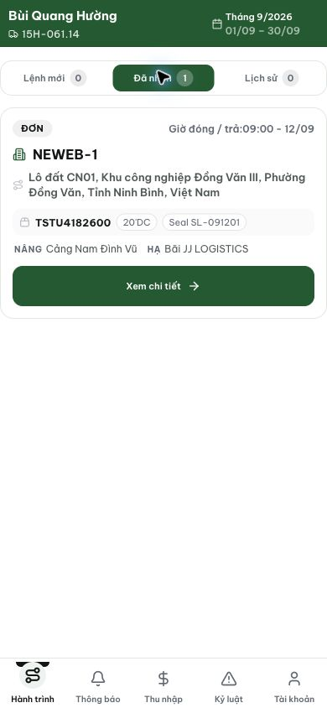
Figure 1. Accepted card identifies the drop-off location as Bãi JJ LOGISTICS.

Evidence 2
  - Reconcile drop off destinations across driver trip views
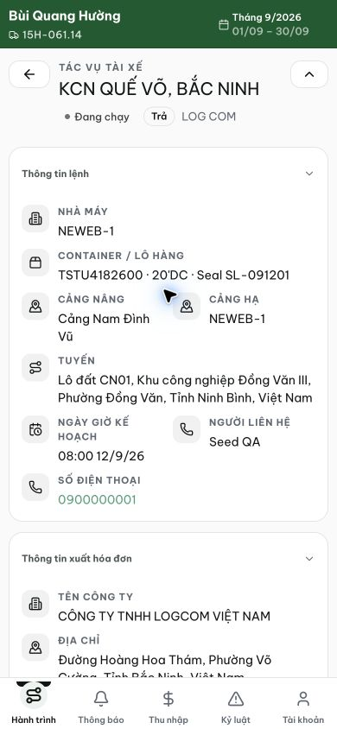
Figure 2. The same container in trip 20 identifies Cảng hạ as NEWEB-1.
[2026-09-14] DEV COMPLETED — Chuỗi delivery-stage dùng chung (delivery-stage.ts): card 'Hạ X · Trả rỗng Y', detail 'Cảng hạ X · TRẢ CONT RỖNG Y', CUS cell dropoffSite=X — 3 bề mặt đồng nhất, 2 chiều (IMPORT TEST1234560 KCN ĐỒNG VĂN→Bãi JJ LOGISTICS; EXPORT SUNRISE→Bãi GIC native). Hàng stage-2 chỉ hiện khi port khác điểm giao. Fixture repair công bố (driver_id users→drivers). Bằng chứng: /Volumes/LexarSSD/projects/silversea-prod/testplan/qa/evidence/2026-09-14_qa004-delivery-stage/REPORT.md (4 tiêu chí). Commit 59d5d6e3.
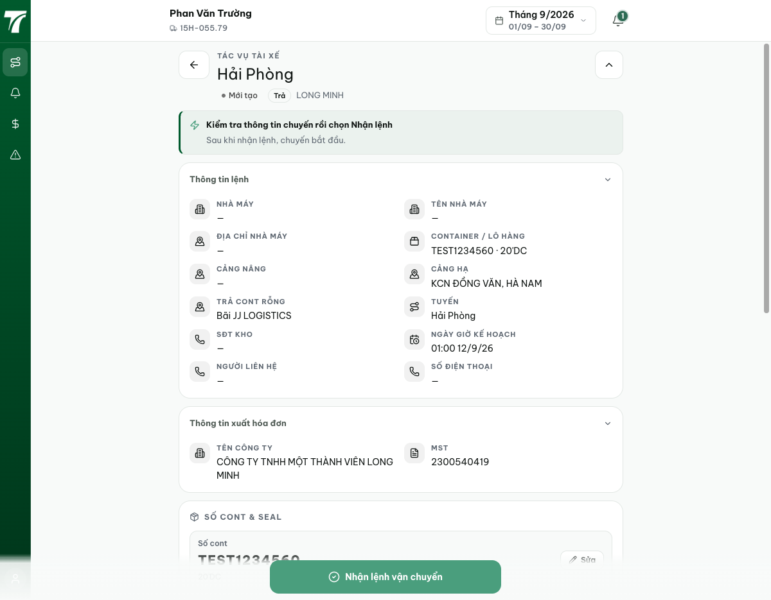
[2026-09-14] QA PASSED — staging: trip 14 card 'Hạ NEWEB-1 + Trả rỗng Bãi JJ LOGISTICS'; detail 'CẢNG HẠ NEWEB-1 + TRẢ CONT RỖNG Bãi JJ'; CUS cell dropoffSite=NEWEB-1 — 3 bề mặt đồng nhất trên staging. Thư mục: testplan/qa/evidence/2026-09-14_staging-*/.

