Reconcile carrier assignment between customer service and dispatch
  - QA-010 | P1 | Bug | TODO
Environment: Staging https://vantai.tingting.vip
Reviewed: 13 September 2026
Role: CUS thanhdc and dispatcher dungnv; Chrome desktop, 13 September 2026
Page: https://vantai.tingting.vip/shipments-detail and https://vantai.tingting.vip/dispatch-detail

Existing behaviour
For Bill EHPH26080202, the customer-service detail ledger shows HÀ AN, plate 51K-PROBE and Đã phân xe. The dispatcher detail plan shows Chưa phân nhà xe, CUS sẽ bổ sung and Đã phát lệnh cho tài xế for the same unnumbered container. Assignment and issue status are contradictory across roles.

Target behaviour
Both workspaces must derive current carrier, vehicle and dispatch status consistently. If a historical or canceled trip exists, distinguish it from the active plan and do not present its resources as the current assignment.

Impact
CUS and dispatch may coordinate against different vehicles or assume a driver has been issued work that is not currently allocated.

Cause and investigation
Likely inconsistent precedence between planned allocation and historical trip resources. A prior source note describes cleanup of a 51K-PROBE trip, but its current backend status was not independently checked; do not treat that note as proof of the root cause.

Steps to reproduce
1. Sign in as thanhdc, open Chi tiết lô hàng, choose Tất cả and search EHPH26080202.
2. Record carrier HÀ AN and vehicle 51K-PROBE in Phân xe.
3. Sign in as dungnv, open Kế hoạch chi tiết, search EHPH26080202 and compare allocation and issue status.

Acceptance criteria
1. Both roles show the same current carrier, plate and meaningful issue state for EHPH26080202.
2. Canceled or superseded assignments do not leak into the active assignment display.
3. Verify assigned, unassigned, canceled-trip and reassigned examples after page reload.

Requirement reference
20260912_2-shipment-detail-unassigned-carrier.docx; 20260912_4-tech-followups-tracker.docx; exploratory staging comparison

Evidence 1
  - Reconcile carrier assignment between customer service and dispatch
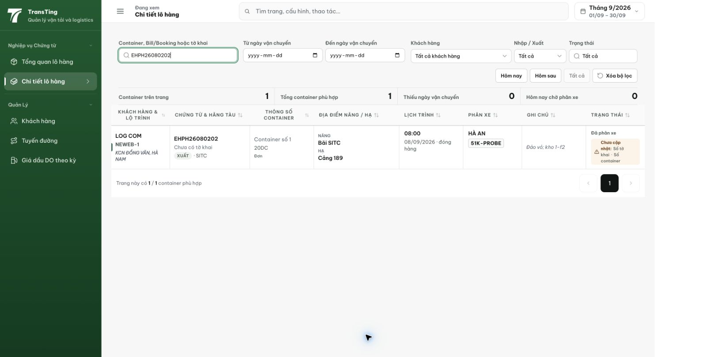
Figure 1. CUS detail ledger shows HÀ AN and 51K-PROBE for EHPH26080202.

Evidence 2
  - Reconcile carrier assignment between customer service and dispatch
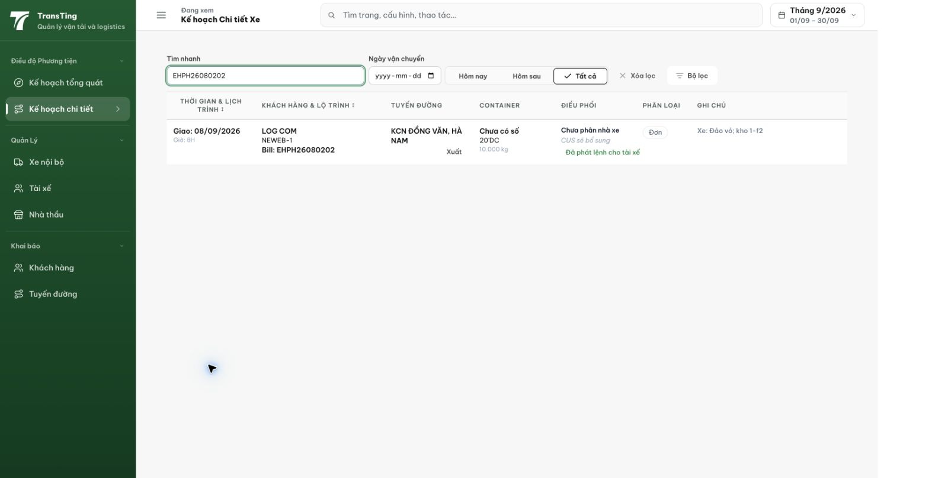
Figure 2. Dispatcher row for EHPH26080202 shows no carrier alongside an issued-to-driver status.
[2026-09-14] DEV COMPLETED — Danh tính nhà xe CUS↔điều phối nhất quán từ phân bổ PLANNED: replica fixture EHPH26080202 (planned HÀ AN/51K-PLANNED + trip CANCELED mang 51K-PROBE) — CUS detail, CUS ledger cell (API), dispatch row, dispatch drawer ĐỀU hiển thị HÀ AN/51K-PLANNED; biển 51K-PROBE không xuất hiện ở bất kỳ bề mặt. Cặp staging (build cũ e228cc9f) tái hiện đúng mâu thuẫn gốc (01/06/07) — sẽ tái kiểm trên staging sau deploy. ShipmentDetailPage tách shipment-detail-view.ts (438→390 dòng). Bằng chứng: /Volumes/LexarSSD/projects/silversea-prod/testplan/qa/evidence/2026-09-14_qa010-cus-dispatch-carrier/REPORT.md (4 tiêu chí). Commit 346c75c0.
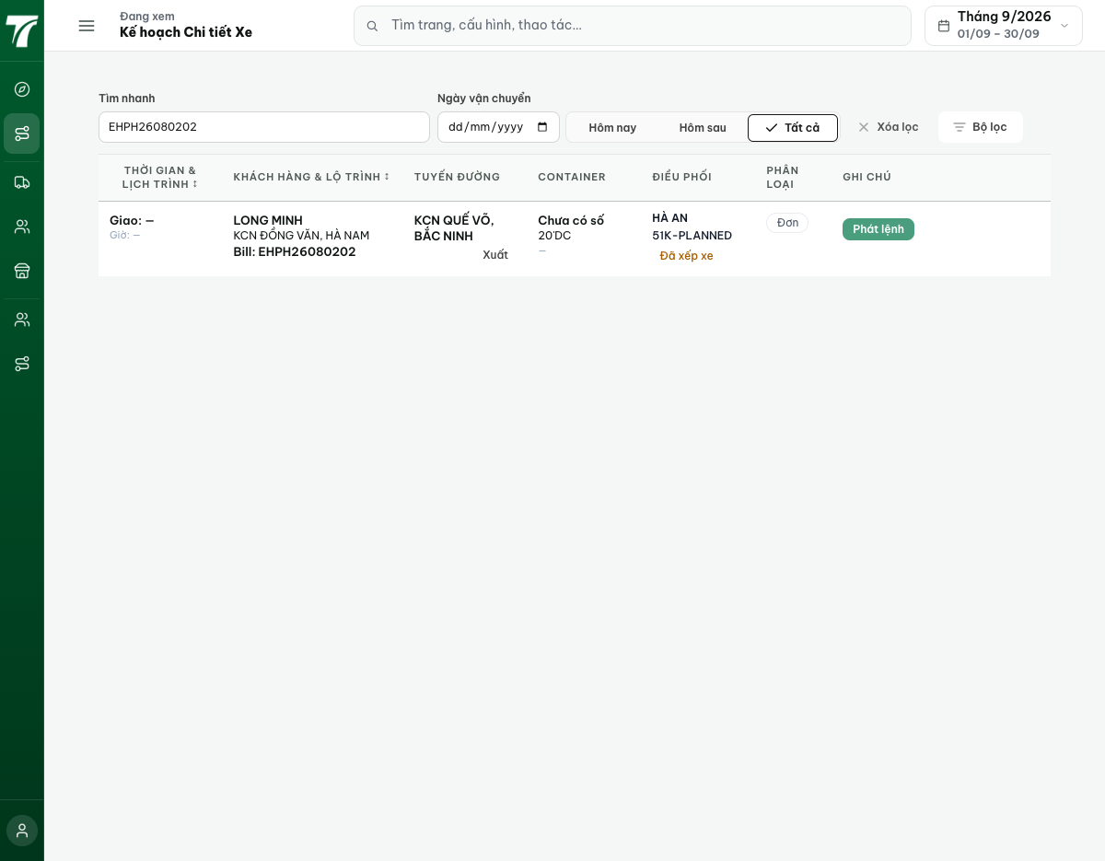
[2026-09-14] QA PASSED — staging (build 531c347c): fixture EHPH thật — drawer CUS giờ 'Chờ phân xe — —' (build cũ: 'Đã phân xe HÀ AN/51K-PROBE') — mâu thuẫn gốc đã giải quyết; lot dương QATU0913544: dispatch row/drawer + CUS detail + ledger cell đồng ý HÀ AN/51K-PLANNED; editor save chặn đúng ('Không thể sửa kế hoạch sau khi đã phát hành lệnh'). Bằng chứng staging: qa010 (05/03/04/06). Thư mục: testplan/qa/evidence/2026-09-14_staging-*/.

