Preserve appointment minutes in the detailed dispatch plan
  - QA-001 | P2 | Bug | TODO
Environment: Staging https://vantai.tingting.vip
Reviewed: 13 September 2026
Role: Dispatcher dungnv; Chrome desktop, 13 September 2026
Page: https://vantai.tingting.vip/dispatch-detail and /dispatch

Existing behaviour
Container MNBU0000283 on shipment SHP-2609-00010, Bill TESTSS2609, displays Giờ: 20H in the detailed plan. The overview and the container drawer show the same container appointment as 20:45 on 11 September 2026. Another overview appointment contains 13:30 while its detailed row shows 13H. Minutes are lost in the dispatch summary.

Target behaviour
Show the exact scheduled time, including minutes, consistently in the overview, detailed plan, sort order and narrow-screen cards. Use an explicit unknown-time placeholder when no time exists.

Impact
Dispatchers cannot distinguish appointments within the same hour and may communicate an incorrect arrival time.

Cause and investigation
Likely a detailed-plan time formatter that keeps only the hour. This is a UI-based hypothesis; implementation was not inspected.

Steps to reproduce
1. Sign in as dungnv and open Kế hoạch tổng quát. Search TESTSS2609.
2. Open Xem chi tiết for SHP-2609-00010 and read MNBU0000283: 20:45 11/9/26.
3. Open Kế hoạch chi tiết, search TESTSS2609, and compare MNBU0000283: Giờ: 20H.

Acceptance criteria
1. MNBU0000283 shows 20:45 on 11/09/2026 in both plans.
2. Times ending in :00, :15, :30 and :45 retain their minutes on desktop and cards.
3. Sorting and filtering use the complete timestamp and agree with the displayed value.

Requirement reference
Exploratory staging QA; related requirements 20260911_3-bug2-detail-plan-show-all-containers.docx and The UI waste lots of space-data-intensive-design.docx

Evidence 1
  - Preserve appointment minutes in the detailed dispatch plan
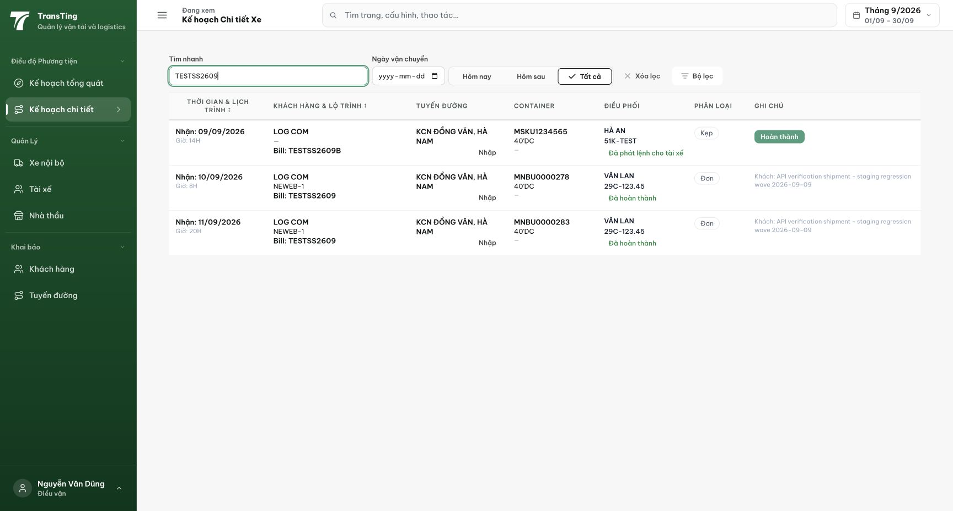
Figure 1. Detailed plan shows MNBU0000283 at 20H.

Evidence 2
  - Preserve appointment minutes in the detailed dispatch plan
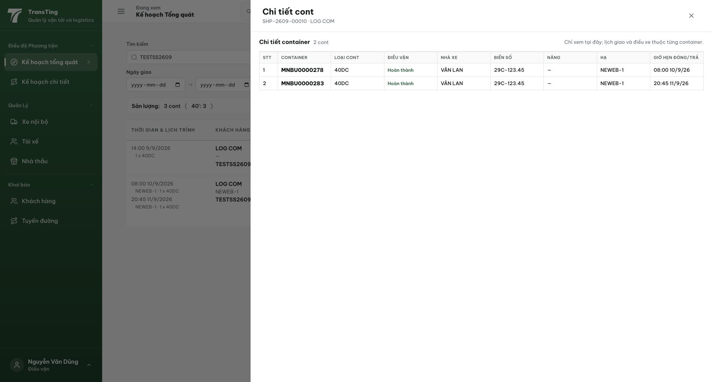
Figure 2. Container drawer for the same shipment shows MNBU0000283 at 20:45.
[2026-09-14] QA (một phần) — AC1–3 ĐẠT: phút hiển thị đủ ở ô Giờ (:30/:45), khớp dòng nhóm ở Kế hoạch Tổng quát, giữ nguyên ở bản 390px. Fixture QA-seeded: MSCU4505740/150574 20:45, MSCU4505731/150573 20:30 (11/09); BBHU2001028/BBHU2001012 (9720) 12:45/12:30 (24/08). AC4 CHƯA ĐẠT: dòng không giờ ('—') đang sắp TRƯỚC (yêu cầu: cuối); bấm header lần 2 chưa đổi thứ tự hiển thị trên bộ 2 dòng — cần chẩn đoán khóa sắp xếp "giờ chạy" vs nguồn hiển thị. Phát hiện mới (ngoài phạm vi): 323 lỗi console React "two children with the same key" (key=null) trên các màn kế hoạch — đã lập thẻ riêng. Bằng chứng: testplan/qa/evidence/2026-09-13_dispatch-minutes-qa001/REPORT.md.

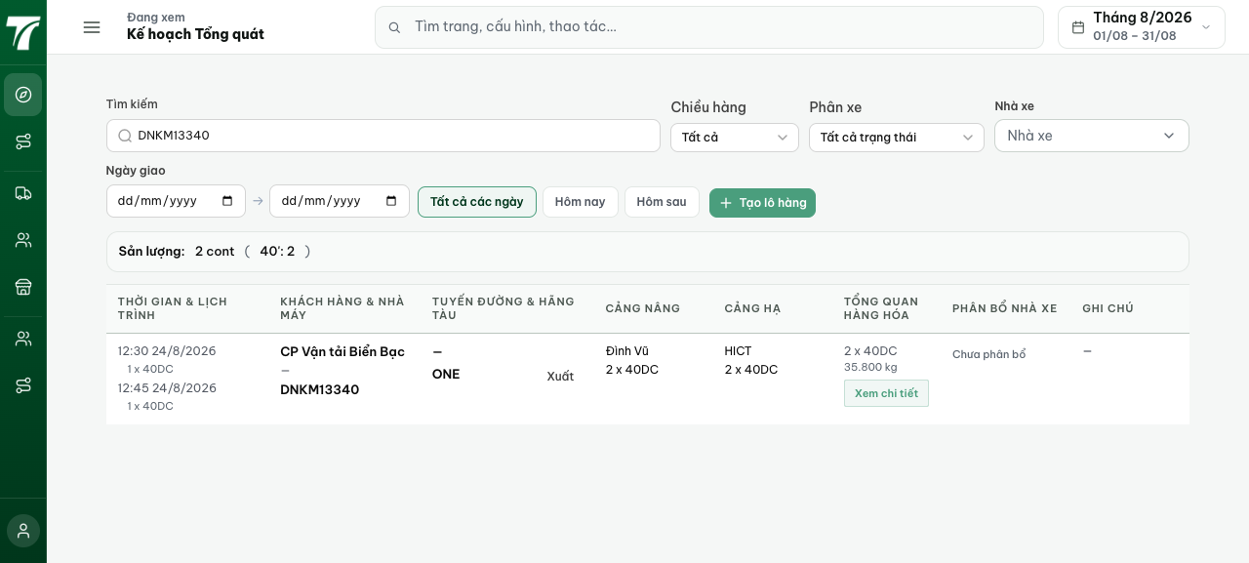
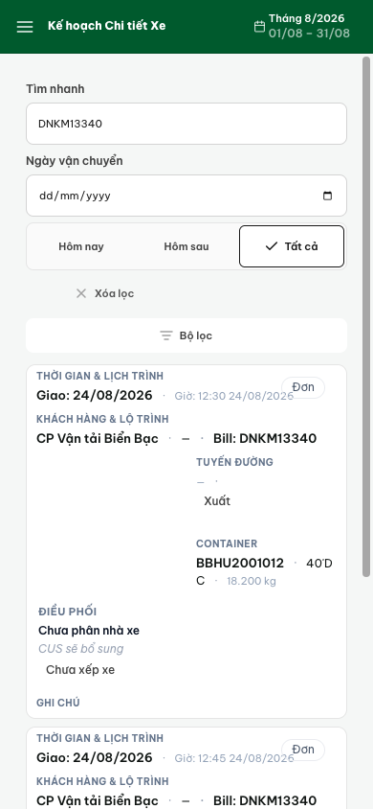
[2026-09-14] QA PASSED — AC4 ĐẠT (sau khi sửa): sắp xếp 3 trạng thái bằng CHẠM THẬT trên header Giờ (hit-test): lần 1 → tăng dần (▲, aria-sort ascending — hàng '—' nằm ĐÚNG 15 vị trí cuối, timed tăng dần 07:31→…); lần 2 → giảm dần (▼, descending — 10:30 trước 09:30, hàng '—' VẪN cuối); lần 3 → trở về mặc định server (↕, hàng '—' dẫn đầu như ban đầu). Root cause: chu kỳ 2 trạng thái cũ không có descending. Ảnh 11/12/13 + console sạch 15-console-dupkey-clean.txt. Commit 9704b809. Đủ 4/4 tiêu chí (AC1–3 đã đạt 2026-09-14 trước đó).
