Show the return or loading operation on driver trip cards
  - QA-002 | P2 | Bug | TODO
Environment: Staging https://vantai.tingting.vip
Reviewed: 13 September 2026
Role: Lái xe — Bùi Quang Hường; login bqhuong; Chrome mobile viewport 390 × 844
Page: https://vantai.tingting.vip/my-trips — Đã nhận; comparison with /my-trips/20

Existing behaviour
The accepted TSTU4182600 card shows the factory, address, container, type, seal and ports, but does not identify Trả hàng or Đóng hàng. Its Giờ đóng / trả label names both possibilities. The corresponding detail at /my-trips/20 shows Trả. Factory and port information are already present.

Target behaviour
Show one explicit operation value, such as TRẢ HÀNG or ĐÓNG HÀNG, alongside container number and type on every driver trip card. Use the same business meaning as the corresponding detail page and retain the current factory, route, port, task-note and detail-button information.

Impact
Drivers must open each trip to learn its operation, slowing list scanning and making otherwise similar jobs harder to distinguish.

Cause and investigation
Hypothesis only: the card renderer may omit an operation value already available to the detail view. No source-code or API mapping diagnosis was performed for this task; inspect the two display mappings before changing data contracts.

Steps to reproduce
1. On 13 September 2026, open the staging site in Chrome at a 390 × 844 viewport and sign in as bqhuong.
2. Open Hành trình and select Đã nhận.
3. Find the NEWEB-1 card for container TSTU4182600. Read the container/type row and the generic Giờ đóng / trả label.
4. Select Xem chi tiết to open /my-trips/20 and compare the visible Trả badge with the card.

Acceptance criteria
1. The TSTU4182600 card visibly identifies TRẢ HÀNG without opening its details.
2. A confirmed loading fixture visibly identifies ĐÓNG HÀNG, using the same operation as its detail page.
3. The operation appears in the container/type information group, remains legible at 390px width, and does not overlap other content.
4. Factory abbreviation, route, both ports, any populated task notes, and Xem chi tiết remain available.

Requirement reference
20260911_2.docx — BUG 2 / FEATURE 1.
20260913_6-driver-card-view-layout.docx — acceptance criterion 3.

Evidence 1
  - Show the return or loading operation on driver trip cards
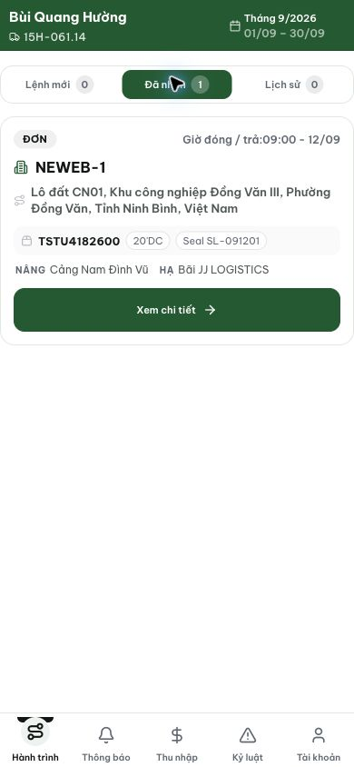
Figure 1. Staging, 13 September 2026, bqhuong: the TSTU4182600 card contains container/type and a generic Giờ đóng / trả label, but no operation value.

Evidence 2
  - Show the return or loading operation on driver trip cards
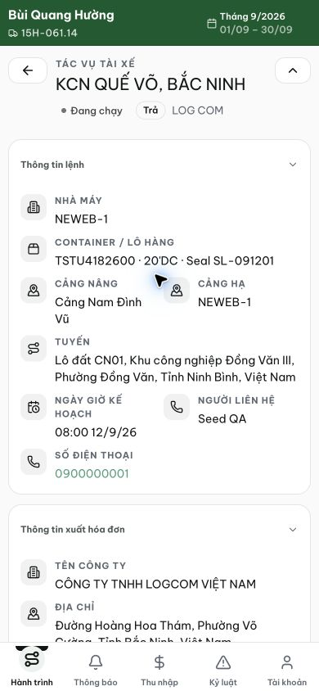
Figure 2. The same trip at /my-trips/20 displays Trả beneath the task heading, confirming that the operation can be shown to the driver.
[2026-09-14] QA PASSED — staging (build 531c347c): cả hai pill sống — ĐÓNG (card nhvuong) / TRẢ (TSTU4182600 bqhuong trip 14). Thẻ staging-written từ đầu; chu trình 1 (local, commit 014d2671) + nay đủ bằng chứng staging. Thư mục: testplan/qa/evidence/2026-09-14_staging-qa002-*/.

