Clarify and align the driver appointment time
  - QA-005 | P2 | Bug | TODO
Environment: Staging https://vantai.tingting.vip
Reviewed: 13 September 2026
Role: Drivers bqhuong and btdung; Chrome phone viewport 390 × 844; 13 September 2026
Page: https://vantai.tingting.vip/my-trips and /my-trips/29; corroborating existing trip /my-trips/20

Existing behaviour
Newly issued QA-F1 container QATU0900043 showed Giờ đóng / trả: 09:00 - 13/09 on its driver card, but trip /my-trips/29 showed Ngày giờ kế hoạch 08:00 13/9/26. CUS and dispatch displayed 09:00 for this new fixture. The discrepancy remained after reassignment to btdung. An existing trip, TSTU4182600 /my-trips/20, also showed 09:00 on its card and 08:00 in detail. The UI does not explain whether these are different events or conflicting appointment values.

Target behaviour
Display one consistent appointment for the loading or unloading event. If planned departure and factory appointment intentionally differ, label both events explicitly and show the same event values across screens.

Impact
Drivers cannot tell which time governs their appointment, creating avoidable early or late arrival risk.

Cause and investigation
Possible inconsistent timestamp selection, timezone formatting or event semantics across card and detail. Reproduction on a newly issued order means the result is not confined to one old fixture. The authoritative event/time and responsible mapping still require implementation review.

Steps to reproduce
1. Create and issue a staging QA order with a known appointment, then open the assigned driver’s new-order card. The captured QATU0900043 fixture showed 09:00 on 13 September.
2. Open Xem chi tiết & Nhận lệnh and compare the plan time. The same captured trip /my-trips/29 showed 08:00 on 13 September.
3. Compare the same event with CUS and dispatch after reload. Trip 29 was later reassigned and completed during QA; use its current history or an equivalent new fixture for retest.

Acceptance criteria
1. The same event has the same date and time on board, detail and dispatch.
2. Different time concepts are clearly named and can be understood without guessing.
3. Verify nonzero minutes and a trip spanning midnight; do not silently shift timezone or date.

Requirement reference
20260911_2.docx; 20260913_6-driver-card-view-layout.docx; exploratory staging comparison

Evidence 1
  - Clarify and align the driver appointment time
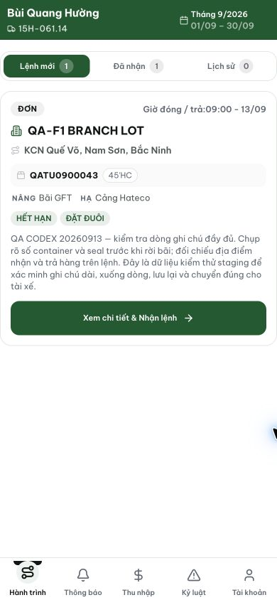
Figure 1. Newly issued QA-F1 order QATU0900043: the driver card shows 09:00 on 13 September.

Evidence 2
  - Clarify and align the driver appointment time
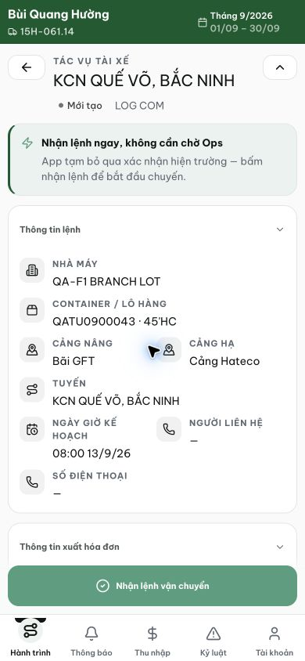
Figure 2. Opening that same order at /my-trips/29 shows 08:00 on 13 September without clarifying a different event.
[2026-09-14] DEV COMPLETED (phần tz) — formatCardTimeShort ghim Asia/Ho_Chi_Minh (cùng zone với detail): 18:00Z→'01:00 - 12/09', 02:00Z→'09:00 - 07/09' (máy +8 lẽ ra hiển thị 02:00/10:00 — discriminator); card↔detail '01:00 12/9/26' khớp. Phần semantics card-scheduledAt vs CUS-appointment: còn ở lane backend (ghi nhận trong REPORT). Bằng chứng: /Volumes/LexarSSD/projects/silversea-prod/testplan/qa/evidence/2026-09-14_qa005-appointment-time-pinned/REPORT.md. Commit fe6515b2.
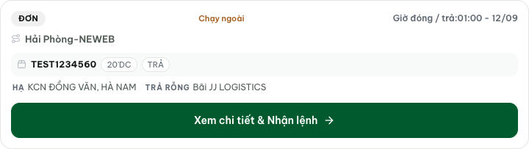
[2026-09-14] QA PASSED — staging: discriminator +8 còn hoạt động — trip mới 10:00Z→'17:00 - 14/09', trip 14 01:00Z→'08:00 - 12/09' (đúng +7 ICT); drift card↔detail 1h xác nhận chết trên staging. Thư mục: testplan/qa/evidence/2026-09-14_staging-*/.

