Keep factory identity prominent and label its address in driver details
  - QA-006 | P2 | Bug | TODO
Environment: Staging https://vantai.tingting.vip
Reviewed: 13 September 2026
Role: Lái xe — Bùi Quang Hường; login bqhuong; Chrome mobile viewport 390 × 844
Page: https://vantai.tingting.vip/my-trips/20

Existing behaviour
On initial entry with the task summary expanded, its heading shows the route “KCN QUẾ VÕ, BẮC NINH”. The same summary prioritizes “NEWEB-1” after being collapsed, so the main identity changes with presentation state. Expanded Thông tin lệnh displays the factory street address “Lô đất CN01, Khu công nghiệp Đồng Văn III, Phường Đồng Văn, Tỉnh Ninh Bình, Việt Nam” under TUYẾN rather than the requested ĐỊA CHỈ NHÀ MÁY label. This task does not claim that the stored full factory name is missing or incorrectly truncated.

Target behaviour
Make the factory abbreviation the primary identity in the initial task summary, with the route subordinate and still available. In expanded order information, show the full factory name when available and label its street address ĐỊA CHỈ NHÀ MÁY. Keep the abbreviation in compact/collapsed identification and apply an explicit fallback when no separate full name exists.

Impact
Drivers must infer whether TUYẾN represents a transport route or the factory street address. Changing the main heading between route and factory when the summary is collapsed also makes destination identification less consistent.

Cause and investigation
Hypothesis only: the expanded and collapsed summary states may select different primary fields, and the address label may remain from the previous route-oriented presentation. Verify the rendered state mappings and available factory fields before changing them; no code-level cause is asserted.

Steps to reproduce
1. On 13 September 2026, sign in to staging as bqhuong in Chrome at 390 × 844.
2. From Đã nhận, open TSTU4182600 with Xem chi tiết to reach /my-trips/20.
3. On initial entry, read the route-led task heading; collapse the summary with its chevron and observe the factory abbreviation NEWEB-1 becoming the main heading.
4. Expand Thông tin lệnh if necessary and inspect the TUYẾN label above the factory street address.

Acceptance criteria
1. The initial task summary identifies the factory first and retains the route in a subordinate position; changing the summary's expanded state does not remove the factory identity.
2. The factory street-address field is labeled ĐỊA CHỈ NHÀ MÁY, while any separate transport route remains clearly distinguished.
3. With a fixture whose full name differs from its abbreviation, expanded order information displays the full factory name and the compact summary retains the abbreviation.
4. A fixture without a separate full name has a clear fallback and does not display undefined, empty duplicate fields or fabricated names.
5. Independent section collapse, container details, ports, phone/contact information and invoicing information remain usable at 390px width.

Requirement reference
20260911_2.docx — BUG 1 requests factory identity in the task summary and renaming the route field to the factory address; FEATURE 1 detail wireframe includes TÊN NHÀ MÁY (TÊN ĐẦY ĐỦ) and ĐỊA CHỈ NHÀ MÁY.
20260911_3-bug5-driver-ui-factory-abbrev.docx — preserve the factory abbreviation and fallback in the driver-facing summary. The full factory identity belongs in expanded detail, so this task must not remove the abbreviation requirement.

Evidence 1
  - Keep factory identity prominent and label its address in driver details
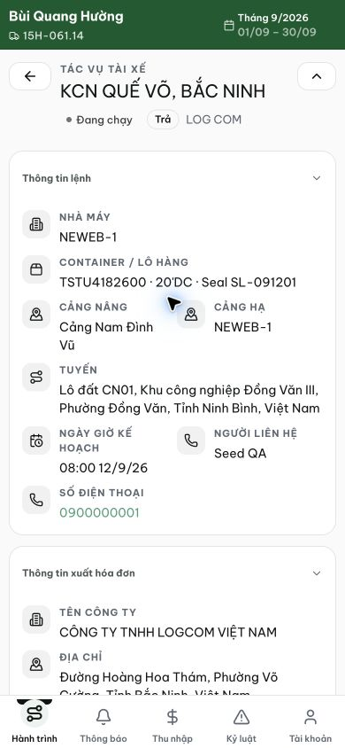
Figure 1. Staging, 13 September 2026, /my-trips/20: expanded task summary leads with the route; the factory street address appears under TUYẾN.

Evidence 2
  - Keep factory identity prominent and label its address in driver details
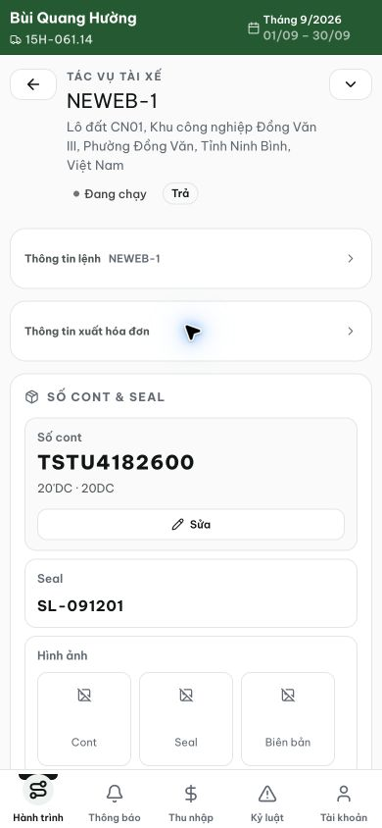
Figure 2. After collapsing the task summary, NEWEB-1 becomes the main identity.
[2026-09-13] QA PASSED — đóng bởi task 20260913_7 (kèm 2 delta gấp vào phạm vi), cùng commit
AC1 — factory là định danh chính của summary ở trạng thái ban đầu, tuyến phụ thuộc, đổi trạng thái không mất định danh nhà máy: ĐẠT (heading factory-first cả hai trạng thái — ảnh 08 task 7; before/after so với ảnh task 6).
AC2 — địa chỉ nhà máy có nhãn ĐỊA CHỈ NHÀ MÁY, tuyến tách bạch: ĐẠT (dòng riêng 04/10; TUYẾN chỉ còn tuyến; dòng thu gọn không bao giờ chứa địa chỉ — 07).
AC3 — fixture tên đầy đủ ≠ viết tắt: expanded hiển thị tên đầy đủ, compact giữ viết tắt: ĐẠT (03/09 + heading 08).
AC4 — fixture không có tên đầy đủ riêng: fallback rõ ràng, không undefined/trùng lặp hàng/tên bịa: ĐẠT (13: toàn '—'; guard chống hàng trùng — unit test khóa).
AC5 — các section độc lập, container, cảng, SĐT/liên hệ, hóa đơn dùng được ở 390px: ĐẠT (QA pass chạy 390×844; C3/C4 + regression watch xanh).
Ghi chú trung thực: bằng chứng trên dev local; repro staging (bqhuong /my-trips/20) sẽ xác minh sau đợt cắt staging. Bằng chứng đầy đủ: testplan/qa/evidence/2026-09-13_driver-detail-factory-info/REPORT.md.

