Improve readability of secondary dispatch information
  - QA-007 | P2 | Enhancement | TODO
Environment: Staging https://vantai.tingting.vip
Reviewed: 13 September 2026
Role: Dispatcher dungnv; Chrome desktop 1728 by 929 and 1280 by 900, 13 September 2026
Page: https://vantai.tingting.vip/dispatch-detail

Existing behaviour
Appointment-time lines, cargo weights, customer notes and the CUS sẽ bổ sung hint use very pale gray text on a white table background. In the TESTSS2609 filtered view these operational values are much harder to read than adjacent bold container IDs. The issue was confirmed visually; an exact contrast ratio was not measured.

Target behaviour
Keep secondary data readable at normal zoom while retaining clear hierarchy. Use a text color meeting at least 4.5:1 contrast for normal-size text against every table background and avoid treating operational values as disabled UI.

Impact
Frequent scanning becomes harder, especially on dim displays or for users with reduced vision.

Cause and investigation
Likely an overly light shared muted-text token or inherited opacity. Confirm computed colors and opacity before changing styles.

Steps to reproduce
1. Sign in as dungnv and open Kế hoạch chi tiết.
2. Search TESTSS2609 and read the time, weight and customer-note text at normal zoom.
3. Compare readability at 1280 pixels and in narrow cards.

Acceptance criteria
1. Normal-size operational text meets 4.5:1 contrast on white, highlighted and alternate row backgrounds.
2. Notes, times and weights are comfortably readable without increasing browser zoom.
3. Disabled actions remain distinguishable without dimming unrelated shipment data.

Requirement reference
The UI waste lots of space-data-intensive-design.docx; visual staging review

Evidence 1
  - Improve readability of secondary dispatch information
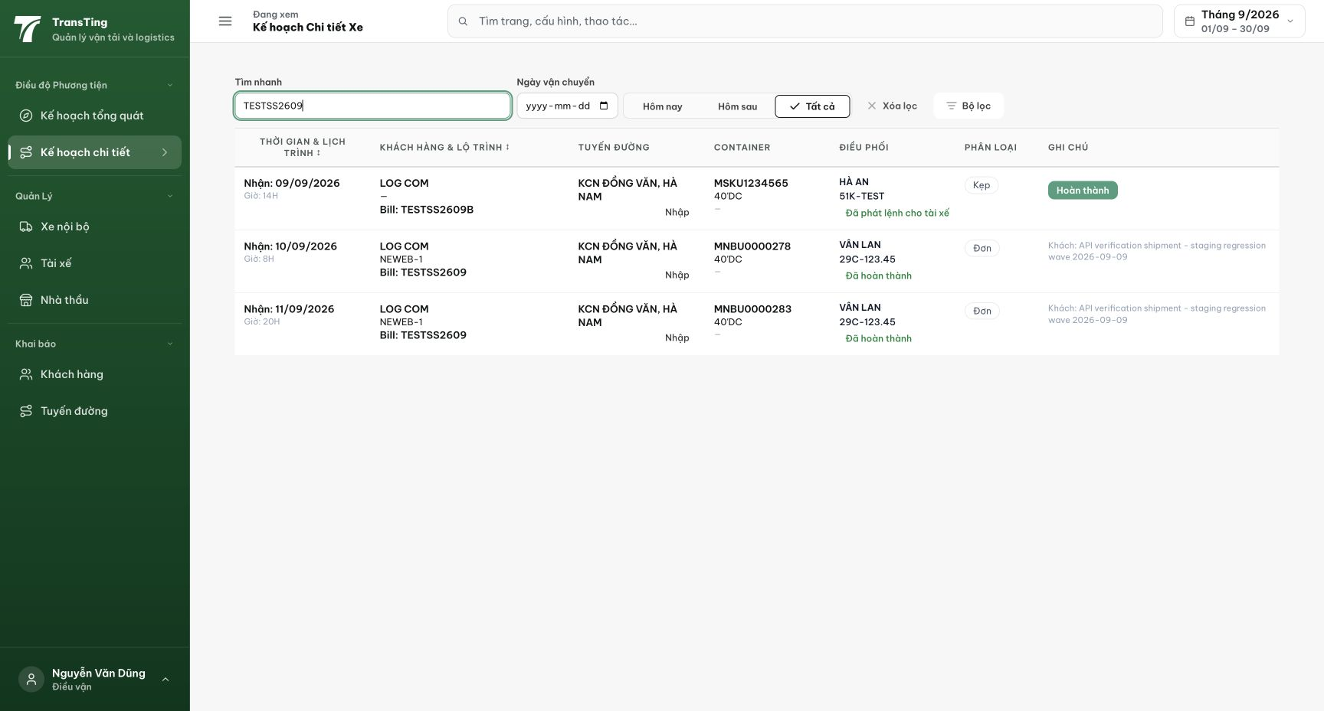
Figure 1. Time and customer-note lines are visibly pale compared with primary row data.
[2026-09-14] DEV COMPLETED — Contrast đo TRỰC TIẾP trên staging (getComputedStyle sau hard-reload, build 531c347c): dòng muted rgb(100,116,139) trên nền trắng = 4.76:1 ĐẠT (walk effective-bg đúng). CSS deployed mang 14× #64748b gồm rule muted + placeholder. Delta còn lại của 393fab38 (empty-rule + pins) chưa trong build — tái kiểm trên cut #2. Bằng chứng: 2026-09-14_staging-qa007-contrast/REPORT.md (đã hiệu đính nguồn).
[2026-09-14] QA PASSED — staging2 (build 7174ebcb): pins giữ — dòng muted ('Giờ: …', '18.500 kg') rgb(100,116,139) = 4.76:1 trên trắng. Lưu ý build: chunk CSS dispatch giống hệt giữa 2 cut (nội dung 393fab38 đã có từ cut-1). Ghi nhận: rule .detailed-plan-grid__empty còn 94a3b8 nhưng phần tử KHÔNG BAO GIỜ render (empty-UI khác) — chấp nhận dormant, sửa ở lần chạm sau. Bằng chứng: 2026-09-14_staging2-qa007-contrast/.

