Allow container number updates without triggering the trip schedule guard
  - QA-013 | P2 | Bug | TODO
Environment: Staging https://vantai.tingting.vip
Reviewed: 13 September 2026
Role: CUS — Đinh Công Thành; login thanhdc; visible Chrome staging review on 13 September 2026
Page: https://vantai.tingting.vip/shipments-detail — Chi tiết lô hàng, Bill 2337300010

Existing behaviour
During the CUS reproduction, Bill 2337300010, Container số 1 had no number, type 40HC, carrier SilverSea, plate 15H-149.80 and visible status Đã phân xe. Its enabled editor rejected a number-only QATU9001239 save with: “Container đã gắn chuyến xe (TRP-202609-0004). Vui lòng đổi lịch trên chuyến xe hoặc gỡ phân xe trước khi sửa.” No schedule was edited, and cancelling left the CUS row unnumbered. Container số 2 was a different running row and was not tested. Later, driver nvquynh saved QATU9001239 plus seal QA-NULL-SEAL on the associated unaccepted /my-trips/7 container, confirmed after reload. The CUS ledger was not read back, and later dispatch still displayed Chưa có số for the shipment row. Driver save does not certify cross-surface propagation or establish that the CUS row is now numbered. Re-establish both CUS and linked-trip initial states before retesting. No SQL NULL representation was queried.

Target behaviour
Allow CUS to add a missing container number on an assigned, nonterminal shipment through the enabled editor, without an approval step or a requirement to reschedule or remove its assignment. Persist the number while leaving the schedule, carrier, vehicle and trip linkage unchanged. Preserve existing terminal-lot protections and guards for actual schedule or resource changes. If another documented field-specific restriction applies, expose that restriction accurately in the UI rather than reporting an unrequested schedule change.

Impact
CUS cannot complete the missing container identifier after allocation and receives advice to disturb a trip schedule or assignment that was not being edited. This blocks the late-number entry workflow requested by the customer.

Cause and investigation
Hypothesis only: a shared CUS save path may apply a linked-trip scheduling guard to every container edit, or submit unchanged schedule fields in a way that is treated as a plan change. The request payload and implementation were not inspected. Confirm the changed-field detection and the linked-trip guard before adjusting either; do not remove terminal or real schedule-change protection.

Steps to reproduce
1. Sign in to staging as thanhdc and open Chi tiết lô hàng at /shipments-detail.
2. Choose Tất cả and search Bill 2337300010, then select Container số 1 with SilverSea / 15H-149.80 and Đã phân xe, not the separate running Container số 2. Re-establish the CUS and linked-trip initial states: the associated driver trip later received a number, but CUS propagation was not verified. Use an equivalent fixture if needed.
3. Open Chỉnh sửa thông số container. Confirm Số container is empty, and enter QATU9001239 without changing schedule, route, allocation or other fields.
4. Click Lưu. Observe the linked-trip message referring to TRP-202609-0004 and asking to change the trip schedule or remove allocation.
5. Cancel and check the CUS row. In the historical reproduction it remained without a number. Record CUS and linked-trip readbacks separately; do not infer one from the other.

Acceptance criteria
1. For an assigned, initially unnumbered nonterminal fixture equivalent to the original Bill 2337300010 row, adding a valid missing container number saves directly and remains visible after reload, with no approval request.
2. A number-only update leaves schedule, carrier, plate, driver and trip linkage unchanged and does not invoke schedule-change validation.
3. Terminal shipments remain protected by the existing terminal-lot rule with an accurate message; this change does not bypass those guards.
4. Actual schedule or resource edits continue through the required linked-trip workflow and retain their existing validation.
5. Any separate immutable-field restriction is reflected consistently in edit availability and a field-specific error. Do not instruct users to reschedule or unassign for an unrelated rejected number edit.
6. Retest initially unnumbered unassigned and assigned nonterminal rows, the terminal-lot case, and a genuine schedule-change case; confirm that the intended row is updated when one Bill contains multiple containers.

Requirement reference
20260911_3-bug3-auto-approve-shipment-edits.docx — acceptance criteria 1–3 require CUS to add a previously missing container number, save immediately without approval, and retain it after reload.
20260912_4-tech-followups-tracker.docx — item 9a preserves the terminal-lot guard for CUS container writes. This does not establish a blanket prohibition on adding a number to an assigned, nonterminal container.

Evidence 1
  - Allow container number updates without triggering the trip schedule guard
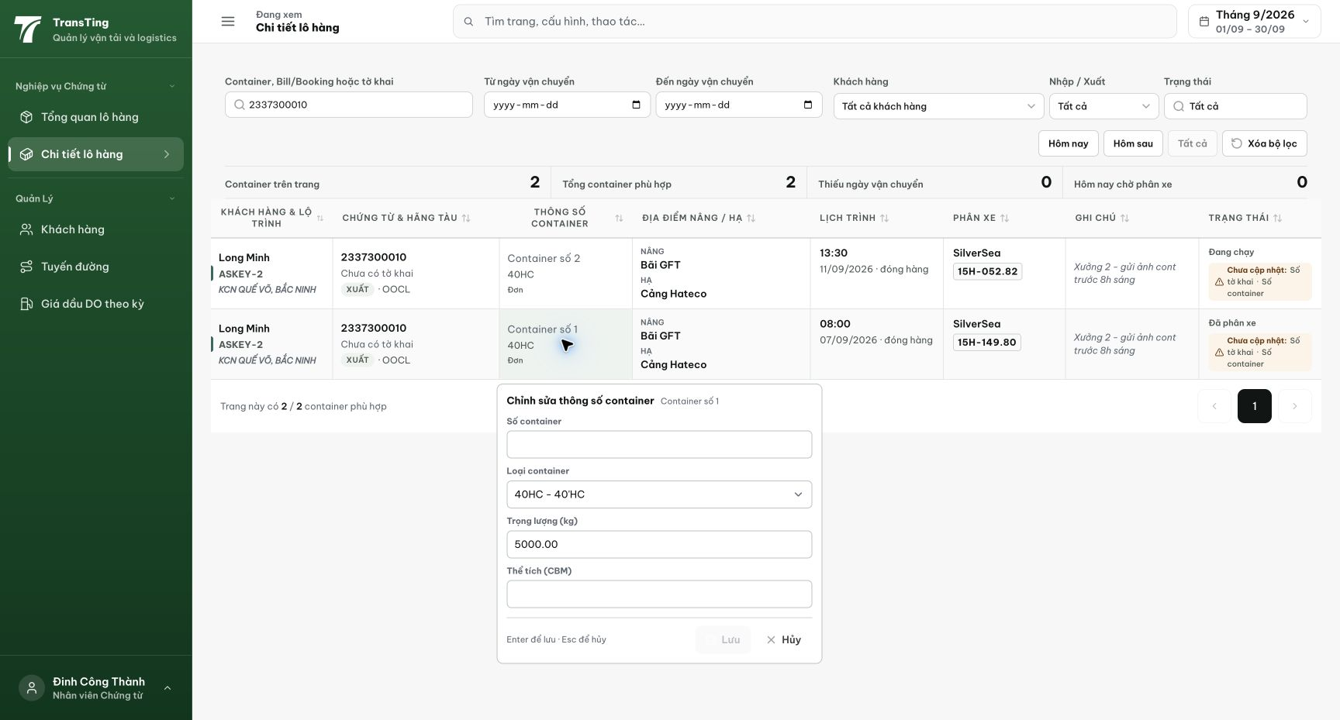
Figure 1. Historical CUS reproduction, before the later driver test: Bill 2337300010, Container số 1 has an empty number and SilverSea / 15H-149.80 allocation. Container số 2 is a separate running row.

Evidence 2
  - Allow container number updates without triggering the trip schedule guard
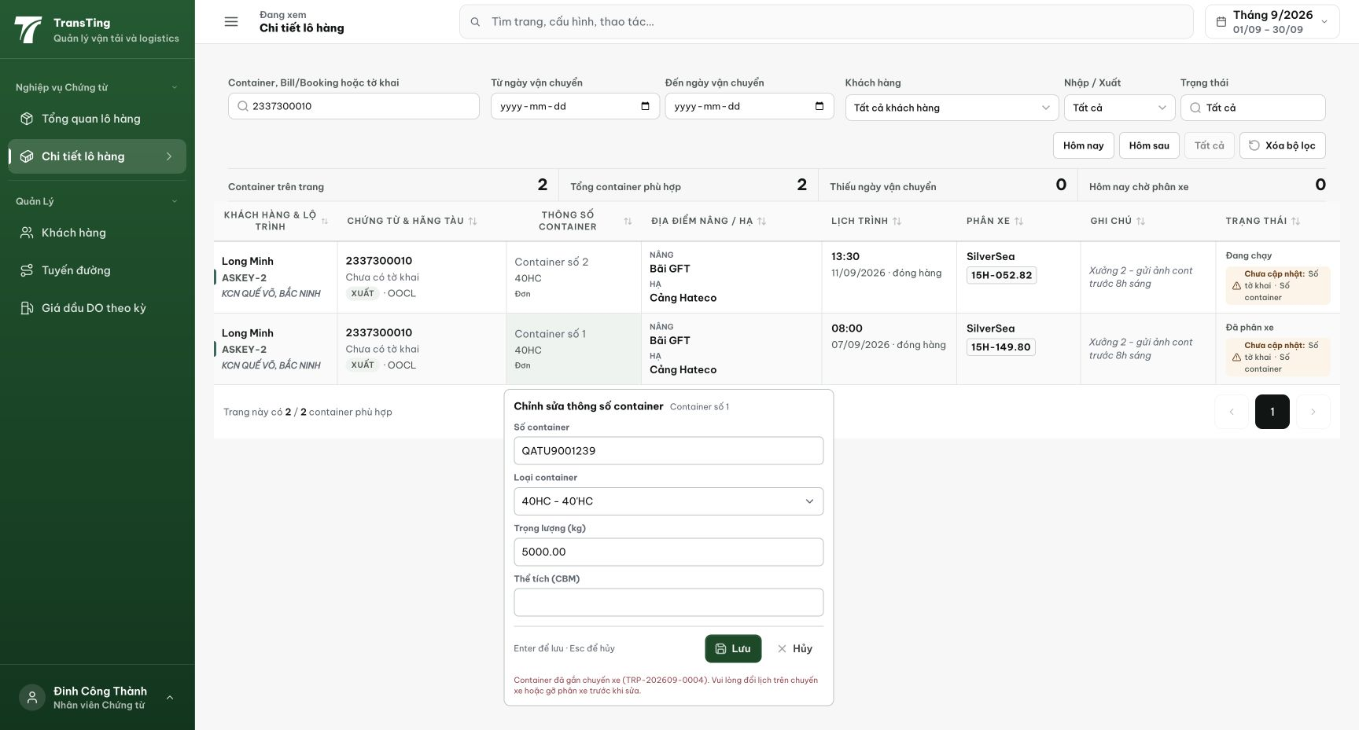
Figure 2. After entering only QATU9001239 and pressing Lưu, the editor rejects the save with a message about changing the linked trip schedule or removing allocation.
[2026-09-14] QA PASSED — Guard đổi thành value-aware (chỉ chặn khi GIÁ TRỊ trường được bảo vệ thực sự đổi; containerNumber là định danh, loại khỏi guard; so sánh từng trường mirror đúng write-block của nó). Bằng chứng DB·API VERIFIED: red-proof — tách fix, chạy repro trên guard cũ → ném đúng thông báo TRP của thẻ; khôi phục fix → xanh. 7 test mới xanh (73/73 suite, tsc BE 0 lỗi, lint baseline): (a) lưu chỉ-số-cont trên hàng đã phân xe非terminal, planned* + version byte-identical, hiển thị lại qua CUS projection; (b) echo full-form (số + type/weight/volume không đổi) vẫn lưu; (c) đổi type thật vẫn 409 TRP; (d) echo hẹn giờ cùng giá trị qua guard; (e) lot terminal vẫn 409 'Lô hàng đã kết thúc'; (f) lot đa cont: số đúng hàng + trùng trong lot vẫn 400; (g) hàng chưa số chưa phân lưu thẳng. AC1–6 đạt. Ghi chú: spot-check UI drawer (lưu chỉ-số qua giao diện) xếp vào sweep #3 như kiểm chứng thêm. Commit 24fee31e.

