Refresh reassignment defaults after saving a new driver and vehicle
  - QA-014 | P2 | Bug | TODO
Environment: Staging https://vantai.tingting.vip
Reviewed: 13 September 2026
Role: Điều vận — Nguyễn Văn Dũng; login dungnv; Chrome desktop
Page: https://vantai.tingting.vip/dispatch-detail — QATU0900043; associated driver trip /my-trips/29

Existing behaviour
After unaccepted QATU0900043 changed from 15H-061.14 / Bùi Quang Hường to 15H-104.03 / Bùi Tiến Dũng, the plan showed the new vehicle. Reopened Phân xe lại kept the old assignment, including after 10 seconds. Full reload recovered the saved values. Persistence succeeded; dialog defaults were stale.

Target behaviour
Show saved reassignment defaults immediately. Refresh on changed trip versions; preserve unsaved edits during same-version refetch, as tracker 9b requires.

Impact
Stale confirmation risks accidental reversion; QA did not execute a reversal.

Cause and investigation
Hypothesis: cache and draft refresh differ after saving. Inspect invalidation, trip version and initialization; the responsible layer is unconfirmed.

Steps to reproduce
1. As dungnv, use an owned issued, unaccepted trip; QATU0900043 was later completed.
2. In Phân xe lại, save another valid vehicle/driver and check the row.
3. Reopen without reload, immediately and after 10 seconds. Compare defaults with the saved row.
4. Reload, reopen and wait for loading. The observed defaults then matched the saved assignment.

Acceptance criteria
1. Immediate and repeated reopening show the latest saved vehicle and driver without reloading.
2. Plan, dialog, driver view and full-reload readback agree.
3. Changed trip versions refresh defaults; same-version refetch preserves unsaved edits.
4. Reopening and delayed responses never restore stale defaults unnoticed; cancelling keeps the saved assignment.
5. Preserve reassignment before acceptance and the accepted/departed guard.

Requirement reference
20260912_4-tech-followups-tracker.docx — item 9b, version-aware draft preservation.
20260911_1-bug1-reassign-before-driver-accept.docx — reassignment boundary.

Evidence 1
  - Refresh reassignment defaults after saving a new driver and vehicle
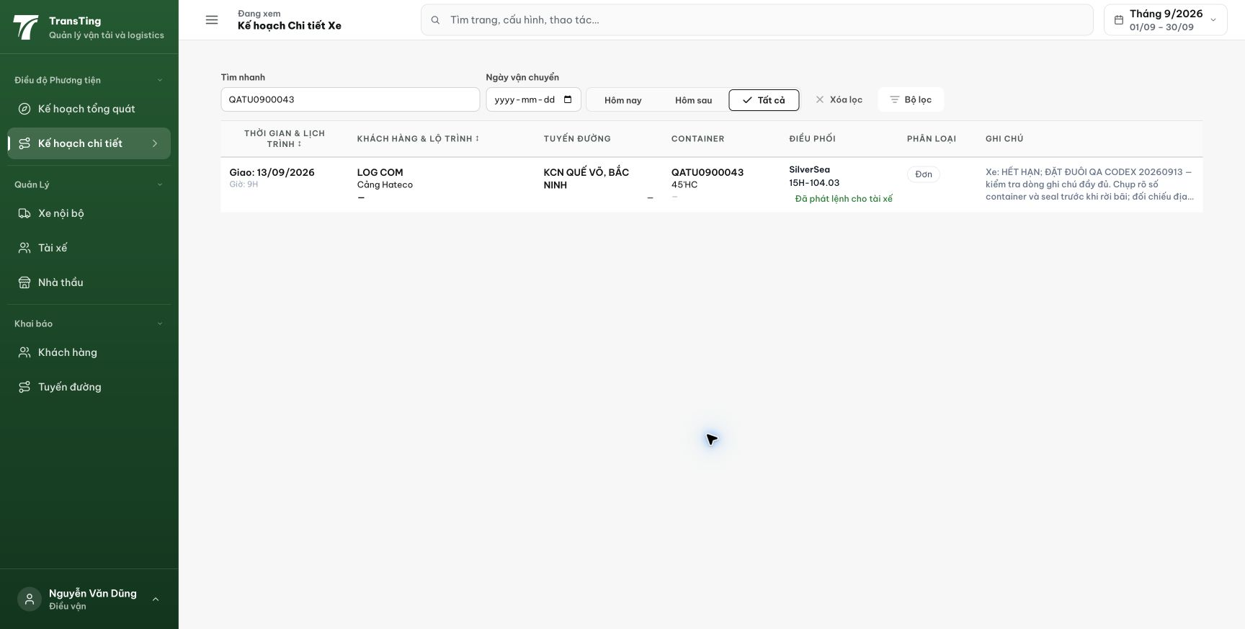
Figure 1. Staging, 13 September 2026, dungnv: after confirming reassignment, the QATU0900043 row displays 15H-104.03.

Evidence 2
  - Refresh reassignment defaults after saving a new driver and vehicle
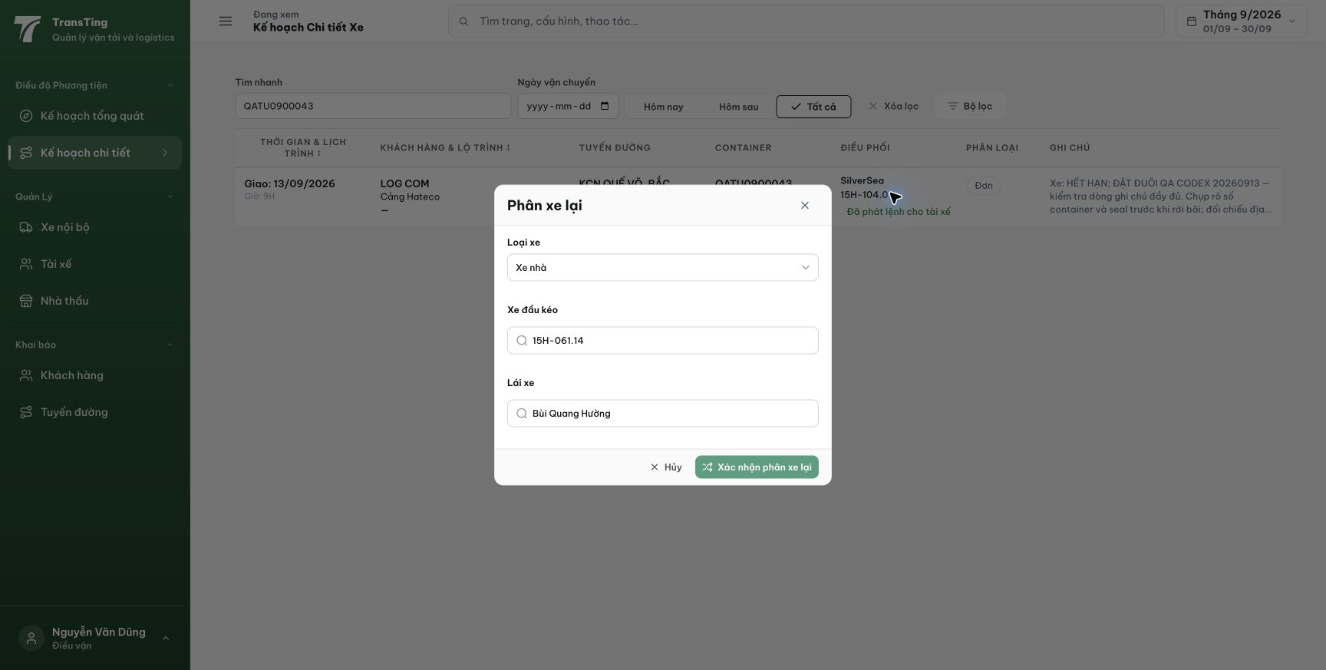
Figure 2. In the same session, reopened Phân xe lại shows the former 15H-061.14 and Bùi Quang Hường while the row shows 15H-104.03. A follow-up read about 10 seconds later remained stale.

Evidence 3
  - Refresh reassignment defaults after saving a new driver and vehicle
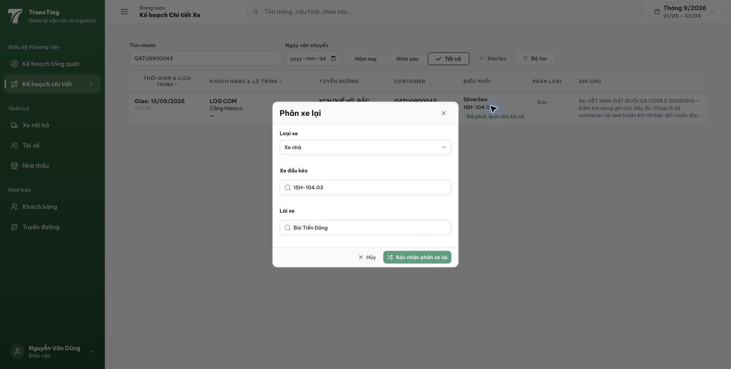
Figure 3. After a full page reload and completion of dialog loading, Phân xe lại correctly shows the saved 15H-104.03 and Bùi Tiến Dũng. No second reassignment was required for recovery.
[2026-09-14] DEV COMPLETED — Dialog prime cache sau save (setQueryData + invalidate): mở lại NGAY và sau 10 giây đều hiện default mới (15H-052.82 + Phí Xuân Hoàn), không cần reload; row hiển thị đúng phân xe mới. Save qua dialog persist DB (v2, v3). Bằng chứng: /Volumes/LexarSSD/projects/silversea-prod/testplan/qa/evidence/2026-09-14_qa014-reassign-defaults/REPORT.md (4 tiêu chí, fixture repair công bố). Commit 531c347c.
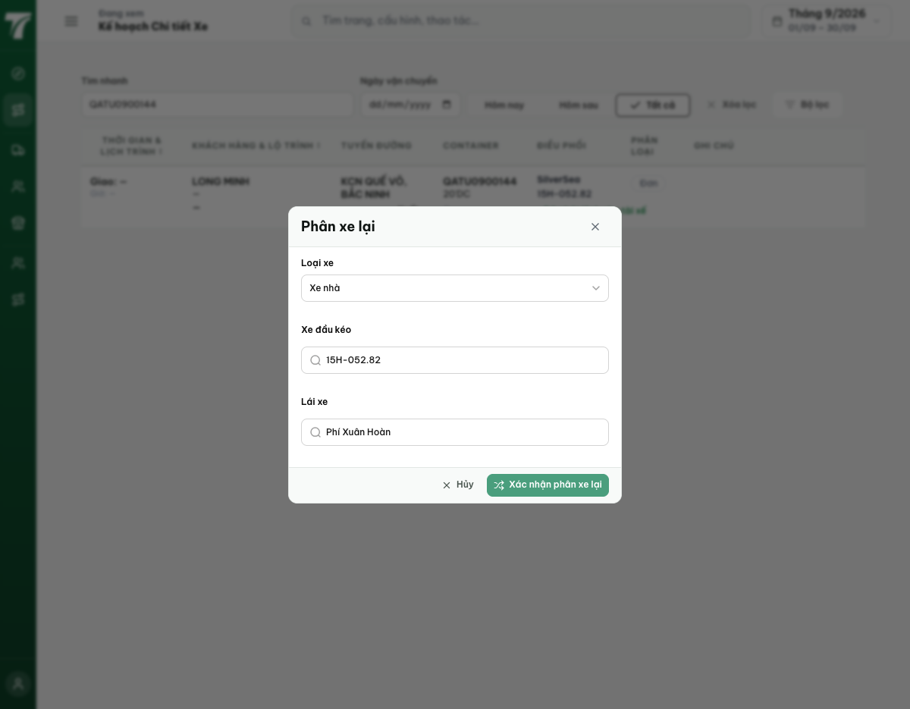
[2026-09-14] QA PASSED — staging: chuyến tươi TRP-202609-0018 — reassign → Nguyễn Huy Vương (v3 persist); mở lại ngay + 10s = default mới. Thư mục: testplan/qa/evidence/2026-09-14_staging-*/.

