Show driver acceptance before offering reassignment
  - QA-016 | P2 | Enhancement | TODO
Environment: Staging https://vantai.tingting.vip
Reviewed: 13 September 2026
Role: Điều vận — Nguyễn Văn Dũng; login dungnv; driver acceptance exercised as Bùi Tiến Dũng; Chrome
Page: https://vantai.tingting.vip/dispatch-detail — QATU0900043; corresponding accepted trip /my-trips/29

Existing behaviour
After driver acceptance, QATU0900043 still showed Đã phát lệnh cho tài xế. Phân xe lại correctly rejected reassignment, but kept vehicle/driver inputs and a green confirmation control. Eligibility becomes clear only after editing; the business guard worked.

Target behaviour
Distinguish unaccepted and accepted trips with compact status. Explain a known acceptance lock before editing, or show the assignment read-only. Preserve the server guard against concurrent acceptance and explain late conflicts in the dialog.

Impact
Dispatchers may prepare an ineligible change because the issued label omits acceptance.

Cause and investigation
Design hypothesis: row/action rendering omits acceptance state. Verify available state; no backend guard failure is alleged.

Steps to reproduce
1. Have the assigned driver accept an owned issued trip. QATU0900043 was later completed; retest an equivalent accepted trip.
2. As dungnv, inspect its Kế hoạch chi tiết row, open Phân xe lại and confirm.
3. Compare the correct rejection, retained form controls and general issued status.

Acceptance criteria
1. Issued-but-unaccepted and accepted states are distinguishable without a large banner or extra row height.
2. Known accepted/departed trips explain the lock before form entry; a read-only view shows their current assignment.
3. Eligible unaccepted trips remain editable. The server still rejects reassignment if acceptance occurs concurrently.
4. Late rejection stays visible and updates the action state, preventing futile retries while preserving unrelated data.

Requirement reference
20260911_1-bug1-reassign-before-driver-accept.docx: allow pre-acceptance reassignment and preserve the accepted/departed guard.
User UI/UX direction, 13 September 2026: smooth, clear and compact interactions.

Evidence 1
  - Show driver acceptance before offering reassignment
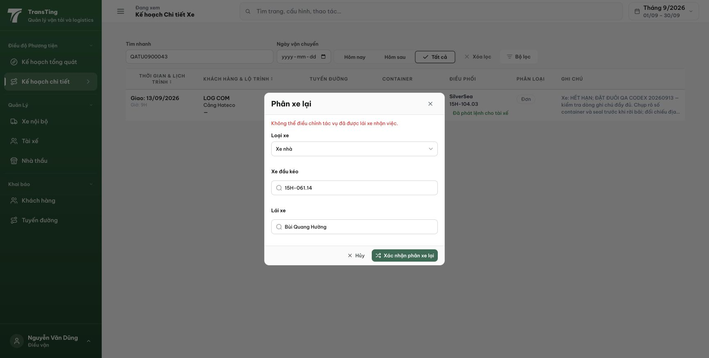
Figure 1. Staging, 13 September 2026: the accepted-trip guard correctly rejects reassignment, while the row still says Đã phát lệnh cho tài xế and the dialog retains an editable-looking form and green confirmation control.
[2026-09-14] DEV COMPLETED — 14/14 tiêu chí DOM-verified (0 console errors), fixture 3 chuyến (67035 IN_TRANSIT+ack khóa; 67036 CREATED+ack vẫn sửa được — edge C3; 67037 IN_TRANSIT chưa nhận — đối chứng): chip 'Đã nhận lệnh' (ACCEPTED) trên hàng A+B vs 'Đã phát lệnh cho tài xế' (ISSUED) trên C; dialog 67035: giải thích khóa + hiện trạng chỉ đọc, KHÔNG có nút xác nhận trong DOM, footer chỉ Hủy; dialog 67036: nút 'Xác nhận phân xe lại' + draft đúng hiện trạng; wire driverAccepted true/true/false khớp từng hàng. Gap trung thực: nhánh 409-muộn→tự khóa (cần acceptance giữa chừng) phủ bằng unit contract. Commits 531c347c (+wire sớm trong 9d5d3aaa). Bằng chứng: /Volumes/LexarSSD/projects/silversea-prod/testplan/qa/evidence/2026-09-14_qa016-acceptance-lock/REPORT.md + 01/02/03. Staging tái kiểm sau cut.
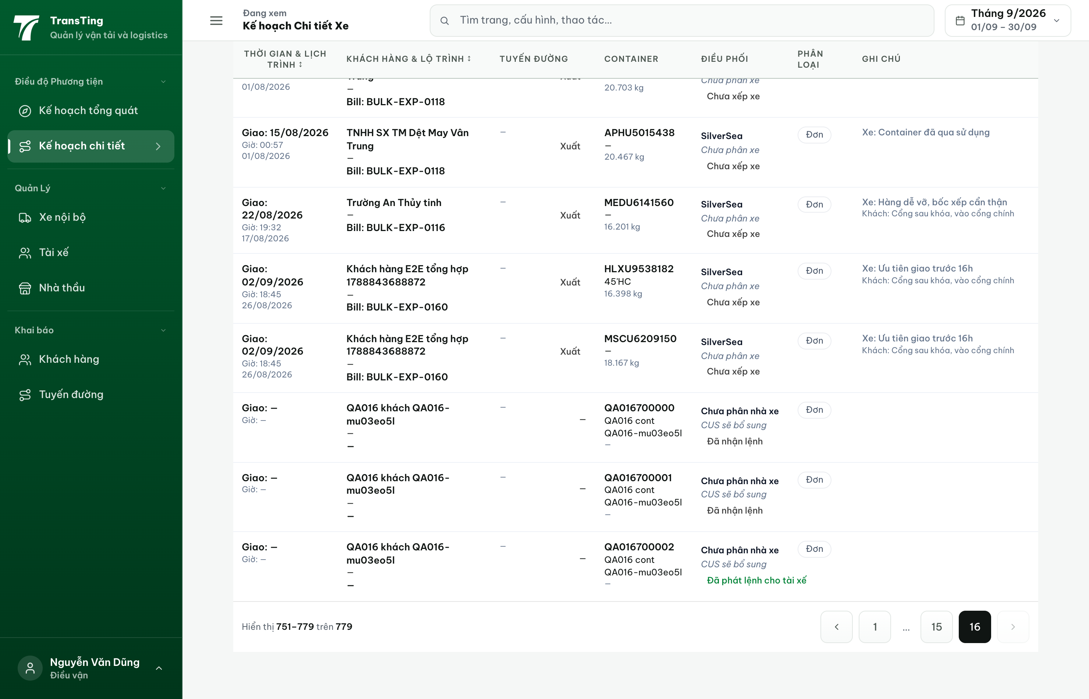
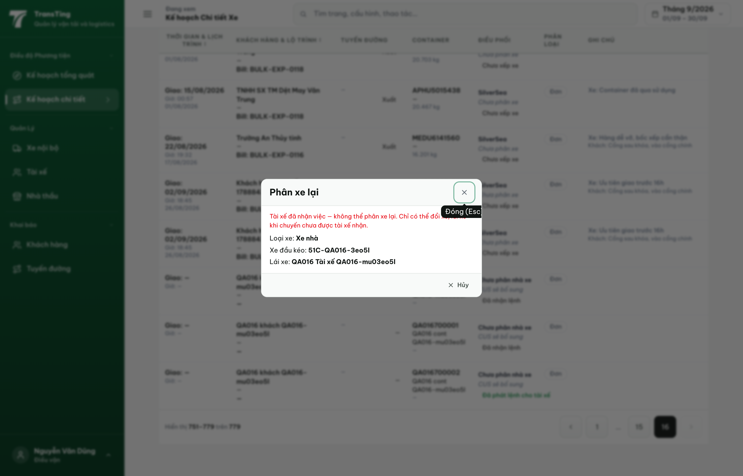
[2026-09-14] QA PASSED — staging2: hàng đã nhận 'Đã nhận lệnh' vs chưa nhận 'Đã phát lệnh cho tài xế'; trip 14 dialog khóa ('Tài xế đã nhận việc — không thể phân xe lại…') + hiện trạng chỉ đọc (0 input bật, không nút lưu). Bằng chứng: staging2-qa016-acceptance-lock/.

