Open driver attachments in a readable full image viewer
  - QA-018 | P2 | Enhancement | TODO
Environment: Staging https://vantai.tingting.vip
Reviewed: 13 September 2026
Role: Lái xe — Bùi Tiến Dũng; login btdung; Chrome mobile viewport 390 × 844
Page: https://vantai.tingting.vip/my-trips/29 — SỐ CONT & SEAL, Hình ảnh

Existing behaviour
Saved container, seal and report images loaded after upload and reload, but Hình ảnh showed small cropped thumbnails. Clicking each opened no enlarged view, dialog or tab. Image text was cropped or too small to inspect comfortably. In contrast, the separate ePOD workflow opened a viewer with zoom, reset, Escape/close and gallery navigation.

Target behaviour
Connect compact attachment thumbnails to the existing ePOD viewing pattern. Initially fit the whole image, support zoom/pan, and close back to the same attachment and scroll position.

Impact
Drivers cannot comfortably verify container/seal details or read reports from cropped thumbnails, although saved images are available.

Cause and investigation
Hypothesis: thumbnails lack an implemented or discoverable viewer action. Inspect the interaction and image source; no component-level cause is established.

Steps to reproduce
1. As btdung at 390 × 844, use an active trip with all three test-image types saved. The observed trip 29 was later completed.
2. Reload and confirm all three Hình ảnh thumbnails load.
3. Click each image and attempt full-image inspection. No enlarged view or new tab opened in the observed run.

Acceptance criteria
1. Each populated image opens through a named touch, pointer and keyboard action; empty slots do not imply an available image.
2. Initially fit the full image; support zoom and pan to inspect source details.
3. Visible close and Escape return focus to the opener and preserve scroll position.
4. All three types preview after reload; opening/closing never changes or deletes attachments.
5. Keep compact thumbnails and readable labels; avoid oversized inline image panels.

Requirement reference
Exploratory staging review, 13 September 2026; user direction for compact, smooth data-heavy UI.
Related: 20260911_2.docx FEATURE 2 and 20260912_6.docx. Full-size viewing is an enhancement proposal.

Evidence 1
  - Open driver attachments in a readable full image viewer
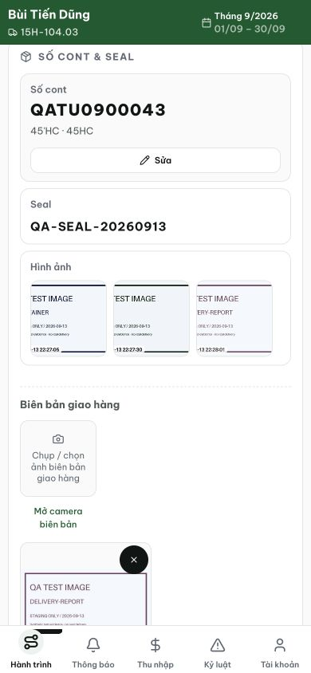
Figure 1. Staging, 13 September 2026, btdung: saved container, seal and report images render as cropped thumbnails. Clicking each image did not open an enlarged view during the interaction check.

Evidence 2
  - Open driver attachments in a readable full image viewer
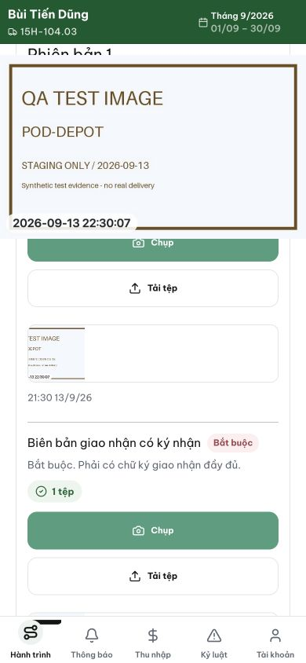
Figure 2. Staging, 13 September 2026: the separate ePOD workflow shows a larger image presentation. The interaction check confirmed an existing viewer with zoom, reset, close/Escape and gallery navigation, which can provide a consistent pattern for these attachments.
[2026-09-14] QA FAILED (một phần) — AC1/5 ĐẠT: chạm thật vào ô Seal (hit-test + listener) mở PhotoViewer toàn ảnh, đọc rõ 100% (850px), thumbnail gọn. AC3 một nửa: ESC đóng được (phím thật). AC2/3 THẤT BẠI ở chuột: toàn bộ nút điều khiển viewer (zoom/rotate/đóng/prev) nằm dưới chrome app — click thật trúng topbar/sidebar (elementFromPoint: topbar--driver / sidebar-brand / sidebar-item), backdrop xuyên pointer-events; viewer KHÔNG đóng được bằng chuột. AC4 phát hiện lỗi thứ hai: ảnh loại OTHER (biên bản) không bao giờ được trả về payload (service chỉ truy vấn CONTAINER+SEAL) → ô chụp biên bản là ngõ cụt. Fixture thật đã staged bằng API upload của app (transcript trong thư mục). Đã giao lane sửa. Bằng chứng: testplan/qa/evidence/2026-09-14_driver-photo-viewer-qa018/REPORT.md
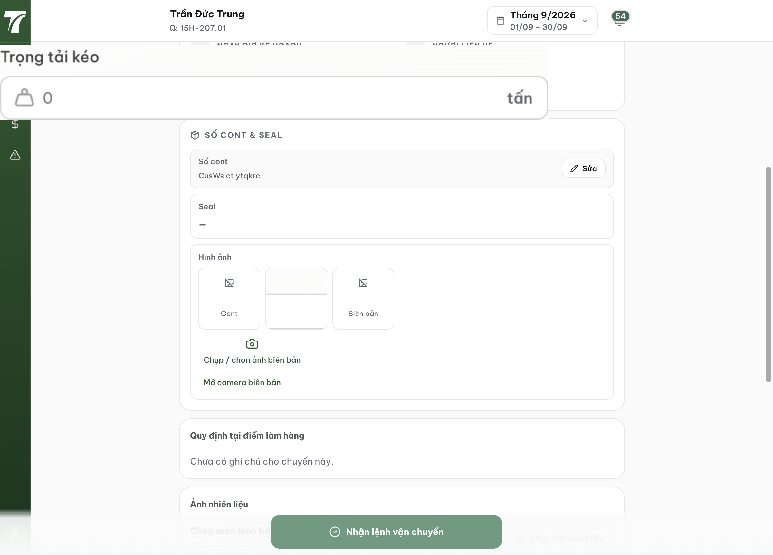
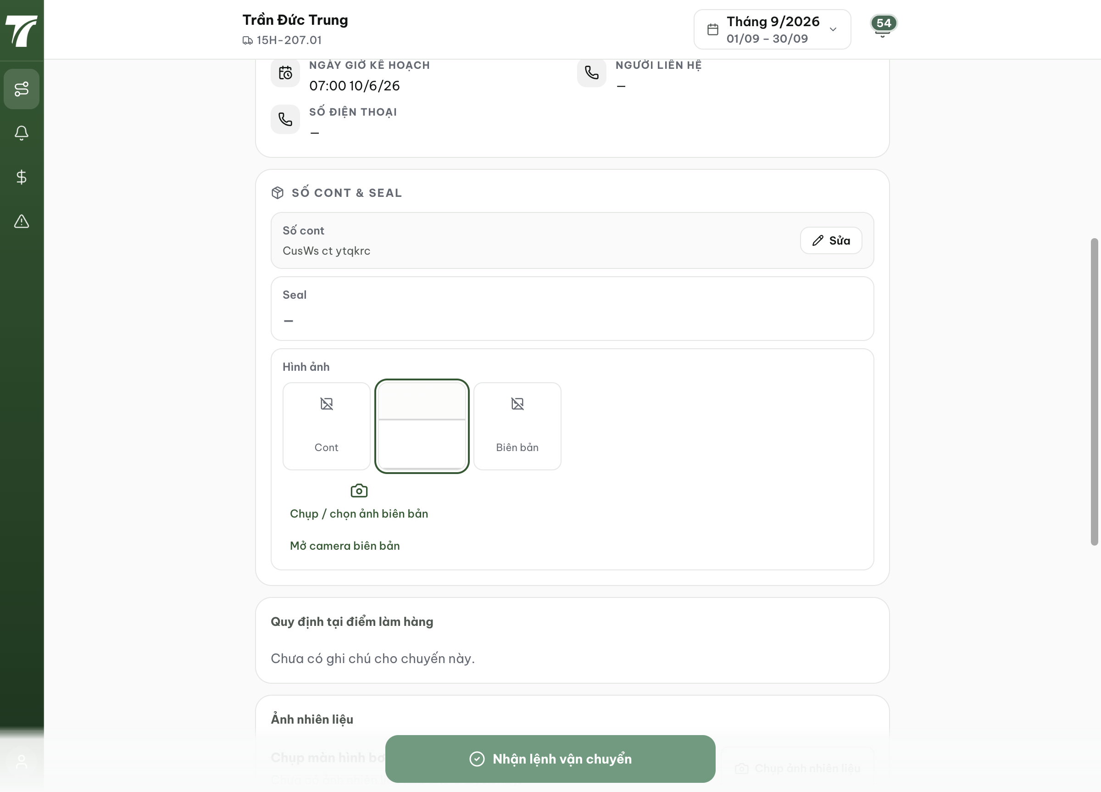
[2026-09-14] QA PASSED (sau sửa + re-QA chạm thật) — AC1: chạm thật vào ô có ảnh (hit-test) mở viewer; Enter trên nút tập trung cũng mở; ô rỗng không phải nút. AC2: ảnh khớp 100% đọc rõ; zoom chạm thật 100%→150%. AC3: nút đóng X chạm thật ĐÓNG được (lỗi cũ: overlay không có css — driver chunk không tải PhotoViewer.css; giờ component tự import, z=300 trên chrome); ESC đóng VÀ focus trả về đúng nút mở. AC4: Seal + Biên bản (fixture DELIVERY_NOTE thật) đều hiển thị sau reload; mở/đóng không đổi ảnh; loại OTHER là phiếu chi phí theo thiết kế (bằng chứng test) — phát hiện 'lỗi 2' của QA đầu rút lại. AC5: thumbnail gọn. Gaps trung thực: pan chưa thử trực tiếp; ô Cont thiếu fixture thật (mock keys). Commit 20b241a5. Ảnh 05–08.
