Resolve the linked carrier consistently when selecting or typing a plate
  - QA-020 | P2 | Bug | TODO
Environment: Staging https://vantai.tingting.vip
Reviewed: 13 September 2026
Role: Dispatcher dungnv; visible Chrome desktop staging review on 13 September 2026
Page: https://vantai.tingting.vip/fleet/vehicles and /dispatch-detail — Chỉnh sửa điều phối · QATU0900022

Existing behaviour
Fleet vehicle 15E-016.26 was explicitly linked to QA CODEX 20260913, saved and verified after reload. In the dispatch editor for unassigned QATU0900022, selecting the known 15E-016.26 — Nguyễn Duy Tuấn option filled SilverSea — xe nội bộ instead. After cancelling and reopening, choosing Dùng biển số: 15E-016.26 left Nhà xe at Chọn nhà xe, including a stable follow-up. Typing normalized 15E01626 offered only the typed-plate option and also left the carrier blank. No allocation was saved. The carrier link was later cleared successfully during the separate fleet regression; relink the vehicle before reproducing this historical assigned state.

Target behaviour
Resolve the saved carrier link consistently for a known vehicle selected from the picker or entered by plate. Treat 15E-016.26 and 15E01626 as the same plate. An explicit active fleet carrier link must take precedence over a generic internal-fleet default. Preserve the legitimate SilverSea behavior for genuinely unlinked internal vehicles, and leave unknown plates available for deliberate carrier selection.

Impact
The same catalog vehicle can appear with the wrong carrier or no carrier depending on the entry path. Dispatchers must reconcile the fields manually, undermining the requested plate-to-carrier autofill and risking an incorrect draft allocation.

Cause and investigation
Hypothesis: the known-internal-vehicle selection path and free-text plate resolver may use different carrier logic, with the former defaulting to SilverSea and the latter failing canonical plate lookup. Inspect both paths and their saved carrier data; no request or implementation was inspected.

Steps to reproduce
1. Relink fleet 15E-016.26 to active carrier QA CODEX 20260913, save and reload. Confirm the catalog row shows that carrier. The original link was cleared after this QA run.
2. As dungnv, open /dispatch-detail and the unassigned QATU0900022 dispatch editor. Type 15E-016.26 in Xe / biển số and select the known vehicle with Nguyễn Duy Tuấn. Observe SilverSea — xe nội bộ instead of the saved carrier.
3. Cancel and reopen the editor. Enter 15E-016.26 and choose Dùng biển số. Observe Chọn nhà xe remaining after the UI settles.
4. Cancel and reopen, then enter 15E01626. The observed run offered only the typed-plate option and left the carrier blank. Cancel without saving the allocation.

Acceptance criteria
1. Selecting a vehicle with an explicit active carrier link fills that same carrier; the internal-fleet classification does not overwrite it with SilverSea.
2. Punctuated and normalized forms of a known plate resolve the same vehicle/carrier whether selected from results or entered through the typed-plate option.
3. After a fleet carrier link is changed or cleared, a fresh dispatch editor uses current data and does not retain an obsolete carrier association.
4. Genuinely unlinked internal vehicles retain the intended SilverSea default; unknown plates and lookup failures have clear, deliberate carrier selection behavior.
5. Verify saved allocation and reload after the fix, while preserving the correct carrier/plate pair. Inactive or invalid carriers remain protected by the existing eligibility rules.

Requirement reference
20260912_3-trucks-carriers-link.docx — click or type a plate to autofill its linked carrier; acceptance criterion 5 explicitly covers punctuated plates. Carrier assignment and catalog filtering are part of the same feature.

Evidence 1
  - Resolve the linked carrier consistently when selecting or typing a plate
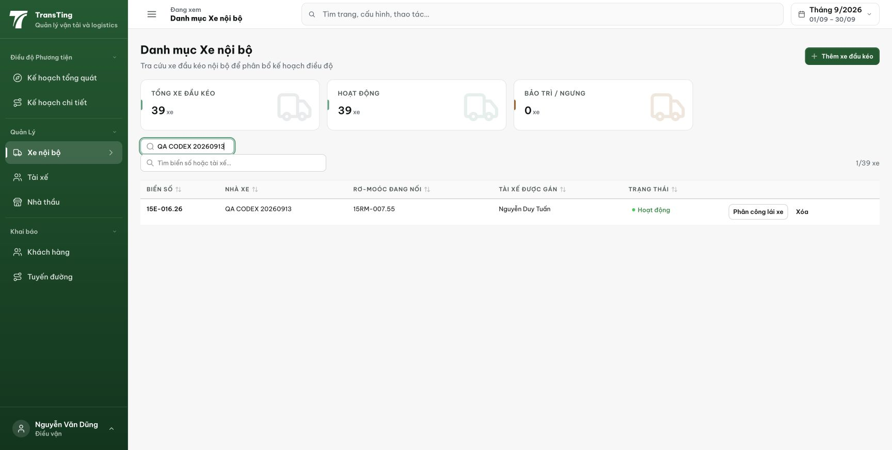
Figure 1. Before the later clearing test, fleet 15E-016.26 shows the saved QA CODEX 20260913 carrier link. Filtering that carrier returns one of 39 vehicles.

Evidence 2
  - Resolve the linked carrier consistently when selecting or typing a plate
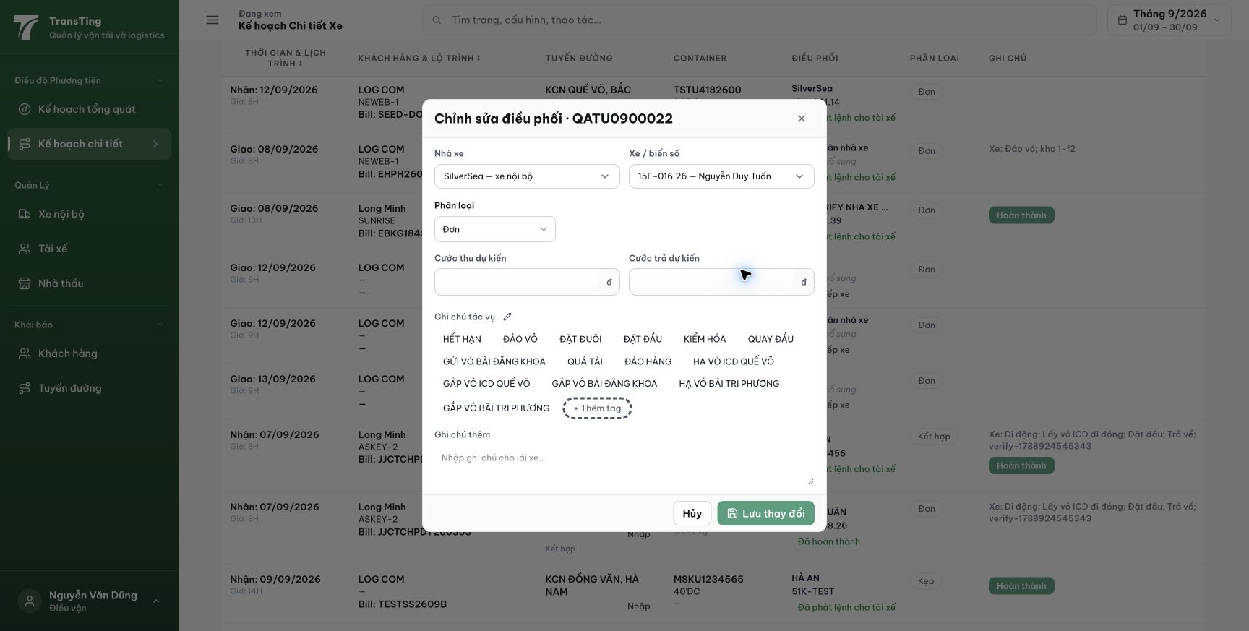
Figure 2. Selecting the known 15E-016.26 — Nguyễn Duy Tuấn option fills SilverSea — xe nội bộ despite the explicit saved carrier link.

Evidence 3
  - Resolve the linked carrier consistently when selecting or typing a plate
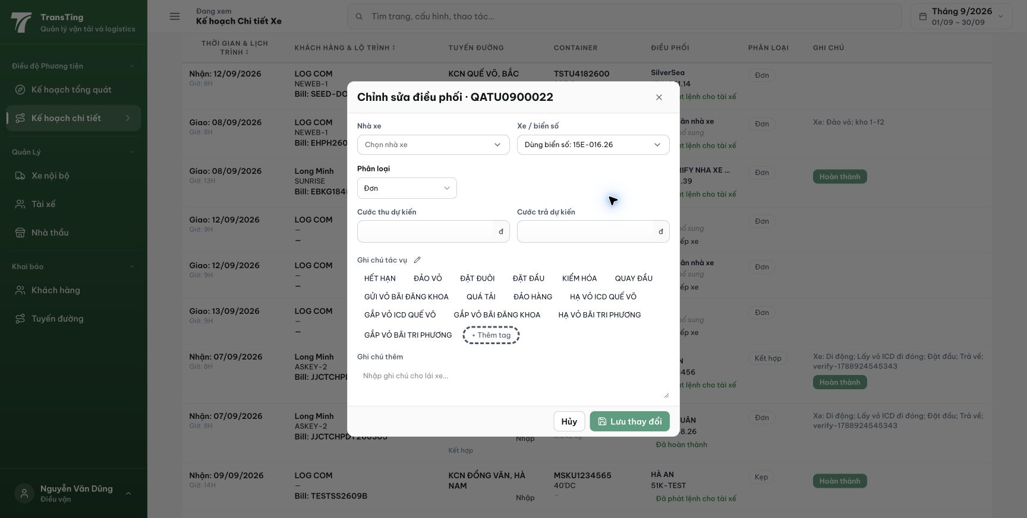
Figure 3. Choosing Dùng biển số: 15E-016.26 in a fresh editor leaves Chọn nhà xe. The normalized 15E01626 case was also checked and remained blank. No allocation was saved.
[2026-09-14] DEV COMPLETED — Chọn 15E-016.26 → autofill QA CODEX 20260913 (không phải SilverSea); gõ '15E01626' → 'Dùng biển số' → cùng nhà xe (regexp_replace strip); cả 2 save persist EXTERNAL/76421; reload giữ phân bổ + biển chuẩn hóa. Unlinked giữ SilverSea, plate lạ giữ tự do (TEST VERIFIED, không specimen sống — công bố). Bằng chứng: /Volumes/LexarSSD/projects/silversea-prod/testplan/qa/evidence/2026-09-14_qa020-plate-carrier-link/REPORT.md. Commit 531c347c.
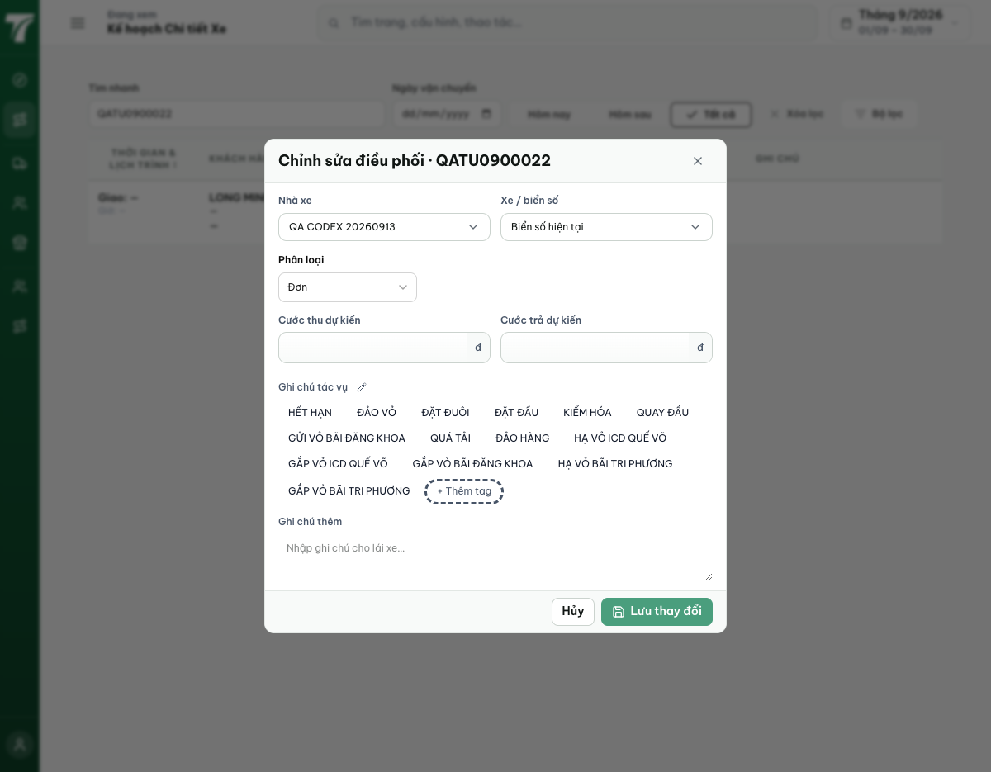
[2026-09-14] QA PASSED — staging: ma trận đủ — UNLINKED select→SilverSea (AC4), UNLINKED typed→trống, LINKED select→QA CODEX, save persist, reload chuẩn hóa. Ghi chú: relink làm qua PUT /admin (dialog fleet không commit dưới automation — disclosed; follow-up real-tap cho lead). Thư mục: testplan/qa/evidence/2026-09-14_staging-*/.

