Use 24 hour formatting in the CUS shipment drawer
  - QA-021 | P2 | Bug | TODO
Environment: Staging https://vantai.tingting.vip
Reviewed: 13 September 2026
Role: CUS thanhdc (Đinh Công Thành); Chrome desktop on macOS
Page: https://vantai.tingting.vip/shipments — CUS shipment drawer, Giờ hẹn đóng/trả

Existing behaviour
The shipment drawer uses a 12-hour GIỜ control with an AM/PM segment. On booking QA-R2-0913-54321 (LOG COM / NEWEB-1, 20DC), selecting the 13:30 preset displays 01:30 PM. The presets themselves use 24-hour labels. The separate /shipments/new form accepted and saved 13:30 through its HH:mm DD/MM/YYYY field, so this failure is specific to the drawer control.

Target behaviour
Use consistent 24-hour HH:mm entry in the CUS shipment drawer, matching the quick presets and creation form. Preserve the intended hour/minute and the working bottom Lưu action.

Impact
CUS operators must switch between 24-hour presets and AM/PM entry, contrary to the requested format and increasing the chance of afternoon or evening entry mistakes.

Cause and investigation
Hypothesis: the native time control follows browser or operating-system locale while the presets use an application formatter. Verify the control and supported locale behavior before choosing a consistent 24-hour presentation.

Steps to reproduce
1. As thanhdc, open /shipments, search QA-R2-0913-54321 and open Chi tiết, or use an equivalent editable container shipment.
2. Open Giờ hẹn đóng/trả, select a valid date and click 13:30. Observe GIỜ displaying 01:30 PM.
3. Use the native keyboard time control to select a morning value and observe the AM segment.

Acceptance criteria
1. The drawer time field displays and accepts 24-hour HH:mm values without AM/PM in supported CUS browsers.
2. 08:00, 13:30, 20:46, 00:15 and 23:45 use the same format in the input and presets.
3. Save, reopen and reload preserve the selected date, hour and minute; bottom Lưu remains usable.
4. Retest /shipments/new and shared schedule-edit controls for consistent 24-hour entry without changing the already working creation-form behavior.
5. Verify the separate hour-alignment fix under QA-022; a formatting change alone does not establish that fix.

Requirement reference
IMG_6360.png — customer explicitly requests 24h format for CUS return-time entry.

Evidence 1
  - Use 24 hour formatting in the CUS shipment drawer
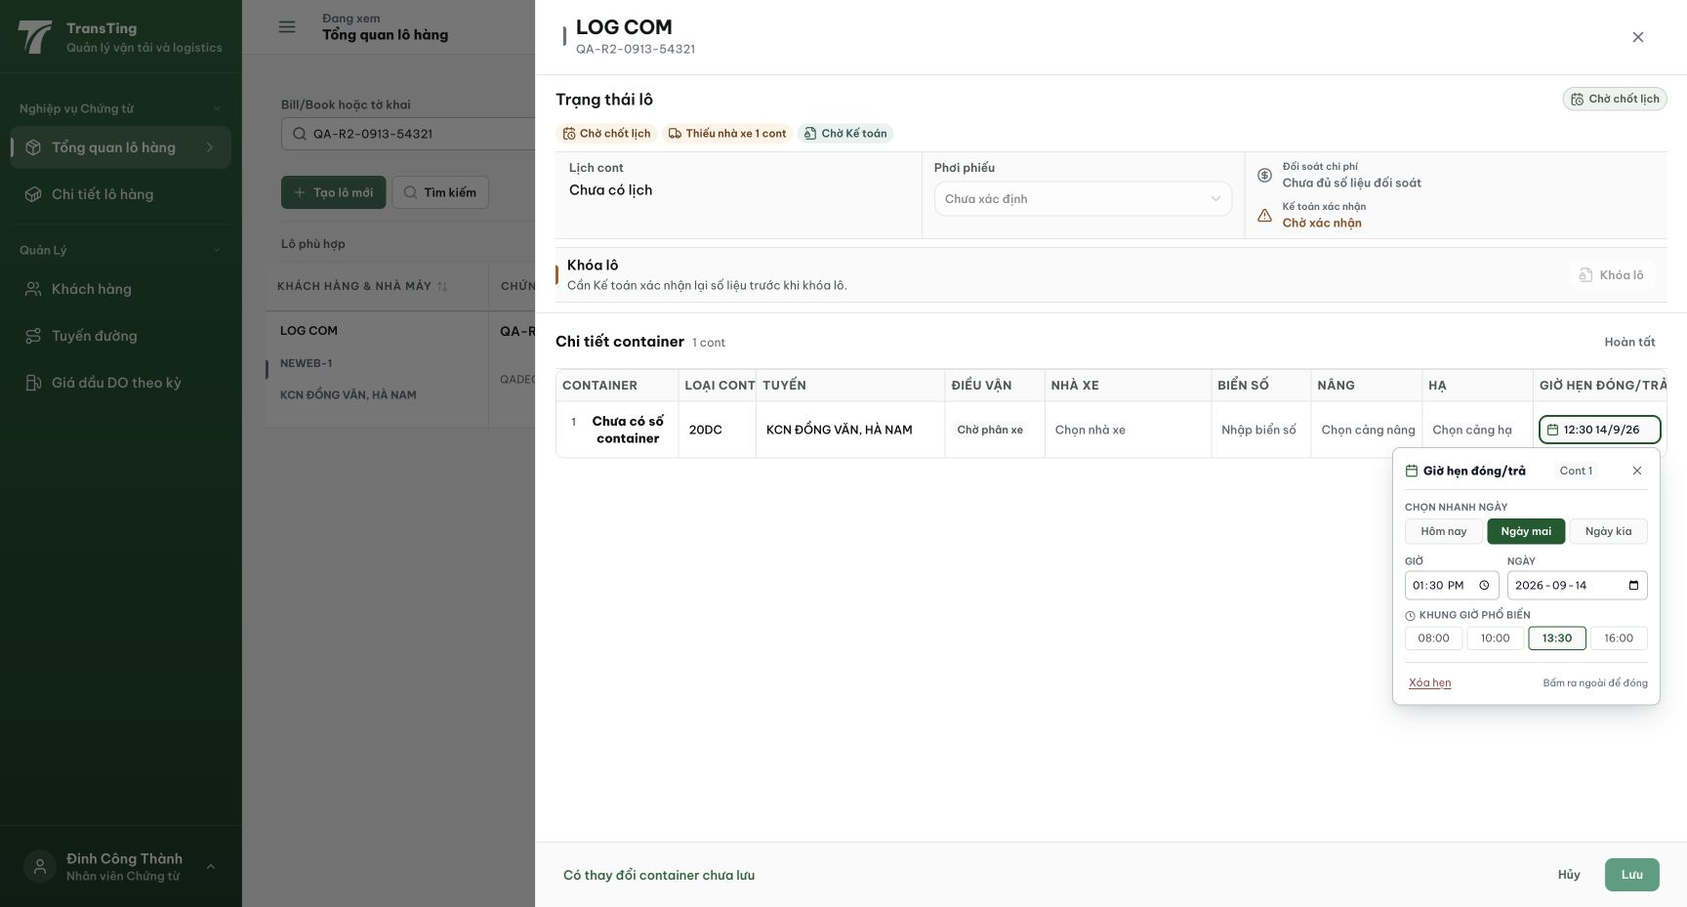
Figure 1. CUS drawer: the 13:30 preset is selected, while GIỜ displays 01:30 PM. Bottom Lưu is enabled. The row-preview hour mismatch is tracked separately in QA-022.
[2026-09-14] DEV COMPLETED — Popover Giờ hẹn dùng MỘT ô text 24h 'HH:mm DD/MM/YYYY' (buffered, cùng contract /shipments/new); không còn input time/date native; không AM/PM ở bất kỳ rung nào. Gõ thật (keyboard events): 20:46, 00:15 hiển thị đúng như gõ; preset 13:30 khớp input + row. Commits 42b959d1 (+16148368 preview). Bằng chứng: /Volumes/LexarSSD/projects/silversea-prod/testplan/qa/evidence/2026-09-14_cus-appointment-popover-qa021-qa022/REPORT.md — 7 ảnh, real-keys cho các mục gõ. Staging tái kiểm sau cut thứ hai.
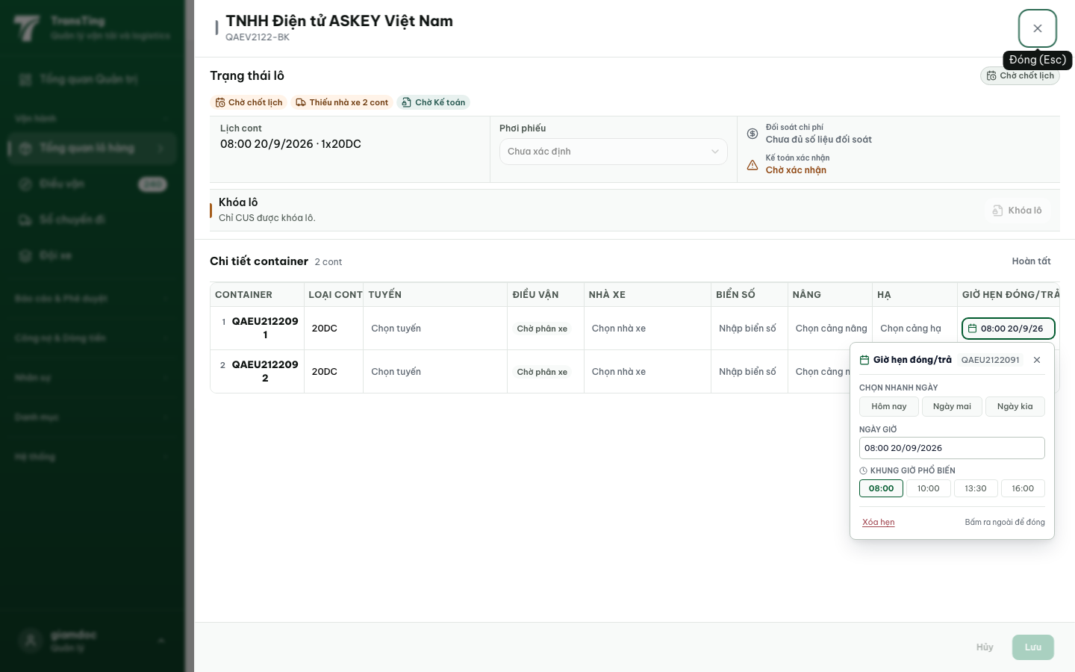
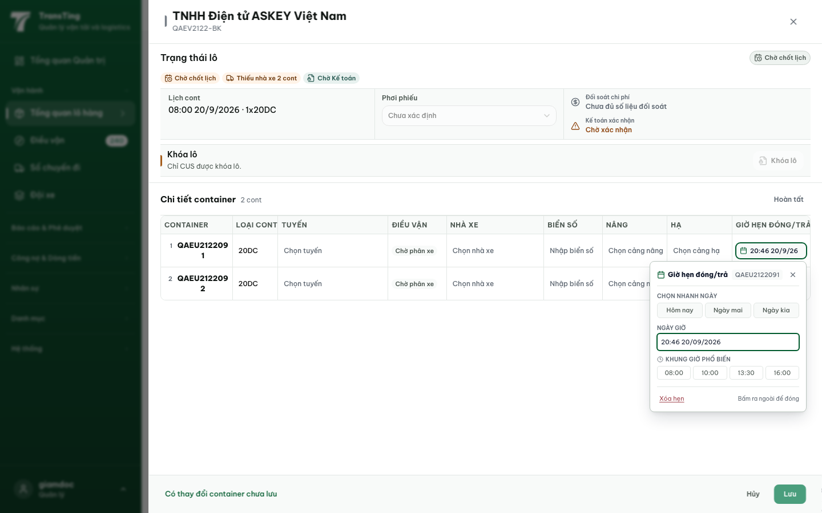
[2026-09-14] QA PASSED — staging2: popover = textbox 24h 'NGÀY GIỜ' ('08:00 14/09/2026'), không AM/PM; gõ '13:30 15/09/2026' chấp nhận. Bằng chứng: staging2-qa021-qa022-appointment-popover/.

