Align the CUS schedule preview with the selected time
  - QA-022 | P2 | Bug | TODO
Environment: Staging https://vantai.tingting.vip
Reviewed: 13 September 2026
Role: CUS thanhdc (Đinh Công Thành); Chrome desktop on macOS
Page: https://vantai.tingting.vip/shipments — Giờ hẹn đóng/trả in the CUS shipment drawer

Existing behaviour
On QA-R2-0913-54321, selecting 13:30 on 14 September 2026 sets GIỜ to 01:30 PM, but the container row immediately shows 12:30 14/9/26. A later keyboard change to 20:46 previewed as 19:46; after Lưu, the overview showed 20:46. The draft preview differs by one hour. This does not establish incorrect database storage.

Target behaviour
Display the same intended appointment date, hour and minute in the picker, immediate row preview and saved summary, using consistent operational-timezone rules. Preserve the explicit Lưu action.

Impact
CUS users cannot reliably review an appointment before saving and may compensate for the misleading preview by changing an already correct selection.

Cause and investigation
Hypothesis: the picker and preview use different timezone rules or apply an extra local-time conversion. Inspect date construction and formatting across these paths before changing storage semantics.

Steps to reproduce
1. As thanhdc, open /shipments, find QA-R2-0913-54321 and open its editable container appointment in Chi tiết.
2. Choose 14 September 2026 and click 13:30. Compare GIỜ 01:30 PM with the simultaneous row preview 12:30 14/9/26.
3. Use the native keyboard time control to enter 20:46. The observed draft preview showed 19:46.
4. Click Lưu. The saved overview showed 20:46; verify reopened and reloaded readback when retesting.

Acceptance criteria
1. 13:30 immediately previews as 13:30, and 20:46 as 20:46, with the same date.
2. Preset and manual entry agree with the saved overview, reopened drawer and reload readback; check date boundaries and supported timezone/locale configurations.
3. Confirm time semantics before changing conversions; do not alter stored appointments to compensate for a display mismatch.
4. Retest shared schedule-edit controls and preserve bottom Lưu. QA-021 separately covers 24-hour input formatting.

Requirement reference
IMG_6359.png and IMG_6360.png — CUS appointment entry and confirmation.

Evidence 1
  - Align the CUS schedule preview with the selected time
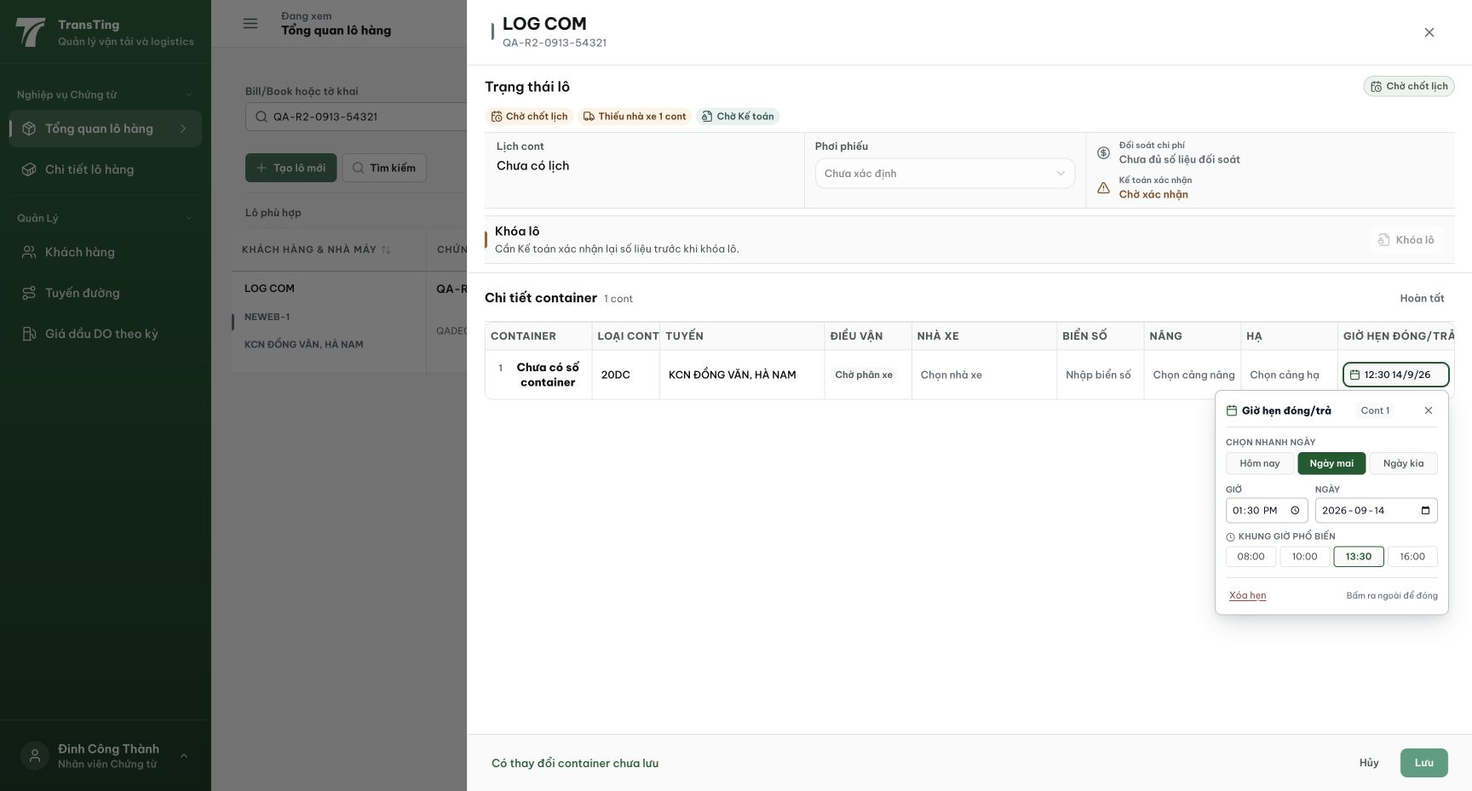
Figure 1. Simultaneous state: the 13:30 preset and 01:30 PM input disagree with the same row’s 12:30 14/9/26 preview.

Evidence 2
  - Align the CUS schedule preview with the selected time
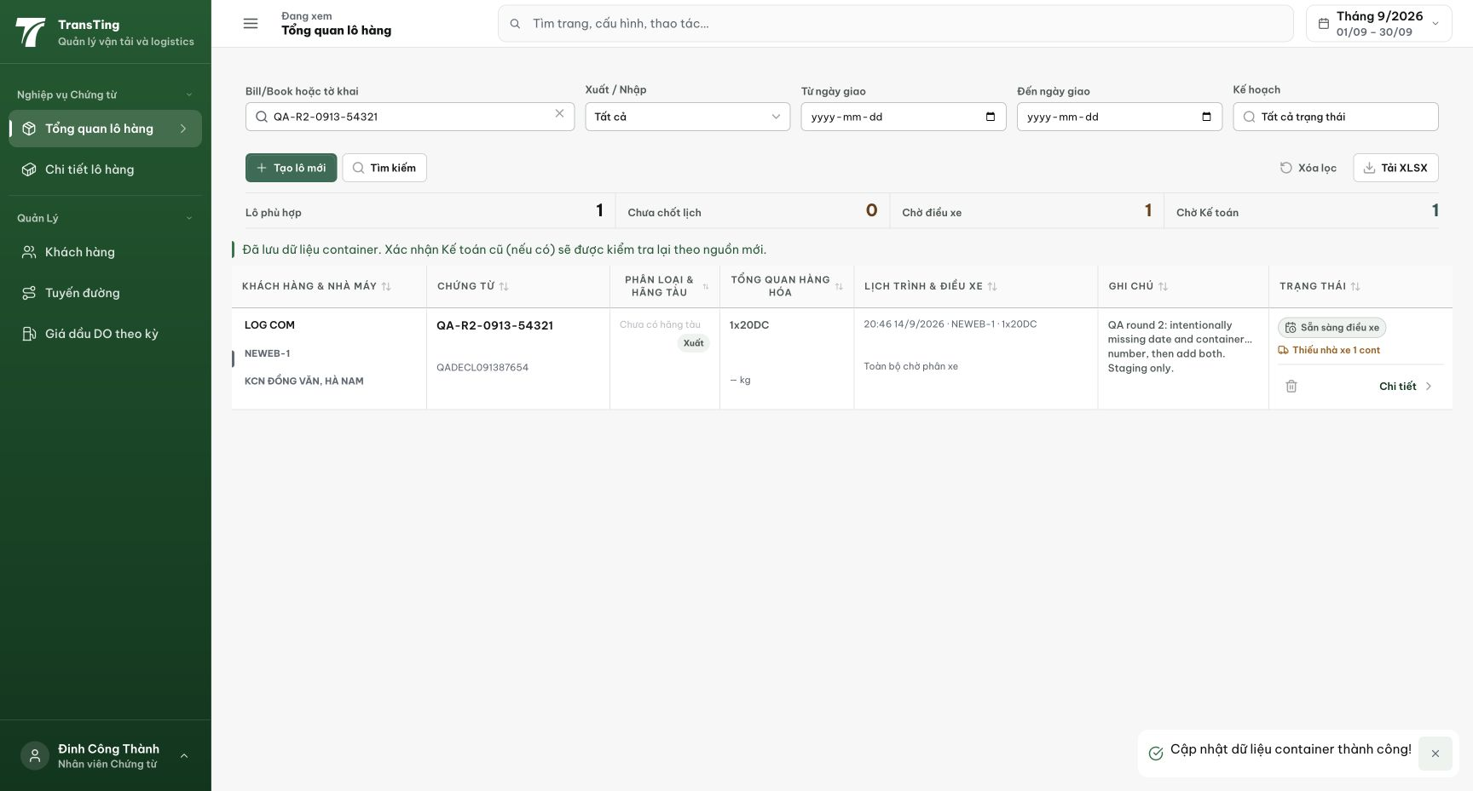
Figure 2. After a later 20:46 selection and Lưu, the saved overview shows 20:46. This capture uses a different selection from Figure 1.
[2026-09-14] DEV COMPLETED — Lỗi −1h đã chết: gõ 13:30 → preview row '13:30 20/9/26' cùng ngày (máy +8 cũ hiển thị 12:30); 20:46 → '20:46 20/9/26' (19:46 chết). Root cause: parse naive theo browser-local + toLocalDateTime dùng getTimezoneOffset — sửa bằng formatVietnamDateTimeInput VN-pinned + naive branch string-surgery cho formatDateTimeShort. Draft-state criterion (không cần save). Commit 16148368. Bằng chứng: /Volumes/LexarSSD/projects/silversea-prod/testplan/qa/evidence/2026-09-14_cus-appointment-popover-qa021-qa022/REPORT.md — 06-typed-1330-preview-agreement là specimen chính. Staging tái kiểm (card-env gốc là staging).
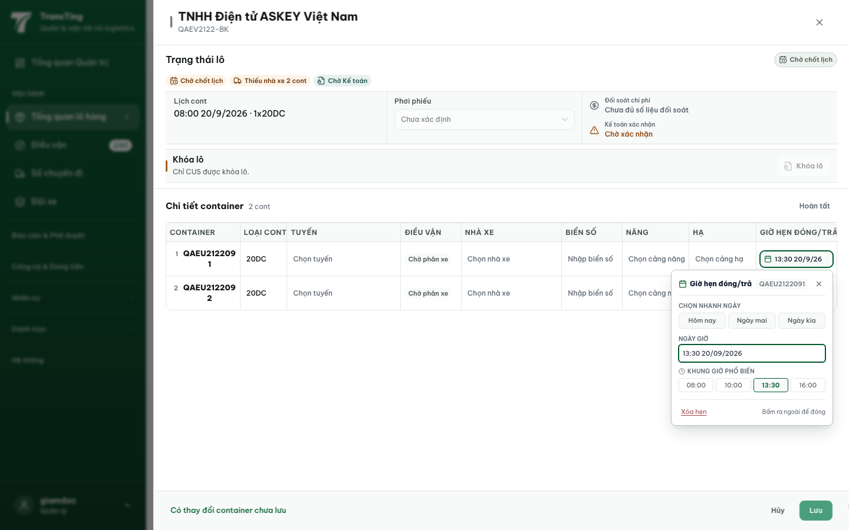
[2026-09-14] QA PASSED — staging2: preview row '13:30 15/9/26' == picker NGAY LẬP TỨC; Lưu → toast + DB container 33 = 2026-09-15T06:30Z = 13:30 ICT — picker/preview/saved 3 chiều khớp. Bằng chứng: staging2-qa021-qa022-appointment-popover/.

