Show the transport route beneath the factory on driver trip cards
  - QA-023 | P2 | Bug | TODO
Environment: Staging https://vantai.tingting.vip
Reviewed: 13 September 2026
Role: Lái xe — Dương Văn Thực; login dvthuc; Chrome 390 × 844
Page: https://vantai.tingting.vip/my-trips — Đã nhận; comparison with /my-trips/8

Existing behaviour
The ASKEY-2 cards show the full street address beneath the factory abbreviation: Lô C7-2, KCN Quế Võ, Phường Nam Sơn, Tỉnh Bắc Ninh, Việt Nam. Trip 8 details separately show the route KCN QUẾ VÕ, BẮC NINH in the task header. The card uses the address where the supplied wireframe requests the route.

Target behaviour
Place the configured route immediately below the factory abbreviation. Keep the full address in expanded details and retain a compact card. The route-led detail header matches the new wireframe.

Impact
The longer address slows card scanning and obscures the separate route identity used in details.

Cause and investigation
Hypothesis: the card subtitle selects factory address instead of the route field used by the detail header. Verify both mappings; no code or API diagnosis was performed.

Steps to reproduce
1. As dvthuc at 390 × 844, open Hành trình → Đã nhận and find the first ASKEY-2 card with the XƯỞNG 2 note.
2. Read the subtitle, then open Xem chi tiết at /my-trips/8.
3. Compare the card subtitle with the detail route and the IMG_6370 board wireframe.

Acceptance criteria
1. Cards show the factory abbreviation first, followed immediately by the correct configured route.
2. With distinct route and address values, each appears in its intended location; details retain the complete street address.
3. At 390px, route text stays compact and readable without overlap, oversized components or font shrinking.
4. Preserve container/type, ports, notes and navigation. Missing operation remains tracked in QA-002.

Requirement reference
IMG_6369.png — factory abbreviation first, route below, then container/type/operation and ports.
IMG_6370.png — compact board route and separate full factory address in details.

Evidence 1
  - Show the transport route beneath the factory on driver trip cards
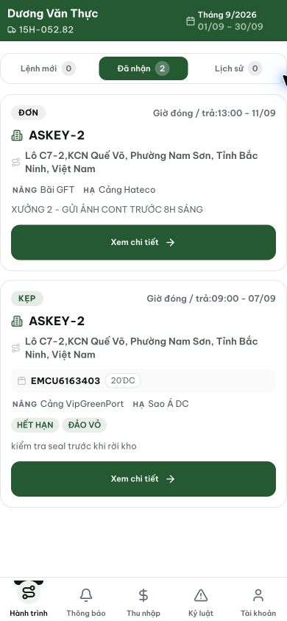
Figure 1. Staging, 13 September 2026, dvthuc: both ASKEY-2 cards use a long street address beneath the abbreviated factory name.

Evidence 2
  - Show the transport route beneath the factory on driver trip cards
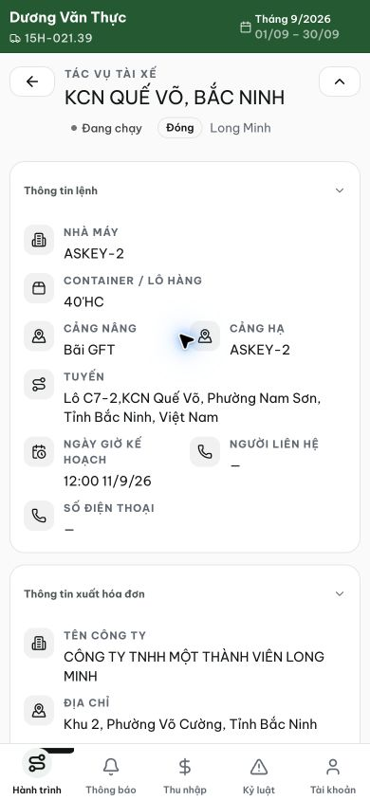
Figure 2. Trip 8 details show KCN QUẾ VÕ, BẮC NINH as the route and a separate full street address. The wireframe supports this route-led detail header; the defect concerns the board subtitle.
[2026-09-14] DEV COMPLETED — Xác minh trực tiếp (lead-qa, local dev, nvtho /my-trips): card ASKEY-2 hiển thị ROUTE 'KCN Quế Võ, Nam Sơn, Bắc Ninh' ngay dưới tên viết tắt nhà máy; KHÔNG có địa chỉ đường phố ('Lô C7-2 / Phường Nam Sơn / Việt Nam' vắng mặt trên card — kiểm tra DOM). Địa chỉ đầy đủ vẫn thuộc trang chi tiết. Staging cũ hiển thị địa chỉ vì build cũ — tái kiểm staging sau cut. Bằng chứng: /Volumes/LexarSSD/projects/silversea-prod/testplan/qa/evidence/2026-09-14_journey-card-route-numberless-qa023-qa024/01-nvtho-board.png + 02-closeup-route-numberless.png. Commit 59d5d6e3 (trong cụm journey-card).
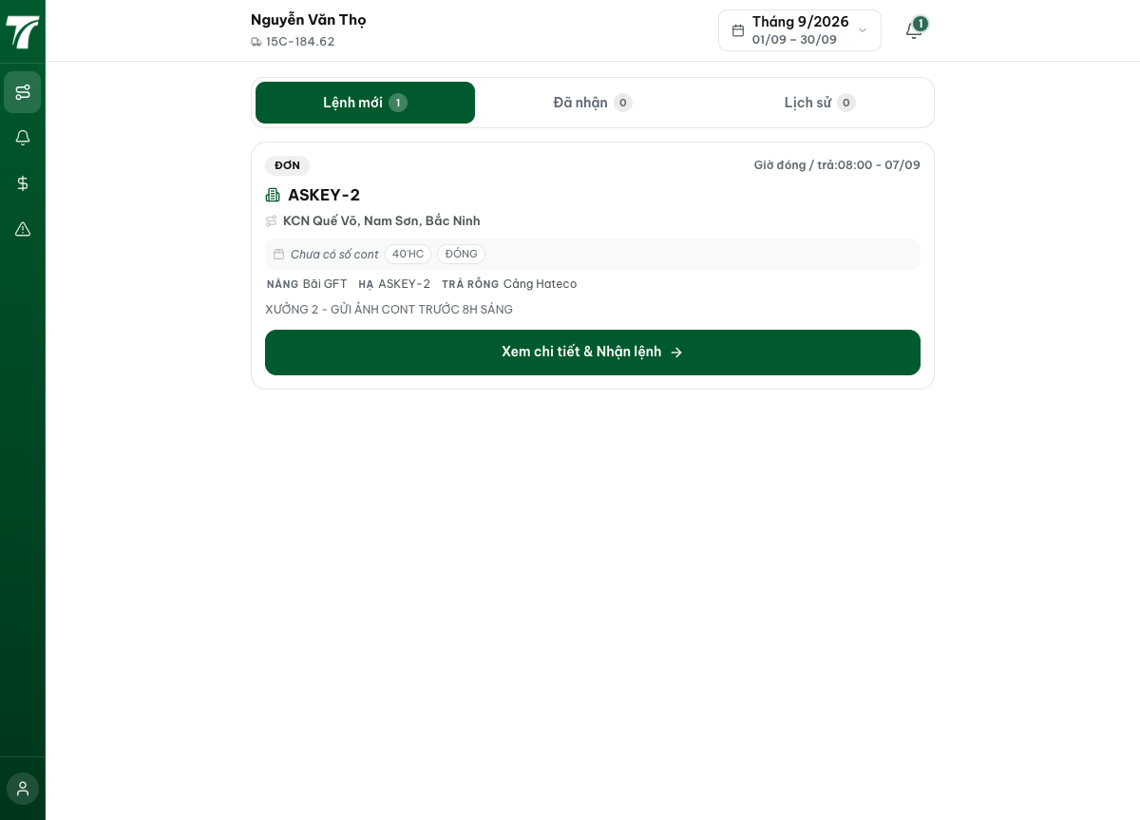
[2026-09-14] QA PASSED — staging2: card hiển thị route 'KCN Quế Võ, Nam Sơn, Bắc Ninh' dưới tên viết tắt; KHÔNG có địa chỉ trên card (DOM) và địa chỉ giữ nguyên ở ĐỊA CHỈ NHÀ MÁY (detail). Bằng chứng: staging2-qa023-route-card/.

