Keep the container type visible when its number is not assigned
  - QA-024 | P2 | Bug | TODO
Environment: Staging https://vantai.tingting.vip
Reviewed: 13 September 2026
Role: Lái xe — Dương Văn Thực; login dvthuc; Chrome 390 × 844
Page: https://vantai.tingting.vip/my-trips — Đã nhận; comparison with /my-trips/8

Existing behaviour
The first ASKEY-2 card, with XƯỞNG 2 - GỬI ẢNH CONT TRƯỚC 8H SÁNG, has no number/type group. Its trip 8 detail shows 40HC without a container number. The card hides this available type and does not indicate that the number is pending. The numbered EMCU6163403 card below displays both number and type.

Target behaviour
Render container type independently of the number. For an unassigned number, show a concise label such as Chưa có số cont beside the known type. Replace the placeholder after the first number is saved, retaining the compact information group.

Impact
Drivers must open the trip to learn its type and cannot distinguish a pending number from omitted information.

Cause and investigation
Hypothesis: the number/type group is conditional on a nonempty number. Verify independent rendering; no code or API mapping was inspected.

Steps to reproduce
1. As dvthuc at 390 × 844, open Đã nhận and find the first ASKEY-2 card with the XƯỞNG 2 note.
2. Compare its absent number/type group with the populated group on EMCU6163403 below.
3. Open the first card at /my-trips/8 and confirm the available 40HC type. Use an equivalent unnumbered trip if its state changes.

Acceptance criteria
1. An unnumbered trip with a known type shows that type and an explicit missing-number label.
2. Saving the first number replaces the placeholder after refresh without losing or duplicating the type.
3. Numbered and unnumbered cards share a compact, readable group at 390px; avoid oversized empty-state panels.
4. If type is also absent, use an honest empty state. Operation labeling remains tracked in QA-002.

Requirement reference
IMG_6369.png and IMG_6370.png — driver cards separately show container number and container type. A clear missing-number label is the proposed empty-state treatment.

Evidence 1
  - Keep the container type visible when its number is not assigned
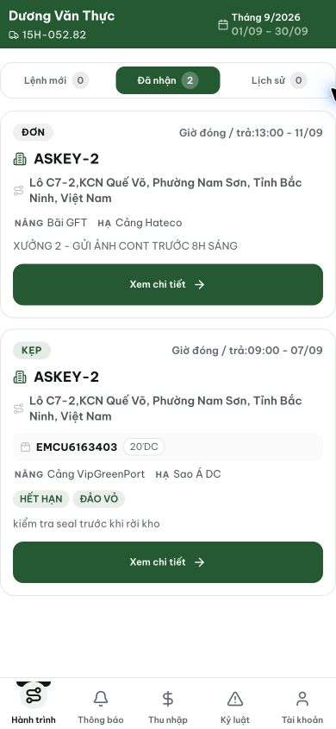
Figure 1. Staging, 13 September 2026, dvthuc: the first ASKEY-2 card has no number/type group or missing-number label; the numbered card below displays EMCU6163403 and 20DC.

Evidence 2
  - Keep the container type visible when its number is not assigned
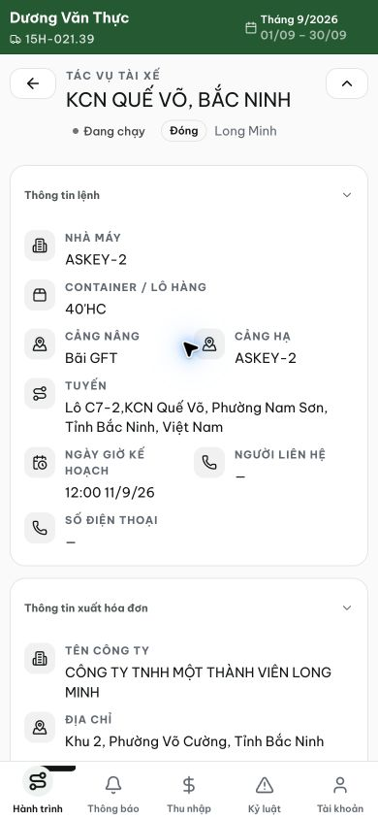
Figure 2. Staging, 13 September 2026, dvthuc: trip 8 details show the known 40HC type without a container number. This is the first ASKEY-2 card shown in Figure 1.
[2026-09-14] DEV COMPLETED — Xác minh trực tiếp (lead-qa, local dev, nvtho): card chưa có số cont hiển thị 'Chưa có số cont' (muted) BÊN CẠNH type '40'HC' đã biết — type không biến mất khi thiếu số; pill ĐÓNG trong strip; các phần khác (route, ports, note XƯỞNG 2) nguyên vẹn. Placeholder theo dữ liệu — số cont đầu tiên lưu xong sẽ thay thế. Commit 59d5d6e3. Bằng chứng: /Volumes/LexarSSD/projects/silversea-prod/testplan/qa/evidence/2026-09-14_journey-card-route-numberless-qa023-qa024/01 + 02-closeup (cùng capture với QA-023).
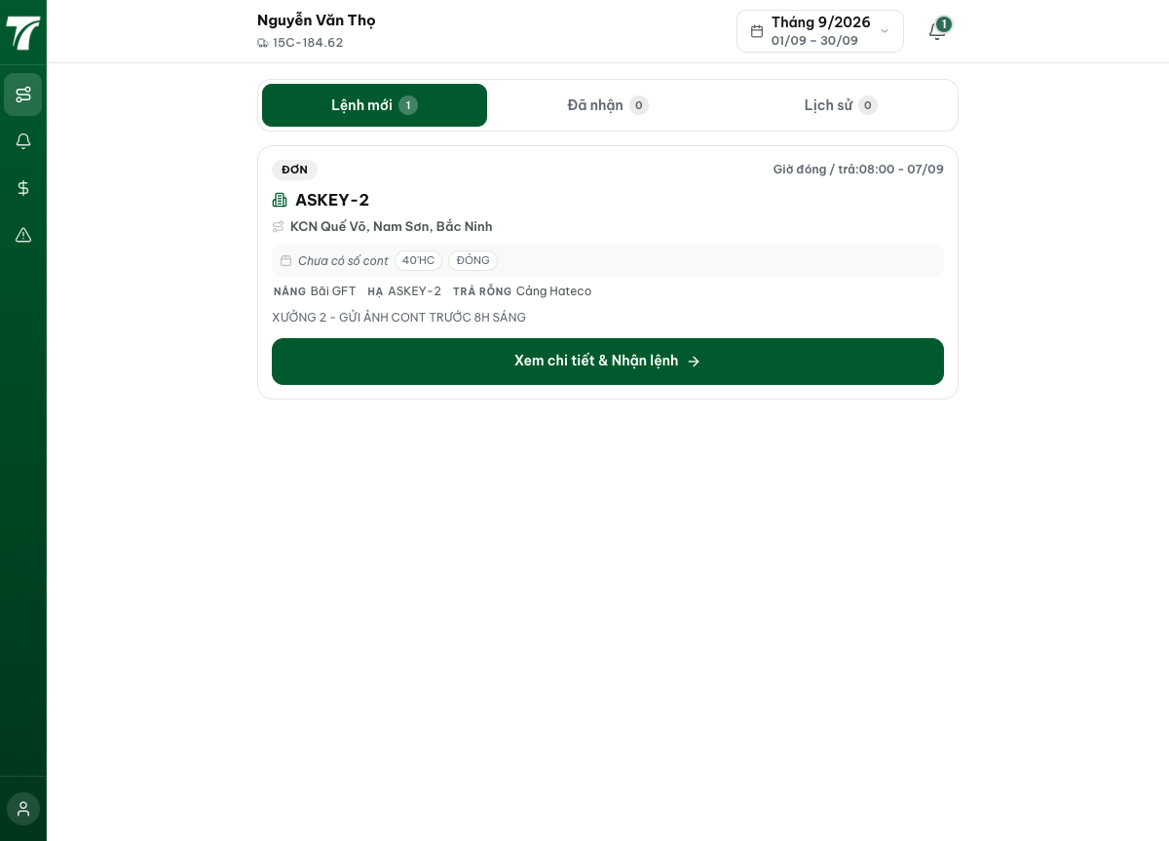
[2026-09-14] QA PASSED — staging2: 'Chưa có số cont40'HC' trên card thiếu số (detail: 'Số cont 40'HC'). Bằng chứng: staging2-qa024-numberless-type/.

