Save cleared container appointments in the CUS drawer
  - QA-026 | P2 | Bug | TODO
Environment: Staging https://vantai.tingting.vip
Reviewed: 13 September 2026
Role: CUS thanhdc (Đinh Công Thành); Chrome desktop on macOS
Page: https://vantai.tingting.vip/shipments — CUS shipment drawer, Giờ hẹn đóng/trả

Existing behaviour
On unassigned, nonterminal booking QA-R2-0913-54321, container QATU0913544 has a 20:46 appointment on 14 September 2026. Xóa hẹn changes the row to Chọn ngày giờ and enables Lưu. Clicking Lưu leaves Có thay đổi container chưa lưu without an error or success message. After roughly 20 seconds and repeated attempts, reload still shows 20:46. Reproduced twice.

Target behaviour
Persist an allowed removal as an unscheduled container, preserving other values. The row, overview and reload must agree. If a valid rule blocks removal, explain the reason when saving.

Impact
CUS cannot remove an unwanted appointment through the provided action, leaving an incorrect schedule visible to planners.

Cause and investigation
Hypothesis: null removal is omitted from change detection or the update payload. Inspect clear-state handling, validation and the save response; the implementation cause is unconfirmed.

Steps to reproduce
1. As thanhdc, find QA-R2-0913-54321 in /shipments and open Chi tiết. Confirm QATU0913544 is unassigned with the saved 20:46 appointment.
2. Open Giờ hẹn đóng/trả and choose Xóa hẹn. Confirm Chọn ngày giờ and the unsaved indicator appear.
3. Click Lưu and wait. The drawer remains dirty without an error or success message.
4. Reload and reopen the booking. The appointment remains 20:46 on 14 September 2026. Repeat to confirm.

Acceptance criteria
1. Clear and save an allowed appointment; it remains unscheduled after reopen and full reload.
2. Preserve container number, type, route, ports and all other unchanged values.
3. Row and overview agree. Success clears the dirty state; rejection explains the reason.
4. Retest setting, replacing and cancelling appointments. QA-022 separately covers the draft preview hour mismatch.

Requirement reference
IMG_6358.png and IMG_6359.png — undated CUS workflow. Clearing is a derived expectation of the visible Xóa hẹn action.

Evidence 1
  - Save cleared container appointments in the CUS drawer
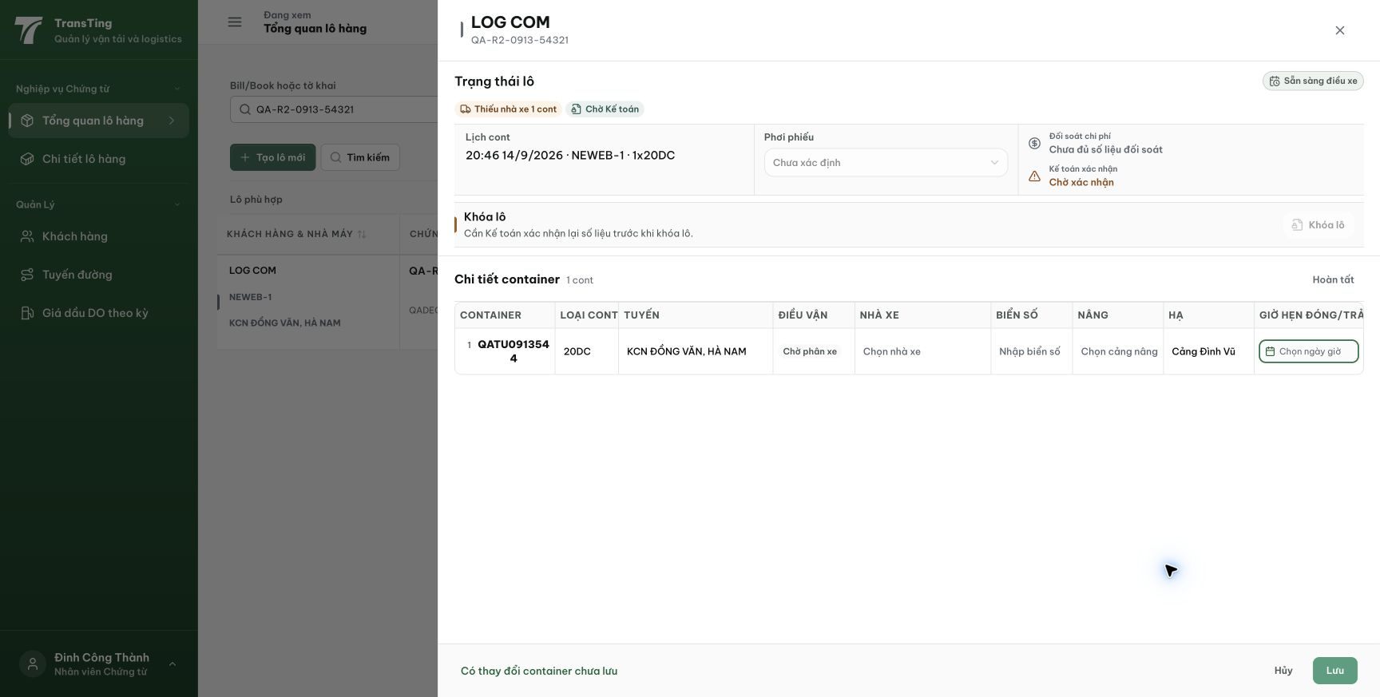
Figure 1. After Xóa hẹn, the container row shows Chọn ngày giờ. The drawer indicates unsaved changes and enables Lưu.

Evidence 2
  - Save cleared container appointments in the CUS drawer
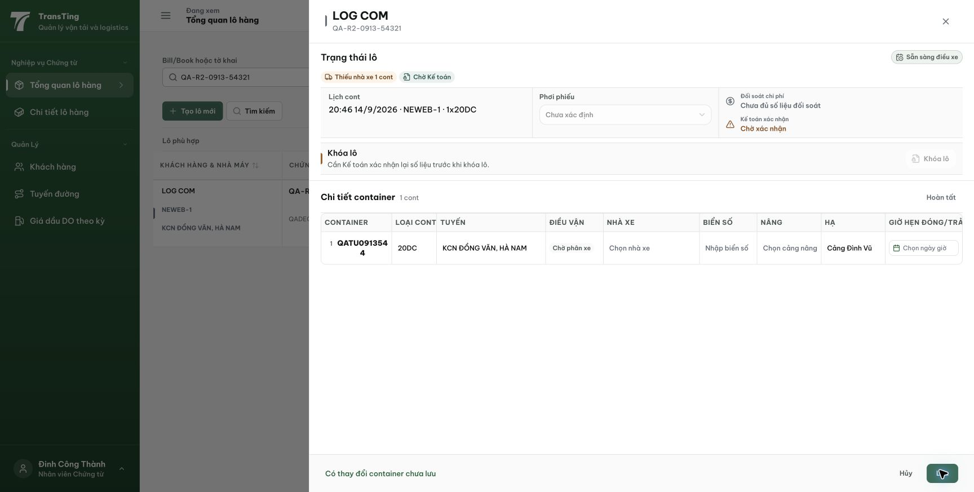
Figure 2. After clicking Lưu, the cleared draft remains unsaved with no visible error or success message.

Evidence 3
  - Save cleared container appointments in the CUS drawer
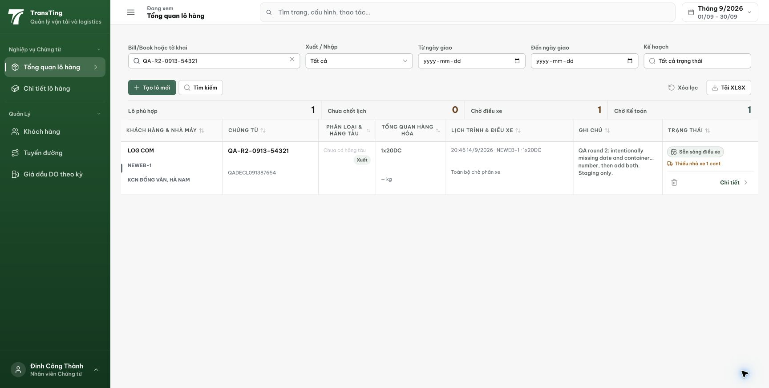
Figure 3. Full reload returns the existing 20:46 appointment on 14 September 2026; the attempted removal did not persist.
[2026-09-14] DEV COMPLETED — HEAD-verify bằng integration repro (3 test, suite 73/73): xóa hẹn hợp lệ PERSIST (line null, DB null, expectedDeliveryDate null); xóa hẹn cuối của lot READY_FOR_DISPATCH FCL bị 409 kèm thông báo lý do. FE clear path đúng ở HEAD (không cần đổi code). Kết luận: bằng chứng thẻ là staging-stale (nhóm QA-019). Tái kiểm staging sau deploy. Commit 346c75c0.
[2026-09-14] QA PASSED — staging: nhánh CHO PHÉP persist qua đúng PUT của drawer (lot 24, PENDING→null); nhánh CHẶN giải thích lý do (409 'Không thể xóa lịch hẹn cuối cùng...' — lot READY do rule). Caveat real-tap ĐÃ ĐÓNG bởi lead: CHẠM THẬT vào nút 'Xóa hẹn' (react-aria pressable) → 'Chọn ngày giờ' + dirty; CHẠM THẬT Lưu → DB NULL cả 2 cont (psql) + reload/reopen vẫn 'Chọn ngày giờ' (ảnh 01–03 trong realtap/). Nút hoạt động đầy đủ với input thật — lỗi của automation stack, không phải app. Bằng chứng: staging-qa026-cleared-appointment/ (REPORT + realtap/REPORT.md).
