Display container type once in the driver container summary
  - QA-008 | P3 | Enhancement | TODO
Environment: Staging https://vantai.tingting.vip
Reviewed: 13 September 2026
Role: Lái xe — Bùi Quang Hường; login bqhuong; Chrome mobile viewport 390 × 844
Page: https://vantai.tingting.vip/my-trips/20

Existing behaviour
Under Số cont TSTU4182600, the summary line reads ‘20’DC · 20DC’. Two visually different spellings of the same apparent container type are displayed side by side without labels that distinguish them.

Target behaviour
Show one consistently formatted container-type value in the driver summary. If the two values actually represent different business concepts, use distinct descriptive labels rather than presenting them as an unexplained duplicate.

Impact
The repeated value adds noise to a compact mobile card and can make drivers wonder whether the two codes have different meanings.

Cause and investigation
Hypothesis only: the summary may concatenate a formatted type label with its raw code. Inspect the fields before removing either; this visual review does not prove their backend semantics.

Steps to reproduce
1. On 13 September 2026, sign in to staging as bqhuong and open /my-trips/20 in Chrome at 390 × 844.
2. Collapse Thông tin lệnh and Thông tin xuất hóa đơn, then find SỐ CONT & SEAL.
3. Read the line directly below TSTU4182600: 20’DC · 20DC.

Acceptance criteria
1. TSTU4182600 displays one canonical container-type value without an equivalent raw-code duplicate.
2. If the values are semantically different, each is clearly labeled and both remain available.
3. Other supported container types render consistently without losing container number, seal or edit controls.

Requirement reference
Visual review on 13 September 2026 — driver detail /my-trips/20. Related design intent: 20260912_6.docx calls for a consistent, clear detail presentation; no explicit requirement for this duplicate value was found.

Evidence 1
  - Display container type once in the driver container summary
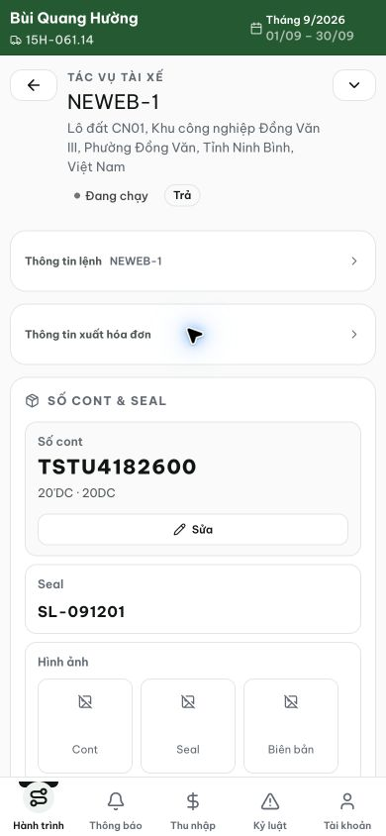
Figure 1. Staging, 13 September 2026, bqhuong: the TSTU4182600 summary shows the unexplained adjacent values 20’DC · 20DC.
[2026-09-14] DEV COMPLETED — 'TEST1234560 20'DC' hiển thị MỘT giá trị định dạng; phụ thuộc raw-code (' · 20DC') đã loại ở nguồn; quét DOM đúng 1 lần '20'DC' trong section. Bằng chứng: /Volumes/LexarSSD/projects/silversea-prod/testplan/qa/evidence/2026-09-14_qa008-container-type-once/REPORT.md. Commit 59d5d6e3.
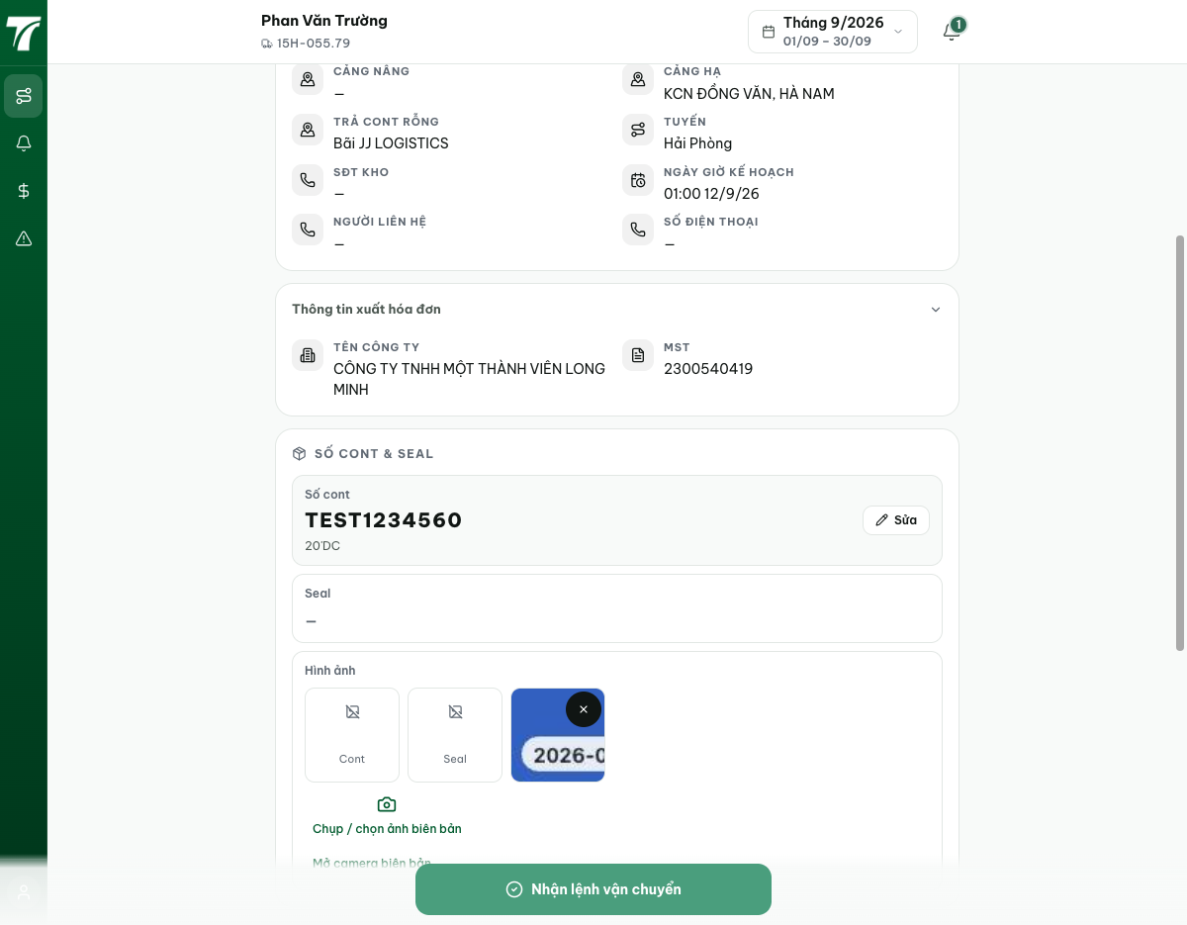
[2026-09-14] QA PASSED — staging: 'TSTU4182600 20'DC' đúng một lần. Thư mục: testplan/qa/evidence/2026-09-14_staging-*/.

