Use concise driver instructions when accepting an order
  - QA-017 | P3 | Enhancement | TODO
Environment: Staging https://vantai.tingting.vip
Reviewed: 13 September 2026
Role: Lái xe — Bùi Quang Hường; login bqhuong; Chrome mobile viewport 390 × 844
Page: https://vantai.tingting.vip/my-trips/29 — new order before acceptance

Existing behaviour
The new-order banner says Nhận lệnh ngay, không cần chờ Ops and App tạm bỏ qua xác nhận hiện trường. This prominent text exposes temporary application behavior and internal terminology above an existing Nhận lệnh vận chuyển action, consuming space without plainly stating the driver’s immediate step.

Target behaviour
Use a short, stable task instruction, such as Kiểm tra thông tin chuyến rồi chọn Nhận lệnh. Accurately state active prerequisites or consequences. Remove internal implementation and temporary-rollout wording; keep guidance compact and visually secondary.

Impact
Internal terminology makes routine acceptance feel provisional and distracts from checking trip information on a small screen.

Cause and investigation
Design hypothesis: rollout wording is being used as normal driver guidance. Confirm active business rules before changing it; preserve any required operational step.

Steps to reproduce
1. At 390 × 844, open an owned newly issued trip as its assigned driver before acceptance. The screenshot shows QATU0900043 as bqhuong; that fixture was later completed.
2. Read the banner above Thông tin lệnh and compare it with the Nhận lệnh vận chuyển action.

Acceptance criteria
1. Use plain Vietnamese without unexplained Ops terminology or App tạm bỏ qua implementation language.
2. Copy accurately describes acceptance prerequisites and effects. No required confirmation is removed or implied away.
3. At 390px width, guidance stays compact and subordinate to a clear acceptance action, preserving text readability and usable touch targets.

Requirement reference
User UI/UX direction, 13 September 2026: professional, compact and user-friendly presentation.
Exploratory new-order review; related driver-screen scope in 20260911_2.docx.

Evidence 1
  - Use concise driver instructions when accepting an order
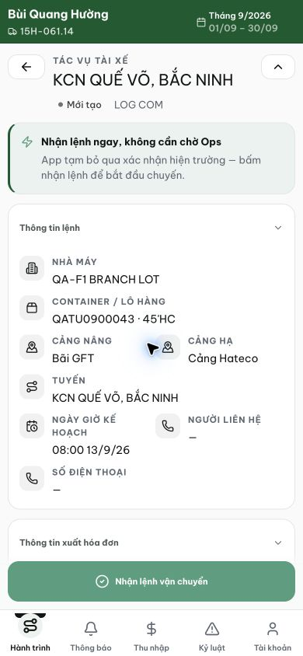
Figure 1. Staging, 13 September 2026, bqhuong: the new-order banner references Ops and temporary application behavior above the order details and existing acceptance action.
[2026-09-14] DEV COMPLETED — Banner nhận lệnh ngắn gọn, xác minh trực tiếp (lead-qa, local dev, nvtho /my-trips/7 CREATED): 'Kiểm tra thông tin chuyến rồi chọn Nhận lệnh' + dòng hiệu lực 'Sau khi nhận lệnh, chuyến bắt đầu.' — không còn văn cũ dài dòng; nút Nhận lệnh trên sticky bar còn nguyên (AC2: không bỏ xác nhận, không đổi flow). Unit test khóa cả hai dòng (52, 34/34). Grep backend/shared sạch: chuỗi là FE-hardcode ở DriverTripDetailPage:347-348 (giả thuyết getTripInstructions bị bác bỏ). Commit 5979664c. Ảnh: 01-banner-concise.png. Chờ staging QA sau deploy demo.
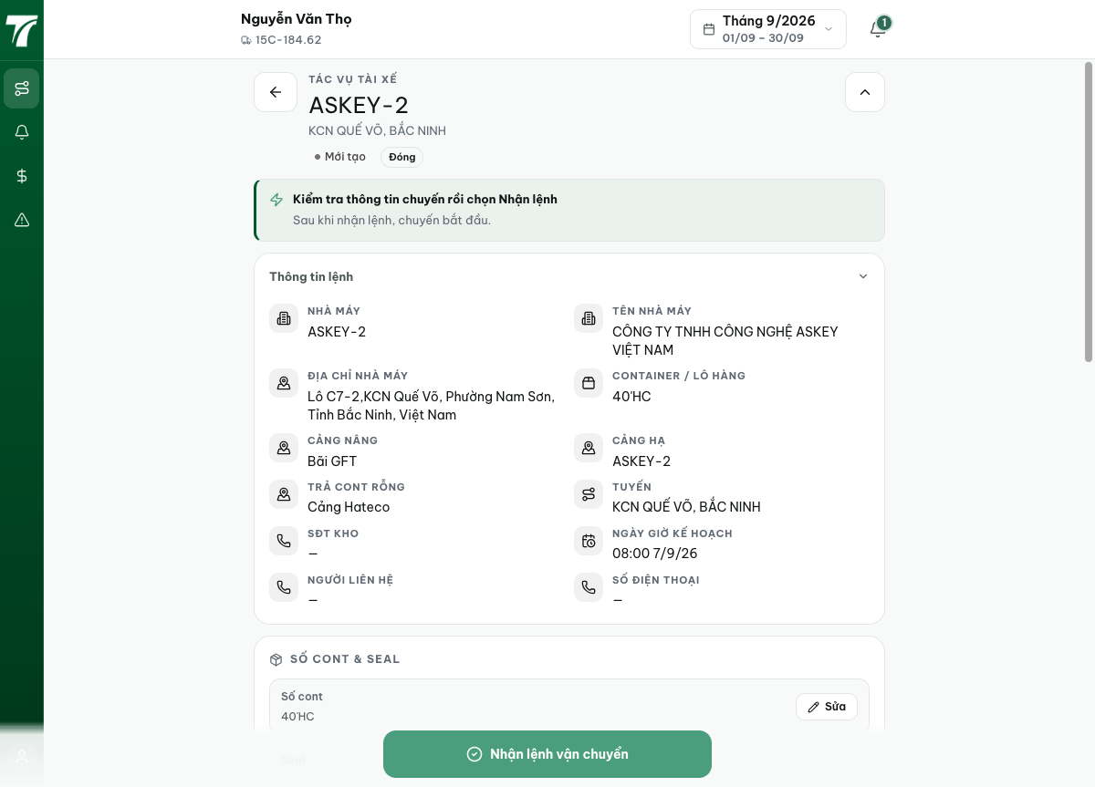
[2026-09-14] QA PASSED — staging: banner 'Kiểm tra thông tin chuyến rồi chọn Nhận lệnh' + dòng hậu quả; văn cũ vắng mặt (DOM-verified); specimen trên nhvuong (truck-4). Thư mục: testplan/qa/evidence/2026-09-14_staging-*/.

