Prevent duplicate trips when creation fails
  - QA-030 | P1 | Bug | TODO
Environment: Staging https://vantai.tingting.vip
Reviewed: 14 September 2026
Role: ADMIN (Quản trị viên); Chrome at 390 × 844 for creation, desktop for readback
Page: https://vantai.tingting.vip/trips/new; readback /trips, /trips/17 and /trips/18

Existing behaviour
Tạo lệnh shows “Leg 1 is invalid (Both origin and destination are required; Distance must be a non-negative number).” and leaves the creation form open, yet TRP-202609-0015 (/trips/17) exists. Correcting the missing endpoints and retrying creates TRP-202609-0016 (/trips/18). Both share QA-FULL-0914-MOBILE; the trip total rises from 14 to 16. The first record opens in Mới tạo state.

Target behaviour
Create one complete trip or none. Rejected submissions must leave no unintended record; retrying the same logical submission must not duplicate it. Validate all generated legs before committing.

Impact
Users can unknowingly create two records for one intended trip and dispatch or reconcile the wrong one.

Cause and investigation
Hypothesis: the base trip saves before leg validation or child writes, then retry starts another create. Inspect request sequencing and transaction boundaries; the implementation cause is unverified.

Steps to reproduce
1. As ADMIN at 390 × 844, open /trips/new. Select customer LOG COM, route KCN QUẾ VÕ, BẮC NINH, Xe ngoài and carrier QA CODEX 20260913.
2. Complete required fields with reference QA-FULL-0914-MOBILE, date 14 September 2026, one 20DC and the QA external vehicle details. Keep the two generated 100 km legs, each missing one endpoint.
3. With Sẵn sàng tạo lệnh shown, click Tạo lệnh. Observe the quoted error and the form remaining open.
4. Fill the missing endpoints and submit again. After success, search the reference in /trips: both /trips/17 and /trips/18 appear. Open /trips/17 to verify the persisted first record.

Acceptance criteria
1. Invalid legs leave no trip or dependent records; list/search counts remain unchanged after reload.
2. A corrected submission creates one complete trip, retaining legs, distance, notes and carrier data.
3. Retries of one logical submission must not duplicate it. Allow legitimate trips that reuse a customer reference.
4. Readiness and field errors agree on endpoint/distance requirements. Test partial-write recovery, then reload on mobile, tablet and desktop.

Requirement reference
Live Chrome audit, 14 September 2026. Error source: trip-create-autogenerated-invalid-legs.txt.
Readback: trip-duplicate-after-error-list.txt and trip17-partial-created-desktop.txt.

Evidence 1
  - Prevent duplicate trips when creation fails
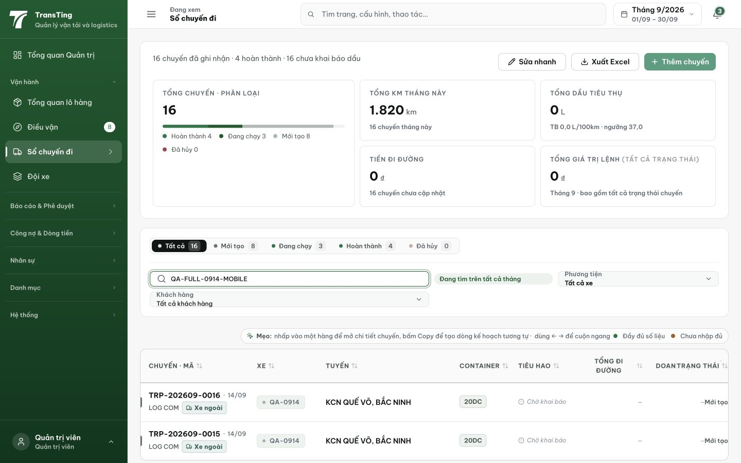
Figure 1. Searching QA-FULL-0914-MOBILE after the failed attempt and successful retry shows TRP-202609-0015 and TRP-202609-0016. The error itself is preserved in the cited DOM capture.

Evidence 2
  - Prevent duplicate trips when creation fails
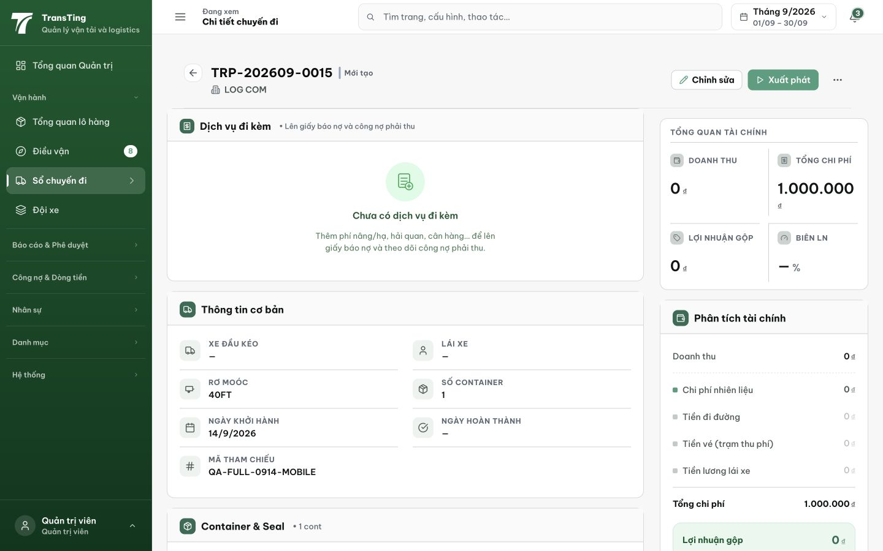
Figure 2. The first attempt’s /trips/17 opens as TRP-202609-0015 in Mới tạo state and retains QA-FULL-0914-MOBILE. This confirms an unintended persisted record despite the create error.
[2026-09-14] DEV COMPLETED — Rung local PASS: AC4 gate (submit disabled + dòng trạng thái hint 'Chặng chưa hợp lệ…', ảnh 1280/390/820) + AC1 network (submit khi gate active → ZERO POST /api/trips, listener-verified mọi lần). Unit (2d8a0b28, 12/12): hoist validate + idempotency-key + conflict-retry. HỞ trung thực: full-flow create→list readback (AC1 leg-specific + AC2 e2e) sang STAGING — listbox Loại hàng/Lái xe rỗng trong automation session trên dev stack (catalog thật có trên staging); recipe đã sửa (ComboBox: aria-label targeting + ArrowDown+Enter, re-query mỗi bước) bàn cho 88. Card QA_PASSED sau rung staging.
[2026-09-14] QA PASSED — staging (vantai, build 2c41f420→9d064b50, admin): AC1 invalid legs → Tạo lệnh DISABLED, real click + JS click → 0 POST /api/trips (network log) → no partial trip possible; hint "Chặng chưa hợp lệ — cần đủ điểm đi, điểm đến và quãng đường không âm" renders (1280 + 390). AC2 corrected legs (2× Thuận Thành↔KCN ĐỒNG VĂN 60 km) → hint "Sẵn sàng tạo lệnh", submit → POST /api/trips 201, exactly ONE trip TRP-202609-0019 (Mới tạo, legs retained) lists in /trips. AC4 readiness and field errors agree (disabled+warning vs enabled+ready). Evidence: testplan/qa/evidence/2026-09-14_staging-round6-qa030-trip-create/ (REPORT.md + PNGs). Not covered on staging: AC3 double-strand retry replay (needs a mid-create network sever; Idempotency-Key retry contract holds per local DEV rung and round-2 API verification).
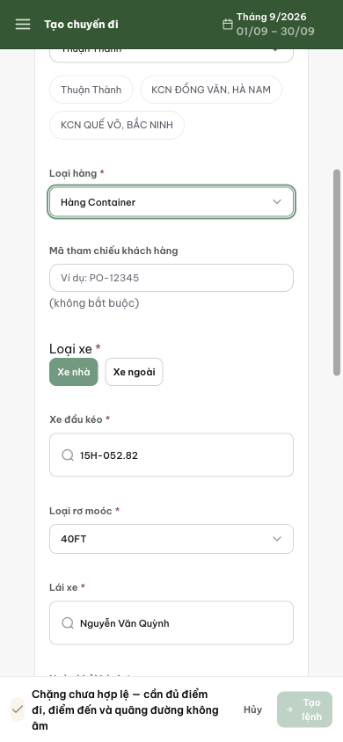
AC1: gate active at 390 — invalid-leg hint + disabled Tạo lệnh (zero POST in network log).
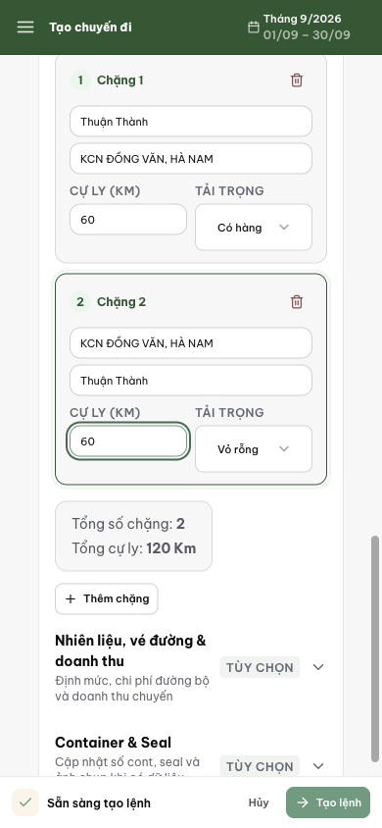
AC2: legs completed — "Sẵn sàng tạo lệnh", submit enabled.
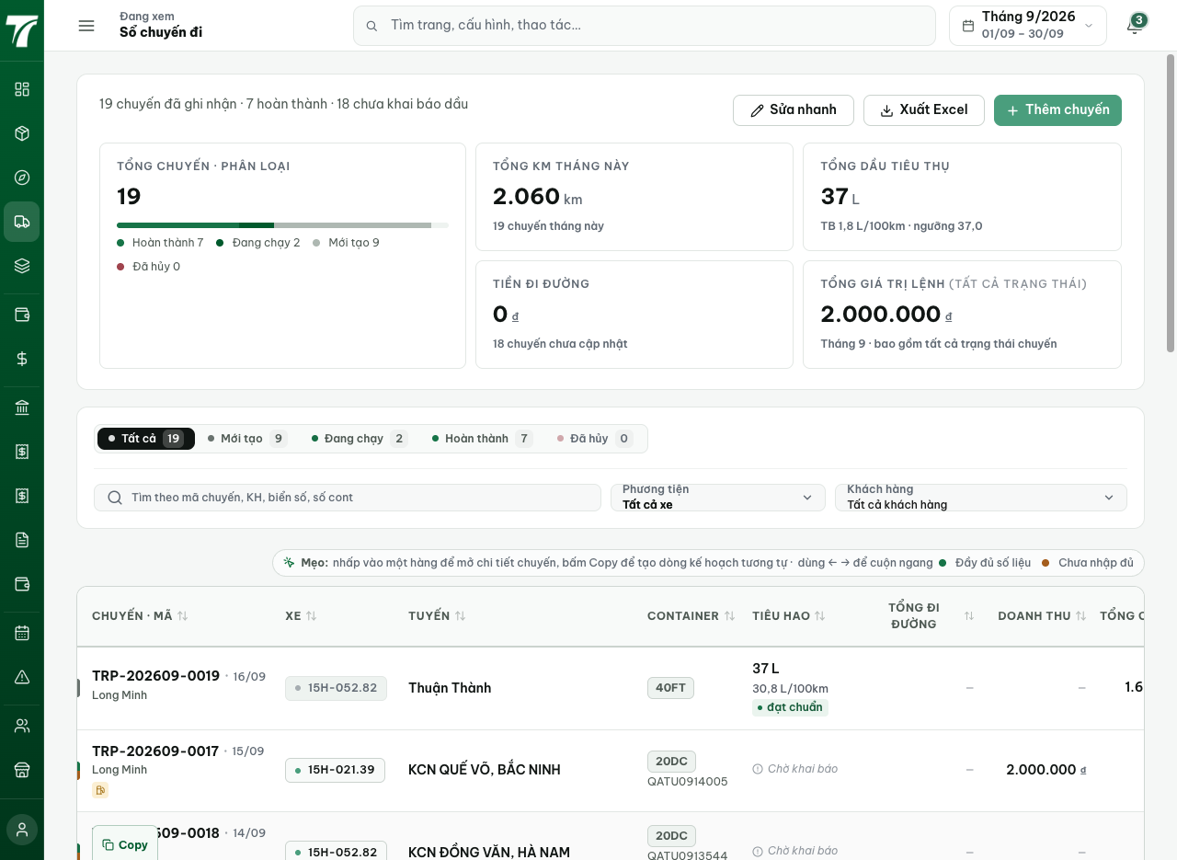
AC2: POST 201 → TRP-202609-0019 listed in /trips (single create, no duplicate).

