Keep expense and supplier debt pending until the promised review is complete
  - QA-086 | P1 | Bug | QA PASSED (API/DB rung; responsive sliver → UI pile)
Environment: Staging https://vantai.tingting.vip
Reviewed: 14 September 2026
Role: ADMIN · desktop 1440 × 900; tablet ledger 834 × 1112
Page: /expenses/new → /expenses/1/edit → /payables/4

Existing behaviour
The form states: “Khoản chi và công nợ chỉ được ghi nhận sau khi một người kiểm tra và một người khác phê duyệt.” One Admin click on Gửi duyệt chi phí nevertheless records a 123,000 VND Ghi nợ expense. SBI’s ledger gains that expense, raising its balance from 100,000 to 223,000 VND. No checker or approver was invoked before this readback.

Target behaviour
Submission must create a pending request. Post the expense and supplier debt only after a checker and a different approver complete review, with clear stages and actors.

Impact
A single submission creates an economic obligation before the promised review. No cash transfer occurred.

Cause and investigation
Submission behavior conflicts with the stated approval contract. Inspect routing and posting conditions; backend implementation and global permission bypass are unverified.

Steps to reproduce
1. As Admin, enter supplier CÔNG TY CP SBI, category QA AUDIT 0914 Recurring expense, Ghi nợ, 123000 VND, effective September 14–30 and receipt QA-EXP-0914-01.
2. Enter the required reason and click Gửi duyệt chi phí once, without review or approval.
3. Read /expenses and /payables/4: both already include the new 123,000 VND obligation.

Acceptance criteria
1. Submission leaves posted expenses and supplier debt unchanged while displaying a pending request.
2. Require a checker and a different approver; show pending, rejected and approved states accurately.
3. Approval posts exactly once; retries, rejection and repeated clicks cannot create premature or duplicate debt.
4. Verify approval, posting, readback and role boundaries across desktop, tablet and phone; retain dates and receipt.

Requirement reference
Observed form promise compared with the resulting expense and supplier ledger.

Evidence 1
  - Keep expense and supplier debt pending until the promised review is complete
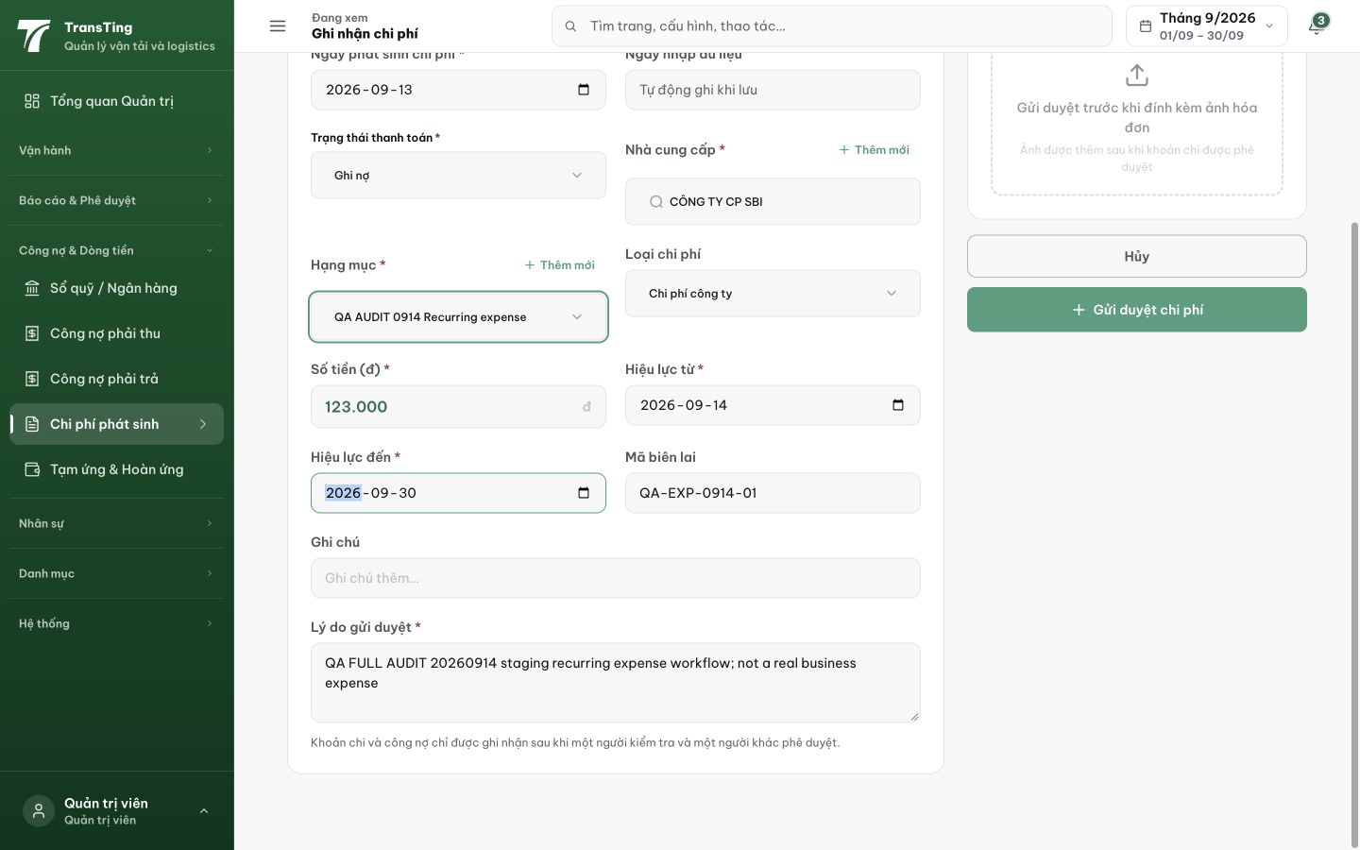
Figure 1. Before submission, the form promises expense and debt recognition only after a checker and a different approver, beside the Gửi duyệt chi phí action.

Evidence 2
  - Keep expense and supplier debt pending until the promised review is complete
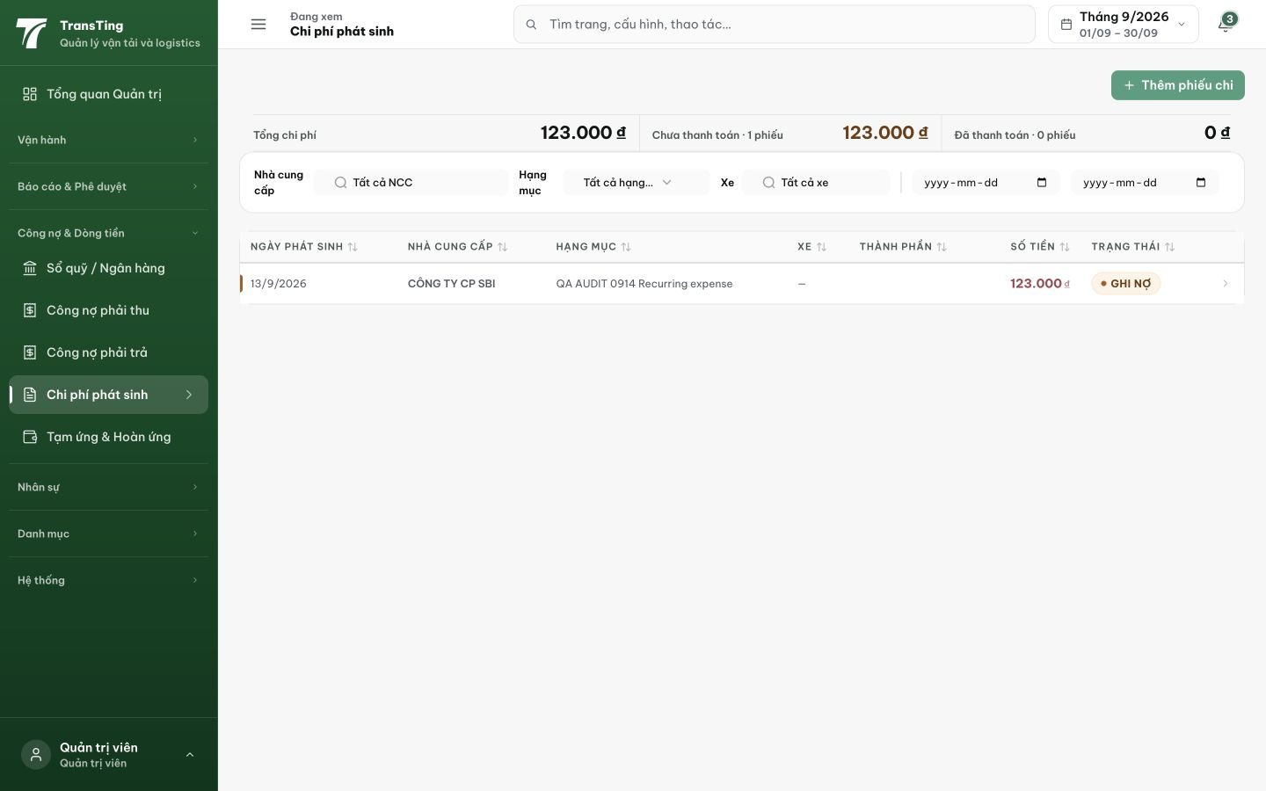
Figure 2. After the single Admin submission, the list immediately shows one 123,000 VND expense as Ghi nợ and includes it in total unpaid expenses.

Evidence 3
  - Keep expense and supplier debt pending until the promised review is complete
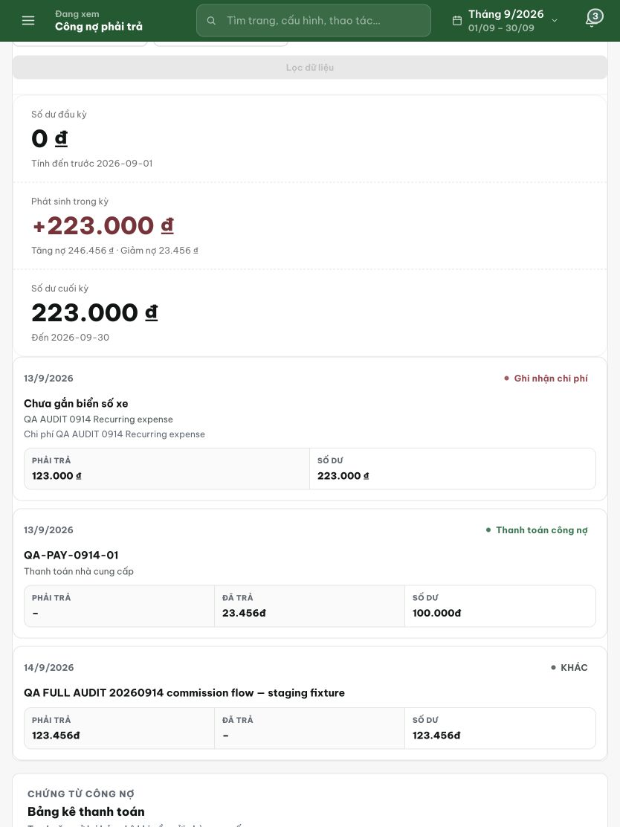
Figure 3. Supplier ledger readback: the new recurring expense adds 123,000 VND, increasing the preceding 100,000 VND balance to 223,000 VND without an intervening review.
Trạng thái: DEV COMPLETED — chờ deploy staging + QA

[2026-09-14] DEV COMPLETED — dual-control expense review (code: 53d6a4b4 + 78741725 + ae22ba8b):
AC1 — submission parks the expense as PENDING with zero supplier debt (no ledger entry; payables are ledger-txn-based) and the pending request is visible in the list (Chờ kiểm tra badge). Backend test: submission → PENDING + 0 ledger entries.
AC2 — checker + DIFFERENT approver enforced: CHECK (ADMIN/MANAGER/ACCOUNTANT, submitter excluded) → CHECKED; APPROVE (ADMIN/MANAGER, ≠ checker) → APPROVED. States render accurately (Chờ kiểm tra / Chờ duyệt / Đã duyệt / Từ chối). Tests: same-actor check 403, checker-approves 403, state transitions pinned.
AC3 — approval posts exactly once (FOR UPDATE row lock + status guard; retry 409s, never a second ledger entry); rejection terminal, no posting. Test: double-approve → 409 + exactly 1 entry.
AC4 — role boundaries pinned (CLERK/DRIVER excluded by route roles); FE actions role-gated; browser verification at 3 widths → staging round.

Hướng dẫn xác minh:
1. Đăng nhập ADMIN → /expenses/new, tạo chi phí Ghi nợ (lý do bắt buộc) → Lưu: danh sách hiển thị badge "Chờ kiểm tra"; /payables của NCC KHÔNG tăng.
2. Tài khoản ACCOUNTANT (khác người gửi) mở /expenses → bấm "Kiểm tra" → badge chuyển "Chờ duyệt"; công nợ vẫn chưa phát sinh.
3. Tài khoản ADMIN (khác checker) → "Duyệt" → badge "Đã duyệt"; /payables của NCC tăng đúng số tiền, đúng 1 lần.
4. Thử bấm "Duyệt" lần 2 → thông báo đã xử lý; số dư NCC không đổi (không nhân đôi).
[2026-09-14] QA PASSED — staging API/DB rung (cut #9, build 9d064b50): dual-control state machine verified end-to-end
Cast: namnv (ADMIN, submitter) / hoapt (ACCOUNTANT, checker) / admin (ADMIN, approver) — 3 distinct users. Own fixture QA86-2609140654 (category 2, supplier 25, 123000 VND Ghi nợ).
AC1 PASS: submit 201 → PENDING; supplier ledger delta after submit = 0; readback queryable. AC2 PASS: self-check 403; checker → CHECKED; checker-approve 403; approver → APPROVED; same-person check+approve 403 ("Người kiểm tra và người phê duyệt phải là hai người khác nhau") with 0 ledger entries. AC3 PASS: second approve 409; VENDOR_EXPENSE ledger entry for the expense = exactly 1 (credit 123000); submit retry same key+body → replayed:true same id; rejection → REJECTED 0 entries; premature approve before check → 409, still PENDING, 0 entries. AC4 data-retention PASS: post-APPROVED readback preserves expenseDate/amount/supplier/category/note+reason.
Not covered by this rung: AC4 responsive rendering (desktop/tablet/phone) and receipt retention with an actual receiptId — flagged to the UI pile. Transcript + verdict JSON: testplan/qa/evidence/2026-09-14_staging-round6-api-7f/ (REPORT-qa086.md, probe-qa086-transcript.json).

