Keep expense payment status consistent with its supplier ledger
  - QA-089 | P1 | Bug | QA PASSED
Environment: Staging https://vantai.tingting.vip
Reviewed: 14 September 2026
Role: ADMIN · desktop 1440 × 900; tablet readback 834 × 1112
Page: /expenses/1/edit → /expenses → /payables/4

Existing behaviour
Saving QA-EXP-0914-01 as Trả ngay changes /expenses to Đã trả: 123,000 VND paid, zero unpaid. Editor readback retains Trả ngay and says Đây là phiếu đã quyết toán. Fresh supplier reload still owes 223,000 VND: the prior 100,000 plus this 123,000 expense, with three entries and no settlement offset. Only the UI status changed; no actual bank payment occurred.

Target behaviour
Keep payment status linked to the supplier ledger. Show paid/settled only after authorized settlement succeeds. Otherwise, show pending status and explain the required action.

Impact
Conflicting payment and debt views risk duplicate payment or missed reconciliation.

Cause and investigation
Inspect status transitions and ledger posting; no backend cause is established. Distinct from QA-086’s initial approval failure.

Steps to reproduce
1. Use the 123,000 VND Ghi nợ expense for CÔNG TY CP SBI, receipt QA-EXP-0914-01, or an equivalent fixture.
2. Edit Trạng thái thanh toán to Trả ngay, enter the required staging reason and click Cập nhật.
3. Verify the paid expense list/editor, then reload /payables/4 and compare the remaining charge and supplier balance.

Acceptance criteria
1. After authorized settlement and reload, expense status, paid/unpaid totals and supplier debt agree.
2. Failed or pending settlement never reports paid/settled; show clear recovery.
3. Retries post once; supported reversals restore consistent status and ledger history.
4. Preserve unrelated debt, permissions and audit links; verify desktop, tablet and phone readback.

Requirement reference
Observed expense status change and fresh supplier-ledger readback.

Evidence 1
  - Keep expense payment status consistent with its supplier ledger
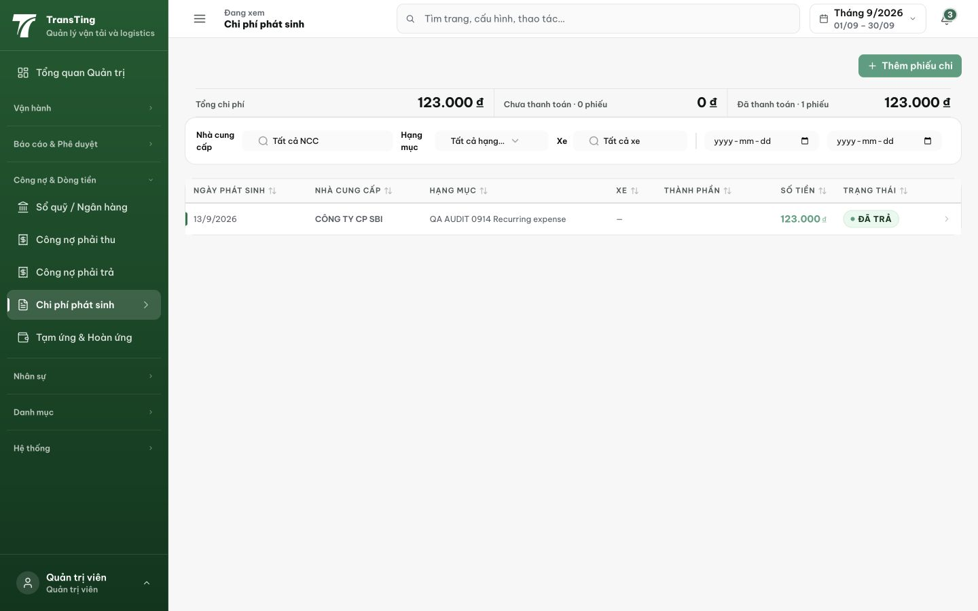
Figure 1. After the update, the expense list marks the 123,000 VND record Đã trả and shows zero unpaid expenses.

Evidence 2
  - Keep expense payment status consistent with its supplier ledger
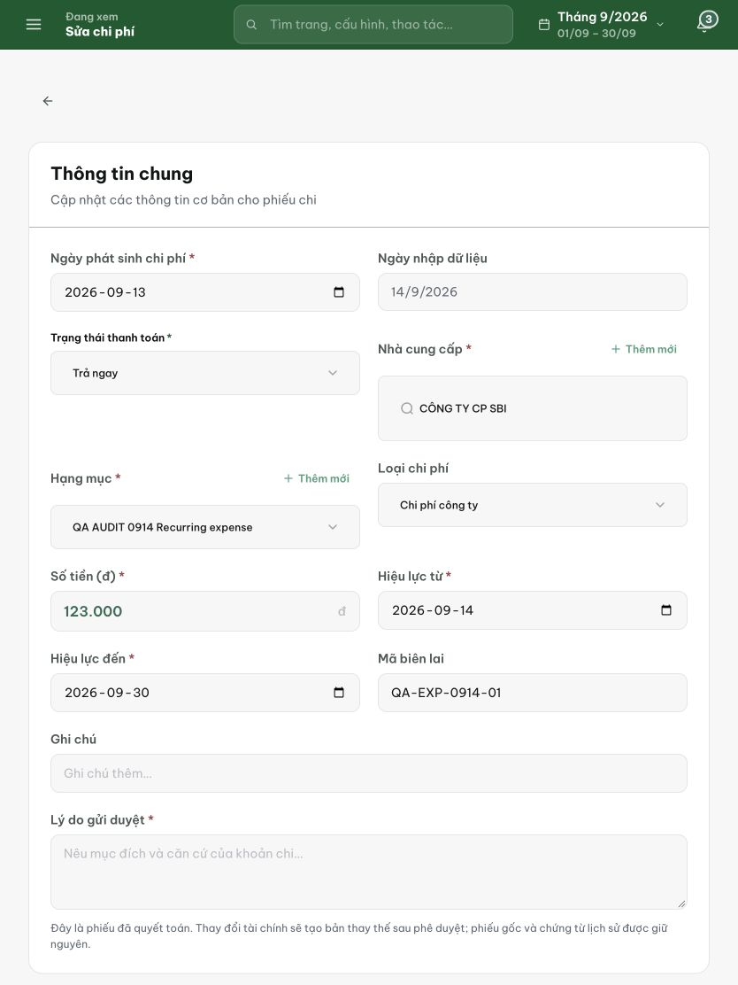
Figure 2. Fresh editor readback retains Trả ngay and describes the record as already settled, with receipt QA-EXP-0914-01 and amount 123,000 VND.

Evidence 3
  - Keep expense payment status consistent with its supplier ledger
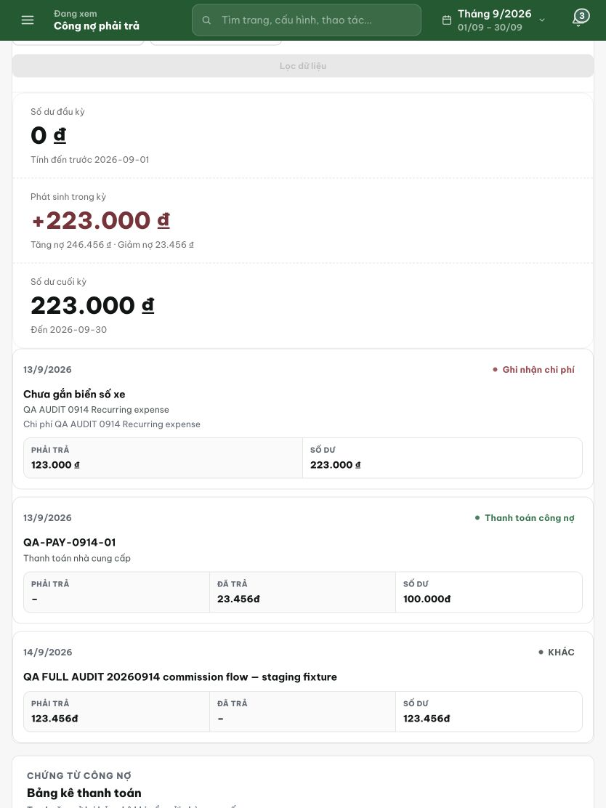
Figure 3. Fresh post-update ledger: the 123,000 VND expense remains payable, with a 223,000 VND balance and no settlement offset among the three entries.
[2026-09-14] DEV COMPLETED — Chặn flip tự do 2 chiều (updateExpense 409 'ghi thanh toán qua Thanh toán NCC'; submitExpense 400 paid-on-create); thanh toán NCC nhận expenseIds (≤200) — settle IN payment transaction: flip PAID + settled_by_payment_id (migration 0079 additive, backup trước apply); bad linkage 409 TRƯỚC khi tiền di chuyển; partial-payment semantics theo ruling (chỉ row được liệt kê flip, remainder unallocated — document ở editor guidance); reversal seam restoreExpensesForPaymentReversal CHỈ UNPAID rows vẫn trỏ payment đó (re-flip guard test). Editor read-only + guidance. financial.service.ts hunks additive (25 dòng, back-compat pin không expenseIds). Unit 7/7. Commit 578e637b. Browser rung (settle-flow 3 width) staging. Cả 3 P1 của wave đã qua local gate.

[2026-09-14] QA PASSED — staging (API·DB rung, build 2c41f420)
Fixture riêng (suffix R6145523): NCC 26/27, khoản chi 4 (123.000₫ APPROVED), 5 (77.000₫ APPROVED), 6 (50.000₫ PENDING); dual-control đúng luật (admin nộp, hoapt kiểm, admin duyệt). AC1: POST /api/payments/vendor expenseIds [4] → 201, settledExpenseIds [4], ledgerEntryId 15; readback chi 4 PAID + settledByPaymentId 15, chi 5 UNPAID (partial-payment), sao kê NCC: 200.000 → 77.000 sau debit 123.000. AC2: flip trực tiếp 409 ('ghi thanh toán qua màn Thanh toán NCC'), link chi PENDING 409, link sai NCC 409 — psql xác nhận 0 dòng ledger cho các phiếu bị từ chối (tiền không di chuyển). AC3: replay cùng Idempotency-Key → 200 replayed, vẫn 1 dòng VENDOR_PAYMENT, số dư 77.000. AC4: fixture cách ly, quyền ACCOUNTANT chạy đúng, audit chain đầy đủ trong governance action.
Not covered (đã ghi rõ trong REPORT): ngược thanh toán NCC chưa có route HTTP trên build này — seam restoreExpensesForPaymentReversal đã có unit test (commit 578e637b), chờ surface thì bổ sung rung API. Readback desktop/tablet/phone thuộc rung browser (lane 88).
Bằng chứng: testplan/qa/evidence/2026-09-14_staging-round6-api-52/qa-089/ (REPORT.md + transcript.log + psqlq.sh transcripts).
Trạng thái: QA PASSED — đã xác minh trên staging (API·DB rung, build 2c41f420)

