Distinguish zero revenue from no completed trips
  - QA-035 | P2 | Bug | TODO
Environment: Staging https://vantai.tingting.vip
Reviewed: 14 September 2026
Role: MANAGER; qa.audit.manager.0914; Chrome desktop
Page: https://vantai.tingting.vip/finance — Báo cáo lãi lỗ, September 2026

Existing behaviour
The revenue chart says “Chưa có chuyến nào hoàn thành trong tháng 9/2026” and “Hoàn thành chuyến để xem xu hướng doanh thu”. The same report shows “4 chuyến × giá cước chặng”; vehicle analysis lists one trip for 15H-104.03 and three for Xe ngoài. A known completed trip, TRP-202609-0013, was matched through the vehicle drilldown. Monetary values are zero. The message incorrectly describes the trip state; no arithmetic defect is asserted.

Target behaviour
Base the no-trip message on completed-trip count. For completed trips with zero amounts, use accurate zero-value messaging. If monetary inputs are demonstrably missing, identify the missing data and the relevant next step.

Impact
The message directs managers to complete trips instead of explaining zero or missing revenue.

Cause and investigation
Hypothesis: the chart treats an all-zero financial series as no completed trips. Inspect the empty-state condition and its data source; the reason for the zero monetary values is outside this finding.

Steps to reproduce
1. Sign in as qa.audit.manager.0914, open /finance and select September 2026.
2. Read the revenue-chart empty message, then compare Doanh thu vận tải on the same page: 4 chuyến × giá cước chặng.
3. Open Phân tích lãi gộp theo phương tiện. Compare 15H-104.03 with one trip and Xe ngoài with three; use the vehicle drilldown to inspect the underlying records.

Acceptance criteria
1. A month with no completed trips shows a genuine no-trip state; a month with completed trips and zero amounts does not claim that none are completed.
2. Distinguish valid zero amounts from missing monetary inputs. Display a zero-value chart or an accurate explanation, with action text appropriate to the known condition.
3. Chart messaging, trip counts, vehicle drilldowns and selected period agree after reload and when switching Ngày/Tháng. Verify mobile, tablet and desktop.
4. Keep financial calculations unchanged while correcting the empty-state selection.

Requirement reference
Full-app Chrome audit, 14 September 2026; manager-profit-loss-desktop.txt and the attached same-page capture.

Evidence 1
  - Distinguish zero revenue from no completed trips
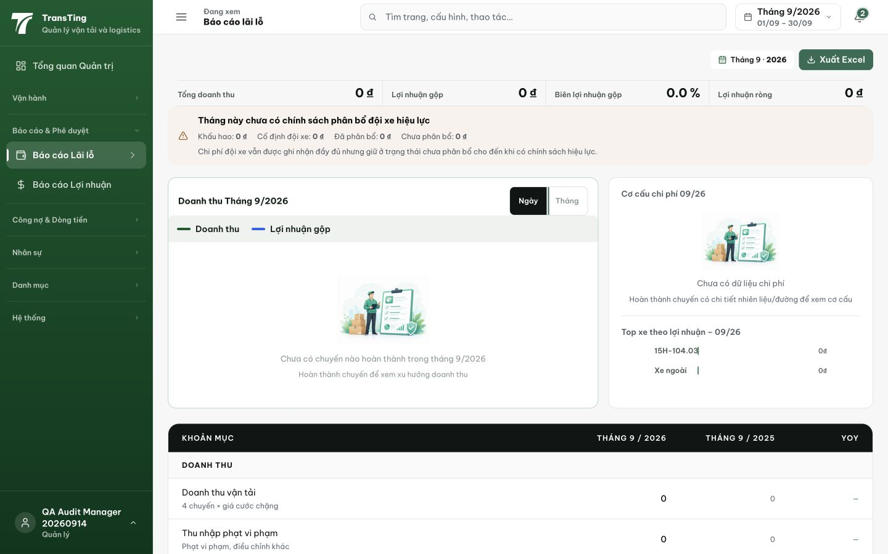
Figure 1. The September 2026 chart says there are no completed trips, while the same page’s Doanh thu vận tải row states 4 chuyến × giá cước chặng. Displayed revenue is 0.
[2026-09-14] DEV COMPLETED — Ba nhánh chart: loading / thật-sự-không-có-chuyến (copy cũ) / HOÀN-THÀNH-nhưng-series-0 → 'Có {N} chuyến hoàn thành … doanh thu/lợi nhuận ghi nhận bằng 0' + 'Kiểm tra giá cước và các khoản thu đã nhập'. PnlReport.tripCount verify TRƯỚC (field thật — fallback không phải dùng). Filter zero-bucket không đổi (AC4). Suite 4/4 (state thẻ: 4 COMPLETED zero-revenue → count=4 AND hasChartData=false — phân biệt được). Commit a322ddc0. Browser rung staging.
[2026-09-14] QA PASSED — staging: Sep 2026: 7 completed trips with 0 revenue → correct "Có 7 chuyến hoàn thành..." message (NOT "Chưa có chuyến nào"); Oct: 0 trips → genuine empty state; arithmetic unchanged Evidence: testplan/qa/evidence/2026-09-14_QA-batch-staging-cut-9/api/20260914_P2_QA-035_bug-distinguish-zero-revenue-from-no-completed-trips.md
Trạng thái: QA PASSED — đã xác minh trên staging

