Open blocked transport records from the accounting work queue
  - QA-036 | P2 | Bug | TODO
Environment: Staging https://vantai.tingting.vip
Reviewed: 14 September 2026
Role: ACCOUNTANT; hoapt (Phạm Thị Hòa); Chrome desktop
Page: /accounting → ?view=transport&search=TRP-202609-0013

Existing behaviour
Công việc shows four blocked records. TRP-202609-0013 lacks accepted POD and names Vận hành as owner. Its Mở hồ sơ vận tải link opens a transport list showing 0 financially eligible trips and no matching record or POD action. All filters are at their defaults; the working period 01–13 September includes this trip’s 13 September completion. Clearing the search still returns no records.

Target behaviour
Open the exact blocked record in an authorized view, with the blocker and a usable route to its owner’s resolution workflow. Accounting must be able to inspect the record before it becomes financially ready.

Impact
The advertised resolution link leaves accounting unable to inspect or follow up the blocked record.

Cause and investigation
The link opens a list explicitly limited to financially eligible trips. Investigate record routing and visibility; the implementation cause is unconfirmed.

Steps to reproduce
1. Sign in as hoapt, open /accounting and select Công việc.
2. Under Đang bị chặn, locate TRP-202609-0013 and click Mở hồ sơ vận tải.
3. Confirm the trip search and 01–13 September period. Observe the empty result with default filters; clear the search and observe that it remains empty.

Acceptance criteria
1. The blocked record’s link opens TRP-202609-0013 and its current blocker, even while accepted POD is missing.
2. Provide authorized read-only details and an actionable handoff to Vận hành. Preserve role boundaries and the accepted-POD financial gate.
3. After POD acceptance, the same record moves to the eligible workflow without stale links or identity changes.
4. Verify blocked and ready records, period filters and deep links on mobile, tablet and desktop; explain unavailable or unauthorized records clearly.

Requirement reference
Full-app Chrome audit, 14 September 2026; accounting work queue and transport reconciliation captures.

Evidence 1
  - Open blocked transport records from the accounting work queue
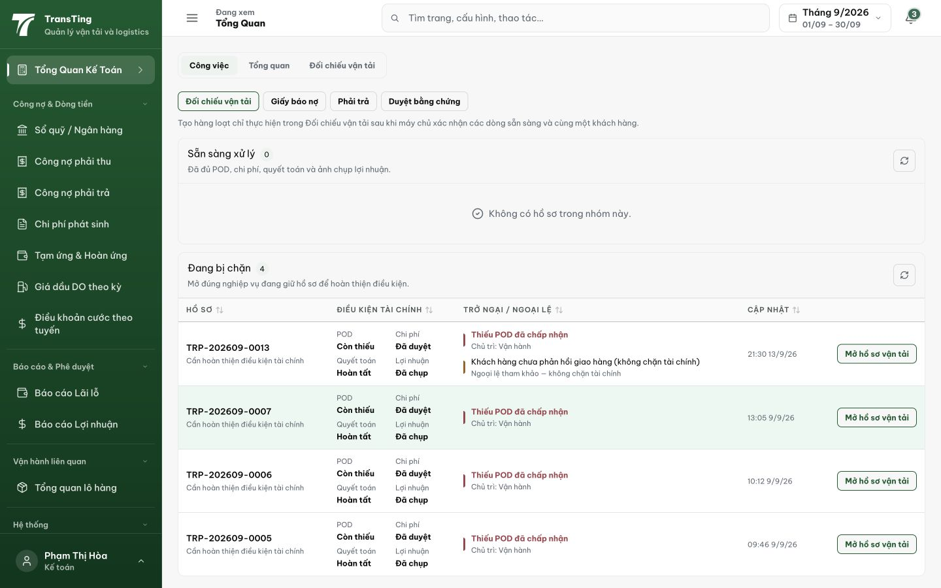
Figure 1. The accounting work queue lists four blocked records. TRP-202609-0013 shows Thiếu POD đã chấp nhận, owner Vận hành, and Mở hồ sơ vận tải.

Evidence 2
  - Open blocked transport records from the accounting work queue
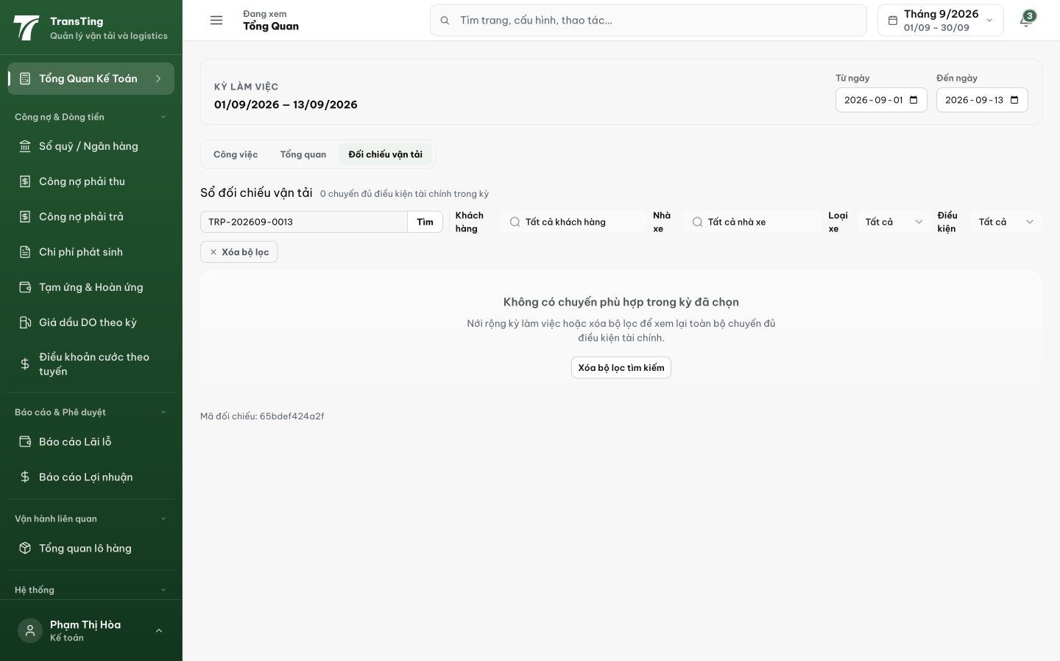
Figure 2. The link opens transport reconciliation with TRP-202609-0013 searched and the working period 01/09/2026–13/09/2026. It shows 0 eligible trips and no matching record.
[2026-09-14] DEV COMPLETED — Register đổi INNER ACCEPTED → podDecisionProjection left-join aggregate (row-multiplication-safe); readiness precedence POD → snapshot → READY + shared enum + nullable provenance; facet đủ 3 giá trị; sort rank mở rộng; claims ACCEPTED_EPOD chỉ khi thật. FE label 'Chờ POD' + facet option. BE register 7/7 (blocked trip lists w/ null provenance; facet + counts agree; sort 3-row), FE 4/4. Commit cfc61446. Browser rung cần fixture POD-blocked in-period (staging round).
[2026-09-14] QA PASSED — staging (3cac3981, round 5): TRP-202609-0013 lists in-period 'Chờ POD' + reconciliation; facets agree.

