Show payable ledger entries on desktop
  - QA-037 | P2 | Bug | TODO
Environment: Staging https://vantai.tingting.vip
Reviewed: 14 September 2026
Role: ACCOUNTANT; hoapt (Phạm Thị Hòa); Chrome
Page: /payables/4 — CÔNG TY CP SBI

Existing behaviour
At 1440×900, the payable detail shows two transactions and a correct 100,000 VND balance after a 123,456 VND commission and 23,456 VND payment. No individual ledger entries appear. Thanh toán công nợ changes the count to one but still shows no row; reload does not restore them. At 390×844 and 768×1024, transaction cards render, including receipt QA-PAY-0914-01. Tạo bảng kê also shows the commission. The defect concerns desktop visibility, not lost data.

Target behaviour
Render a compact, readable ledger in the desktop layout. Preserve the working phone and tablet cards, correct balances, filters and access permissions.

Impact
Desktop users cannot inspect or reconcile the transactions behind a supplier’s balance.

Cause and investigation
Hypothesis: the desktop rendering branch omits or hides transaction rows while responsive cards work. Check layout conditions and entry rendering; the exact breakpoint and implementation cause are unconfirmed.

Steps to reproduce
1. Sign in as hoapt, use a 1440×900 viewport and open /payables/4 for September 2026.
2. Use the existing fixture: commission 123,456 VND linked to TRP-202609-0016 and payment 23,456 VND with receipt QA-PAY-0914-01. Inspect Chi tiết công nợ phải trả through the end of the page.
3. Select Thanh toán công nợ, then reload. Compare the absent desktop rows with the visible cards at 390×844 and 768×1024.

Acceptance criteria
1. Desktop shows both fixture transactions; the payment filter shows its one matching entry. Counts, entries and date/type filters agree after reload.
2. Each entry exposes date, type, reference, payable/paid amount and relevant balance, plus its note and linked source details where authorized.
3. Preserve the correct 100,000 VND closing balance and working phone/tablet cards. Check widths around the actual desktop breakpoint, keyboard access and readable column labels.
4. Show explicit loading, empty and error states; do not silently omit rows when transactions exist.

Requirement reference
Full-app Chrome audit, 14 September 2026; payable creation, payment, reload and responsive comparison.

Evidence 1
  - Show payable ledger entries on desktop
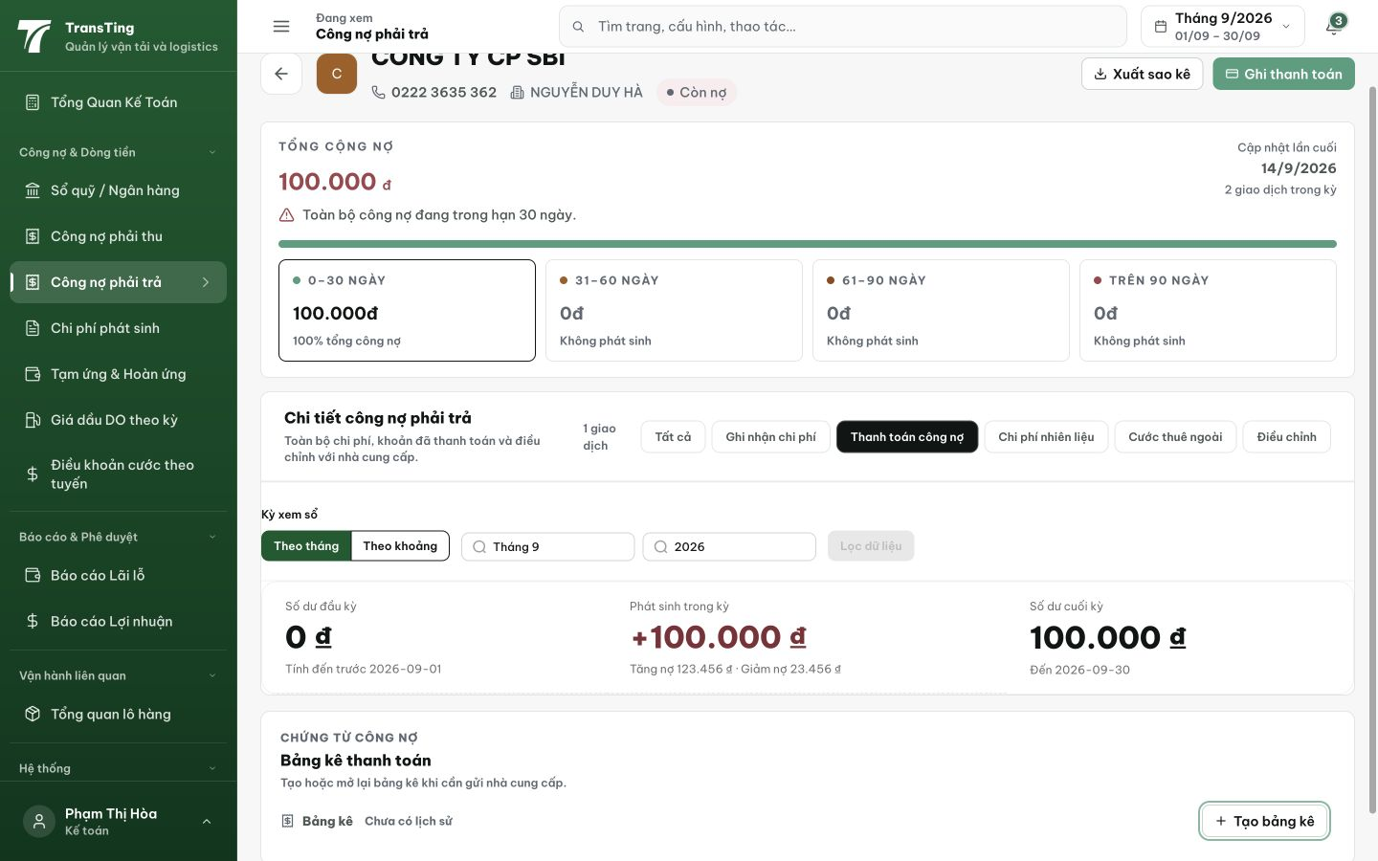
Figure 1. Desktop 1440×900: Thanh toán công nợ reports one transaction, but the detail section ends after the balance summary with no payment row. The page bottom is visible.

Evidence 2
  - Show payable ledger entries on desktop
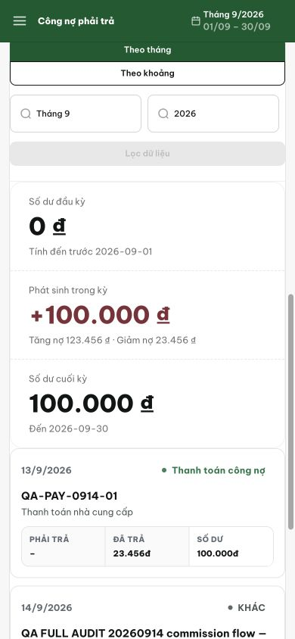
Figure 2. Phone 390×844: the same supplier ledger renders transaction cards. Receipt QA-PAY-0914-01 shows 23,456 VND paid and a 100,000 VND balance. Tablet 768×1024 also passed.
[2026-09-14] DEV COMPLETED — Root cause: nhánh vendor-expense render ExpenseLedgerCard (<li>) bên trong <tbody> — browser drop table-child không hợp lệ → desktop trống dù phone (<ul> hợp lệ) hiển thị. Swap 1 dòng sang ExpenseLedgerRow (<tr>); layout compact không đổi; payable 5/5. Commit 3cac398. Fixture rung (commission+payment + QA-PAY-0914-01) staging round.
[2026-09-14] QA PASSED — staging: desktop ledger 3 tbody rows (commission 123.456₫ + payment ±); 0 li-in-tbody.

