Fix OCR review header overlap on desktop and tablet
  - QA-038 | P2 | Bug | TODO
Environment: Staging https://vantai.tingting.vip
Reviewed: 14 September 2026
Role: Accountant, hoapt (Phạm Thị Hòa); Chrome desktop, tablet and mobile
Page: https://vantai.tingting.vip/accounting/fuel-evidence

Existing behaviour
At 1440 × 900 and 768 × 1024, the OCR guidance collapses into a narrow word-by-word column. The status filter overlaps that column, and the header consumes excessive height despite available width. Reloading desktop reproduces it. At 390 × 844, the guidance and filter wrap into separate readable rows.

Target behaviour
Keep guidance readable beside or above the filter, with a clear back action and no overlap. Use available width and compact spacing while preserving the working phone layout and explicit accountant review requirement.

Impact
The malformed header obscures guidance explaining that OCR is only a suggestion and each image requires accountant confirmation or rejection.

Cause and investigation
Hypothesis: header flex sizing, minimum widths or wrapping allow the guidance to collapse beneath the filter. Inspect responsive header layout; the implementation cause is unconfirmed.

Steps to reproduce
1. As Accountant, open Tổng Quan Kế Toán → Công việc → Duyệt bằng chứng, at 1440 × 900.
2. After loading, inspect the guidance and status filter; reload and repeat at 768 × 1024.
3. Compare 390 × 844. Changing Chờ xác nhận to Tất cả trạng thái works; both captured results are empty.

Acceptance criteria
1. At desktop, tablet and intermediate widths, guidance wraps naturally without word-column collapse or overlap with controls.
2. Back and status controls remain usable by pointer, touch and keyboard; preserve filtering and accountant confirmation or rejection.
3. Retain the readable 390-pixel layout and compact sizing. Verify empty and populated review states without enlarging the whole interface.

Requirement reference
Exploratory staging review, 14 September 2026.
User direction: professional, compact, data-heavy UI across desktop, tablet and mobile.

Evidence 1
  - Fix OCR review header overlap on desktop and tablet
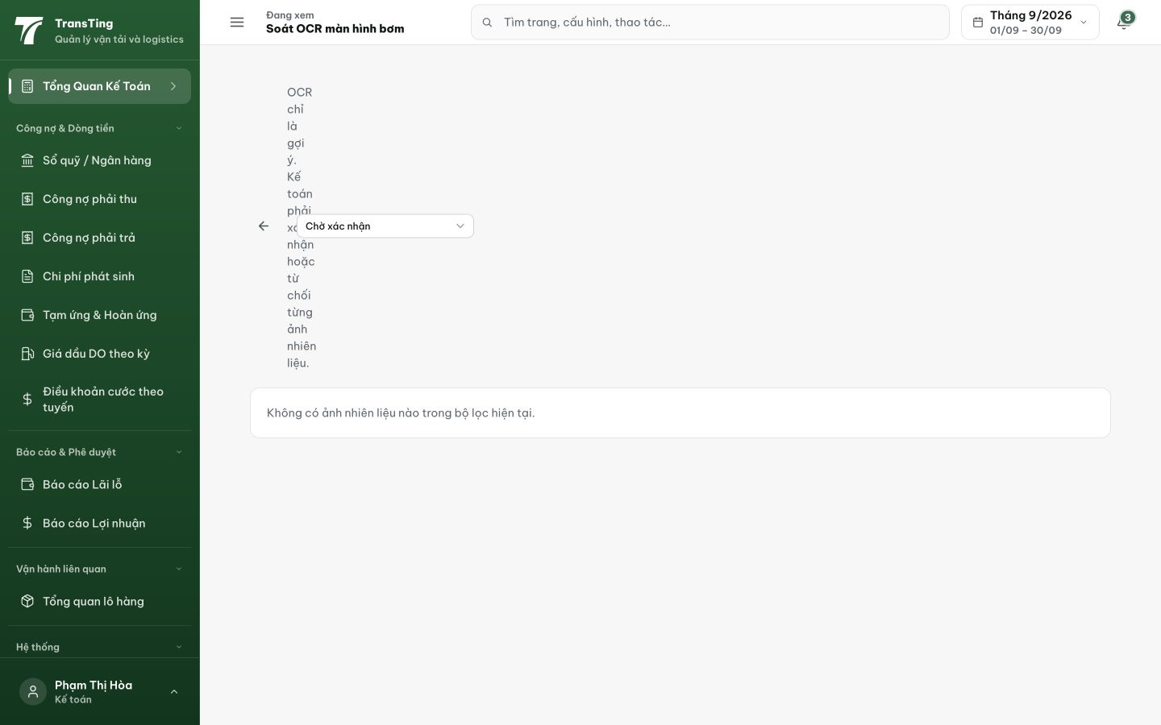
Figure 1. Desktop, 1440 × 900, after reload: guidance forms a narrow vertical column and the Chờ xác nhận filter crosses it. The issue remains after loading.

Evidence 2
  - Fix OCR review header overlap on desktop and tablet
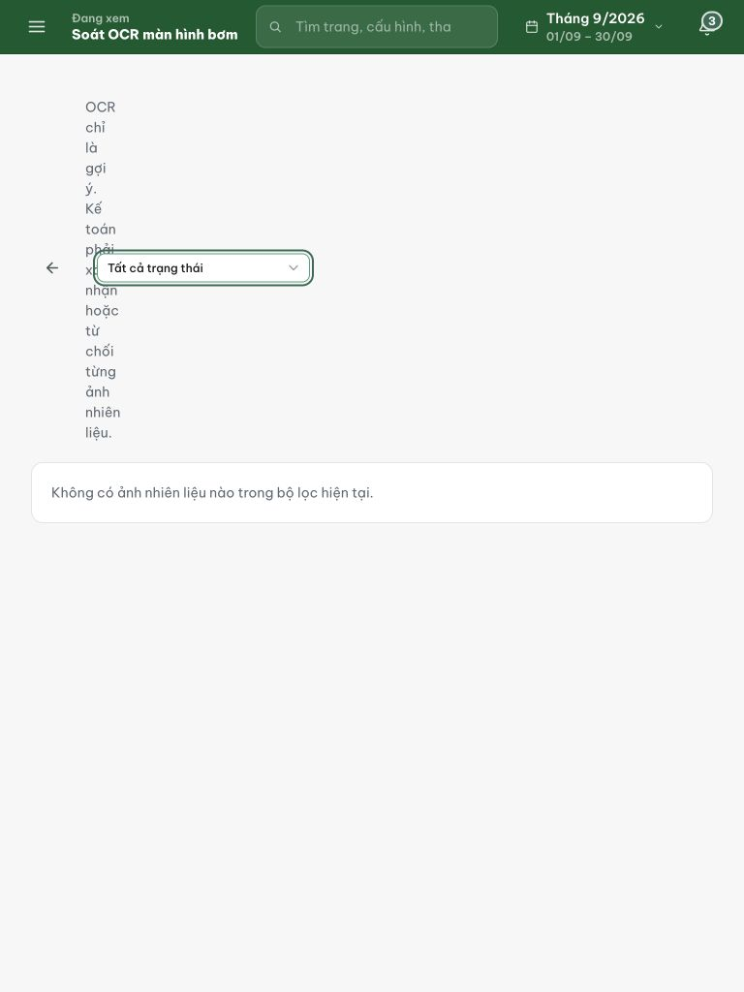
Figure 2. Tablet, 768 × 1024: the same word-column collapse persists with Tất cả trạng thái selected. The empty result is separate from this header defect.

Evidence 3
  - Fix OCR review header overlap on desktop and tablet

Figure 3. Phone, 390 × 844: guidance wraps across the available width and the filter sits on its own row. Preserve this readable compact behavior.
[2026-09-14] DEV COMPLETED — Wrapper select flex-basis 220px (flex:0 0 auto một mình chưa đủ — basis auto suy về width:100%); guidance 790px@1440/416@768/334@390 (trước: 0px). Commit 1f80311c (rider).
[2026-09-14] QA PASSED — staging (build ae22ba8b, vòng 3): xác minh đủ tiêu chí — chi tiết trong 2026-09-14_staging3-batch/REPORT.md + dir riêng.

