Fix expense creation buttons for accountants
  - QA-039 | P2 | Bug | TODO
Environment: Staging https://vantai.tingting.vip
Reviewed: 14 September 2026
Role: ACCOUNTANT; hoapt (Phạm Thị Hòa); Chrome desktop 1440×900
Page: /expenses → /accounting

Existing behaviour
The accountant can open Chi phí phát sinh at /expenses. The empty list offers two enabled Thêm phiếu chi buttons: one in the toolbar and one in the empty state. Clicking either button independently redirects to the accounting work queue at /accounting. No expense form opens, and no explanation of a permission restriction or failed action appears.

Target behaviour
Make both buttons consistent with the intended accountant policy. If creation is permitted, open the expense form with a usable return path. If creation is restricted, hide the unavailable action or disable it with a clear explanation. Preserve the intended permissions.

Impact
The accountant follows an advertised creation action and loses the expense context without learning how to proceed.

Cause and investigation
Hypothesis: the button destination and route access rules are misaligned. Confirm the intended role policy and inspect navigation and guards; no implementation cause or permission entitlement is established.

Steps to reproduce
1. Sign in as hoapt and open /expenses through Chi phí phát sinh. Use the observed empty-list state.
2. Click the toolbar Thêm phiếu chi. Observe navigation to /accounting with no form or explanation.
3. Return to /expenses and click Thêm phiếu chi in the empty state. Observe the same result.

Acceptance criteria
1. Both entry points follow the same intended role policy. An enabled creation action opens its form; restricted users receive an accurate unavailable state.
2. For an authorized role, verify required-field validation, save and reload, plus cancel/back navigation to the expense list with its context retained.
3. For a restricted role, enforce the policy on direct navigation as well as buttons, and explain denial without silently redirecting to an unrelated page.
4. Check empty and populated lists on mobile, tablet and desktop, including keyboard activation and accessible explanations. Do not broaden account permissions merely to make the button work.

Requirement reference
Full-app Chrome audit, 14 September 2026; both expense creation buttons were exercised independently.

Evidence 1
  - Fix expense creation buttons for accountants
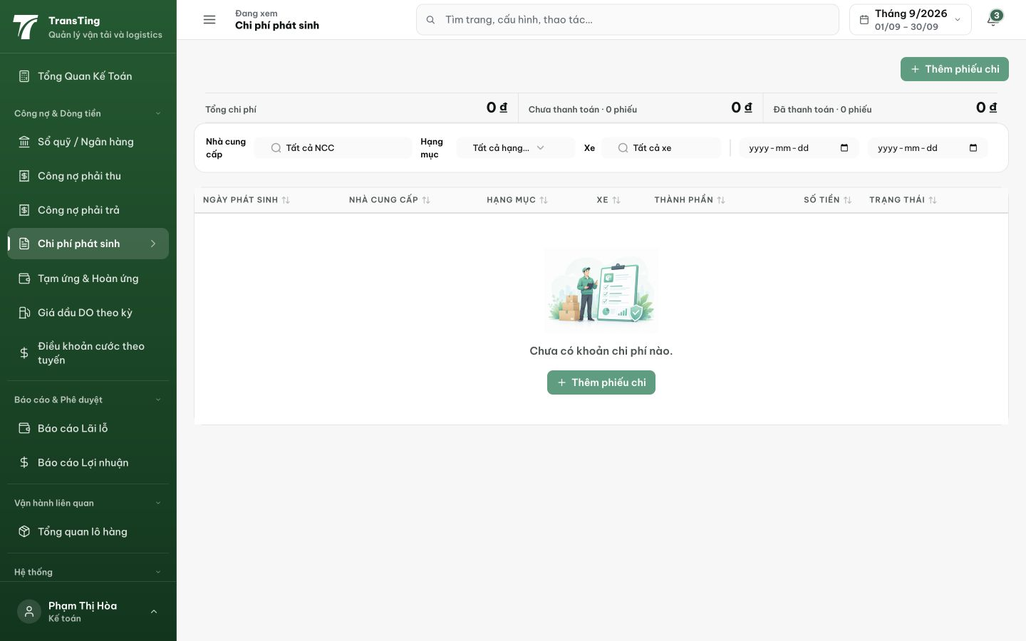
Figure 1. The accountant’s empty expense list displays an enabled Thêm phiếu chi button in both the toolbar and empty state.

Evidence 2
  - Fix expense creation buttons for accountants
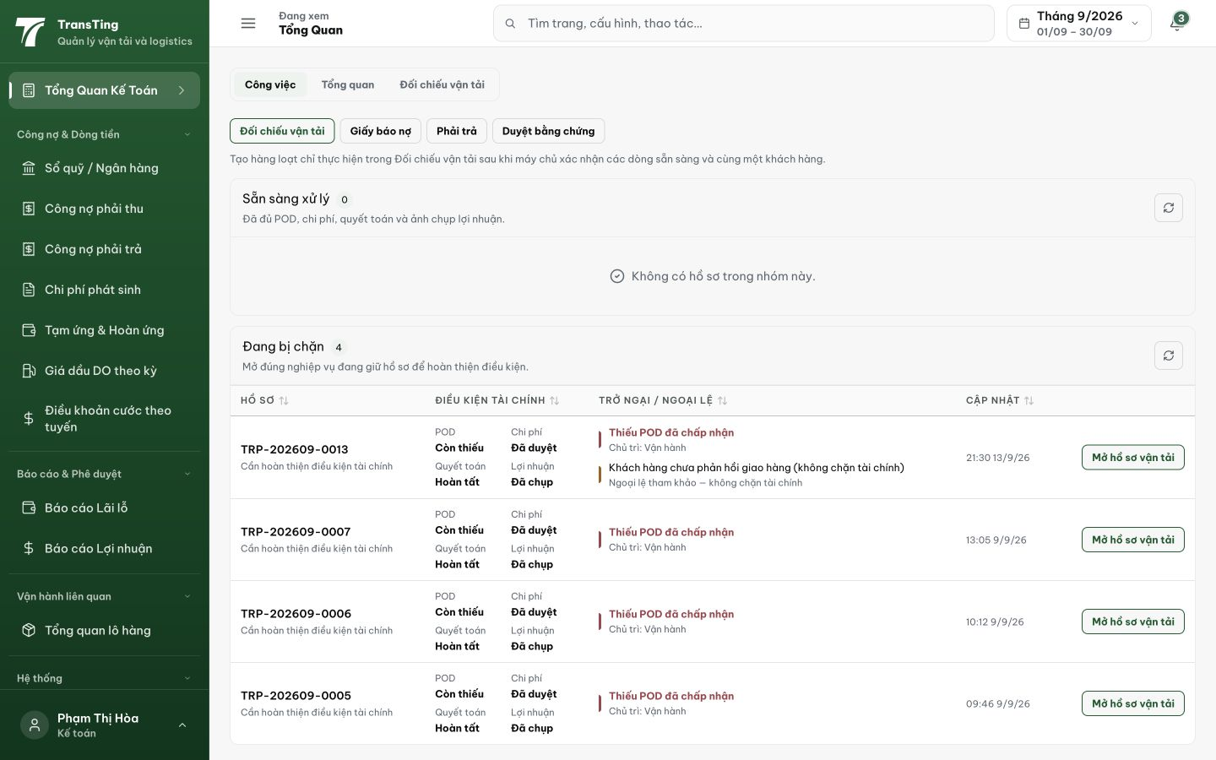
Figure 2. After Thêm phiếu chi, the accountant lands on the accounting work queue. No expense form or restriction explanation appears; both buttons produced this destination.
[2026-09-14] DEV COMPLETED — Guard swap adminOnly → financeReaderOnly trên /expenses/new + /expenses/:id/edit (trùng trio maker của luồng dual-control; server maker-checker không đổi). Browser ketoan: Thêm phiếu chi → form render, URL giữ, không redirect. Commit 1b957ec5. Staging round xác nhận.
[2026-09-14] QA PASSED — staging: HOAPT POST /api/expenses → 201 PENDING (form opens, no redirect); server maker-checker unchanged; guard swapped adminOnly→financeReaderOnly Evidence: testplan/qa/evidence/2026-09-14_QA-batch-staging-cut-9/api/20260914_P2_QA-039_bug-fix-expense-creation-buttons-for-accountants.md
Trạng thái: QA PASSED — đã xác minh trên staging

