Reject negative OPS advance and expense amounts
  - QA-040 | P2 | Bug | TODO
Environment: Staging https://vantai.tingting.vip
Reviewed: 14 September 2026
Role: OPS; hoangnh (Nguyễn Huy Hoàng); Chrome desktop 1440×900
Page: /ops/wallet → Xin Tạm Ứng; /ops/orders → Khai chi phí; comparison /my-advances

Existing behaviour
Entering -12345 in the wallet advance form becomes positive 12.345 in the field and summary; Gửi yêu cầu stays enabled. This repeated twice. The /ops/orders expense form similarly changes -12345 to positive 12.345. Neither converted negative-input case was submitted. In contrast, /my-advances preserves -12345 and blocks submission, leaving three requests unchanged. Separately entered positive amounts saved successfully: 12,345 VND advance and 23,456 VND expense.

Target behaviour
Preserve the entered amount’s meaning. Reject disallowed negatives with an accessible inline error and block submission until corrected; retain readable thousands separators.

Impact
Silently changing the sign can create a positive advance or expense the user did not intend.

Cause and investigation
Hypothesis: currency formatting strips the minus sign before validation. No backend defect or persistence of the converted negative-input cases is established.

Steps to reproduce
1. As hoangnh, open /ops/wallet → Xin Tạm Ứng. Enter a reason and -12345; observe positive formatting and enabled submission. Close without submitting.
2. Open /ops/orders → Khai chi phí. Select a category, enter -12345 and observe positive 12.345 without saving.
3. Compare /my-advances → Tạo yêu cầu tạm ứng: -12345 remains negative and submission triggers minimum-value validation.

Acceptance criteria
1. Typing or pasting a negative value never silently turns it positive; show an inline error and prevent invalid submission.
2. Each entry point enforces its allowed range for negative, zero, empty and positive values. Editing and blur preserve the intended amount.
3. Valid positive amounts remain consistent through formatting, summary, save and reload.
4. Verify keyboard, paste and mobile input across screen sizes; retain the working minimum-value guard and existing permissions.

Requirement reference
Full-app Chrome audit, 14 September 2026; OPS advance and expense amount forms.

Evidence 1
  - Reject negative OPS advance and expense amounts
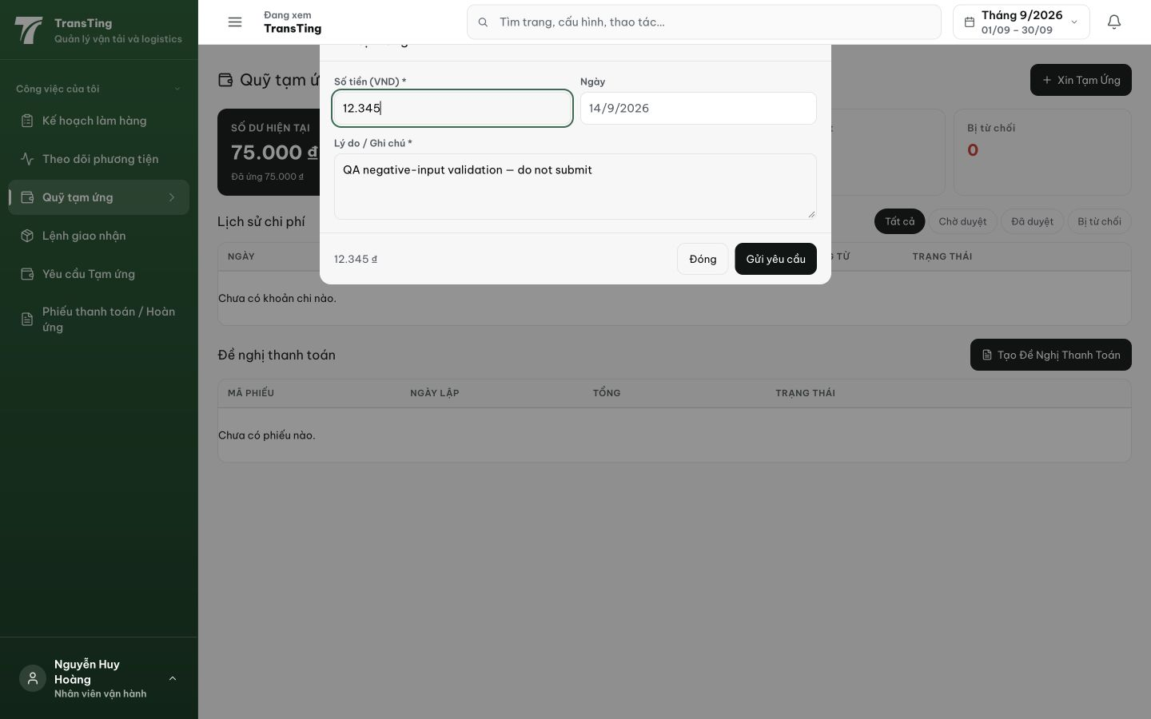
Figure 1. After entering -12345, the wallet dialog shows positive 12.345 in both the amount field and summary. Gửi yêu cầu is enabled. This case was not submitted.

Evidence 2
  - Reject negative OPS advance and expense amounts
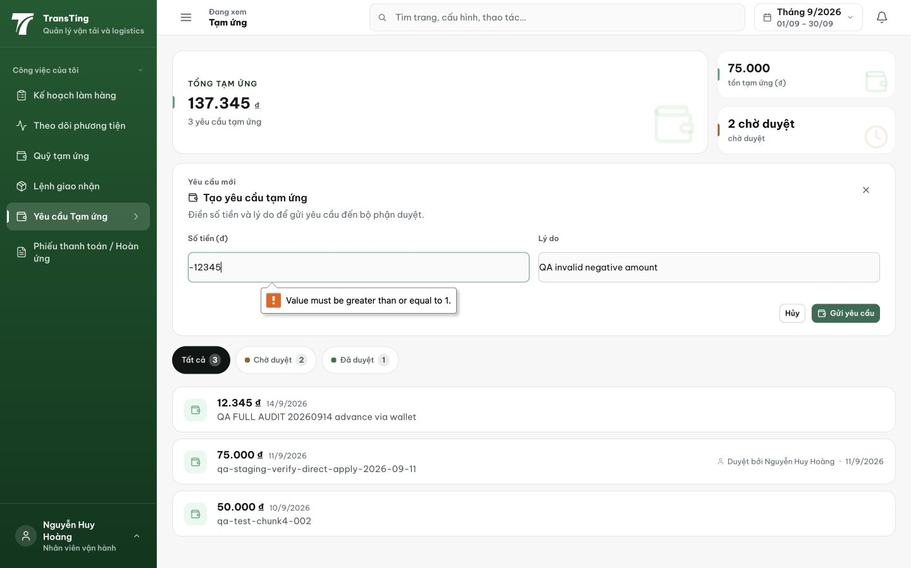
Figure 2. The separate /my-advances form retains -12345 and blocks submission with minimum-value validation. The visible 12,345 VND record was a separate, deliberately positive request.

Evidence 3
  - Reject negative OPS advance and expense amounts
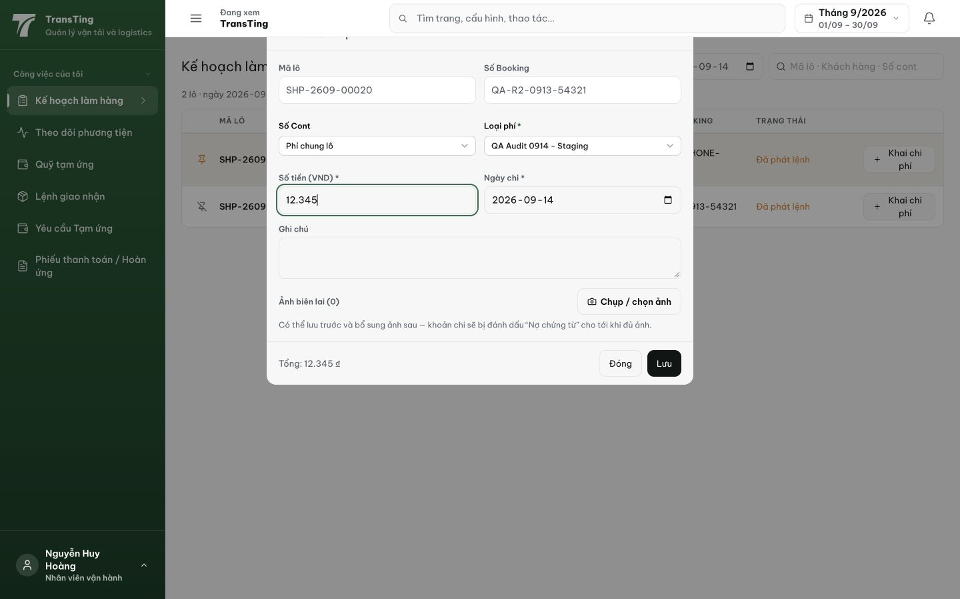
Figure 3. Expense creation also turns entered -12345 into positive 12.345 in the field and summary. This converted case was not saved; the amount was later deliberately replaced with positive 23.456 before creation.

[2026-09-14] DEV COMPLETED — 3 modals preserve minus sign + inline error "Số tiền phải là số dương" + block submit. Commit 961d9d39.

============================================================
QA VERDICT: PASSED
Date: 2026-09-14
API Evidence (staging vantai.tingting.vip)
- Advance request (OPS role) POST /api/forwarder/me/advance-requests with amount=-5000:
→ HTTP 400: "Phải là số dương (amount)" — PASS
- Expense POST /api/expenses with amount=-5000:
→ HTTP 400: "Phải là số dương (amount)" — PASS
- Expense POST /api/expenses with amount="-10000" (string negative):
→ HTTP 400: "Phải là số dương (amount)" — PASS
- Expense POST /api/expenses with amount=0 (zero edge case):
→ HTTP 400: "Phải là số dương (amount)" — PASS
- All negative/zero amounts correctly rejected by positiveNumeric schema transform.

