Align customer shipment status across list and details
  - QA-042 | P2 | Bug | TODO
Environment: Staging https://vantai.tingting.vip
Reviewed: 14 September 2026
Role: Customer qa.audit.customer.0914, scoped to Long Minh; Chrome desktop and phone
Page: https://vantai.tingting.vip/portal/shipments; details /portal/shipments/21 and /3

Existing behaviour
The Đang vận chuyển 6 tab gives each row Nguồn trạng thái: Đang vận chuyển and a Đang chờ badge. Details for SHP-2609-00021 and SHP-2609-00003 instead show Đã phân xe. Their recorded history contains Chờ chốt lịch, Sẵn sàng điều xe and Đã phân xe, without a departure event. These meanings are insufficiently distinguished.

Target behaviour
Use a neutral active-work category or precise operational state mapping. Distinguish assignment, confirmed departure and delivery. Label any separate queue status clearly, and align list and detail wording.

Impact
Customers cannot reliably tell whether a shipment is assigned, moving or waiting, reducing confidence in the tracking view.

Cause and investigation
Hypothesis: category, queue and shipment states use different presentation mappings. Confirm them; physical movement and underlying data correctness were not independently verified.

Steps to reproduce
1. As Customer, open Lô hàng của tôi and select Đang vận chuyển 6.
2. Compare Nguồn trạng thái and the Đang chờ badges. Open SHP-2609-00021 and inspect its current status and history.
3. Repeat for SHP-2609-00003 on phone; its detail also records Đã phân xe.

Acceptance criteria
1. For the same shipment, list and detail use consistent operational state wording derived from recorded business events.
2. Assignment alone does not imply actual departure or delivery. A broader active-work bucket uses neutral wording.
3. If queue and shipment states differ, distinguish them with clear labels and explain what is pending.
4. Verify desktop, tablet and phone while retaining compact layouts. This change requires no GPS tracking or permission changes.

Requirement reference
Exploratory staging review, 14 September 2026.
User direction: professional, compact, data-heavy UI with clear customer-facing states.

Evidence 1
  - Align customer shipment status across list and details
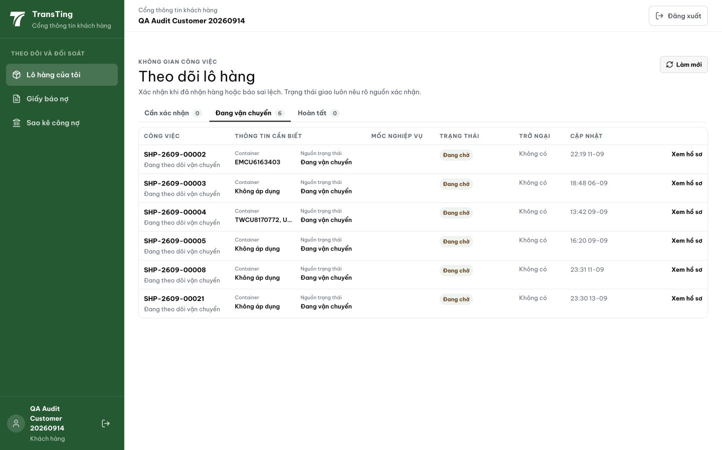
Figure 1. Customer list: Đang vận chuyển 6 is selected. Rows show Nguồn trạng thái: Đang vận chuyển and a separate Đang chờ badge, without explaining the different meanings.

Evidence 2
  - Align customer shipment status across list and details
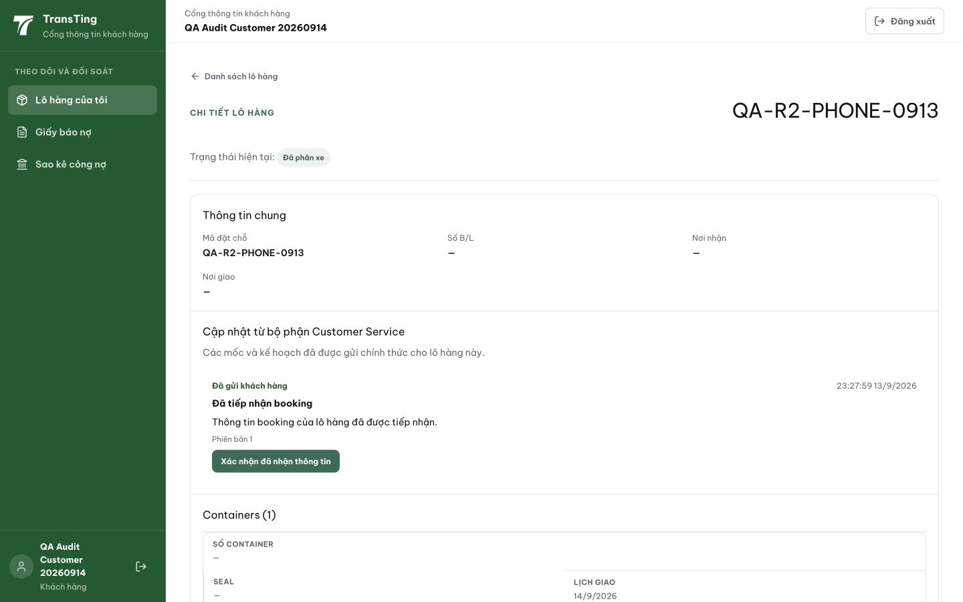
Figure 2. SHP-2609-00021 detail, booking QA-R2-PHONE-0913: Trạng thái hiện tại is Đã phân xe. Capture precedes acknowledgement of the Customer Service update.

Evidence 3
  - Align customer shipment status across list and details
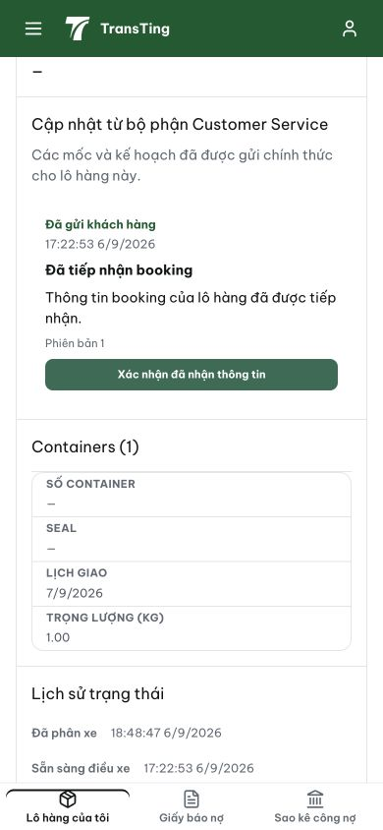
Figure 3. Phone detail for SHP-2609-00003: the visible status history ends at Đã phân xe. Full captured page text also contains Sẵn sàng điều xe and Chờ chốt lịch, with no departure event.
[2026-09-14] DEV COMPLETED — deliveryTruth +NO_REPORT (chỉ shipment đang IN_TRANSIT thật mới claims 'Đang vận chuyển' — status machine trip-gated); bucket khách hàng trung tính 'Đang xử lý' (tab + column + subtitle cùng một tuple, nhất quán); fact 'Chưa có báo cáo giao hàng' vs 'Đang vận chuyển'; detail/máy trạng thái/GPS/permission không đổi. Bằng chứng local đầy đủ: unit 9/9+2/2 BE, 14/14+14/14 FE, full suite 1780/1780 + review 1790/1790; BROWSER rung 8/8 (samsung-cs customer, desktop + 390px, fixture assigned-only 178215 vs in-transit 178216, 0 console errors) — testplan/qa/evidence/2026-09-14_qa042-portal-status-semantics/. Ghi chú deploy: không split-deploy BE/FE (skew window làm lộ lại bug cho row NO_REPORT). Commit 66e911d3. Chờ staging QA sau cut.
[2026-09-14] QA PASSED — staging (build ae22ba8b, vòng 3): xác minh đủ tiêu chí — chi tiết trong 2026-09-14_staging3-batch/REPORT.md + dir riêng.

