Show the shipment route in the Ops plan
  - QA-045 | P2 | Bug | TODO
Environment: Staging https://vantai.tingting.vip
Reviewed: 14 September 2026
Role: OPS hoangnh; source CUS thanhdc; Chrome desktop 1440×900
Page: /ops/orders; source comparison /shipments

Existing behaviour
For SHP-2609-00021, booking QA-R2-PHONE-0913, the Ops plan on 14 September shows — in Tuyến. The CUS overview for the same booking shows KCN QUẾ VÕ, BẮC NINH, with a 13:30 appointment on 14 September 2026 and 1x40HC. Ops identifies the shipment as Đã phát lệnh but omits its known route. The mismatch is confirmed for this fixture; other shipments’ route correctness has not been established.

Target behaviour
Show the shipment’s saved route or correctly resolved stop path in the Ops plan. Use a missing-route state only when the source genuinely lacks route data. Keep the table compact and readable.

Impact
Ops cannot identify the work route from the daily plan and must consult another role’s view.

Cause and investigation
Hypothesis: the Ops route projection uses an incomplete source or fallback. Compare route resolution across the two views; no database loss or implementation cause is established.

Steps to reproduce
1. As thanhdc, open /shipments and search QA-R2-PHONE-0913. Verify KCN QUẾ VÕ, BẮC NINH and the 14 September appointment.
2. As hoangnh, open /ops/orders for 14 September 2026 and locate SHP-2609-00021 by the same booking.
3. Compare its Tuyến cell with CUS: Ops displays —. Recheck both loaded views against the same record during retest.

Acceptance criteria
1. SHP-2609-00021 displays the known route in Ops and agrees with the current CUS source after reload and date/search changes.
2. Distinguish a genuinely missing route from loading or resolution failure; do not silently replace a known route with —.
3. For multiple containers with different routes, show their relationship accurately rather than presenting one misleading route for the whole shipment.
4. Keep route text readable on phone, tablet and desktop without oversized cards or excessive row height. Preserve existing Ops permissions and actions.

Requirement reference
Full-app Chrome audit, 14 September 2026; same-booking CUS and Ops comparison.

Evidence 1
  - Show the shipment route in the Ops plan
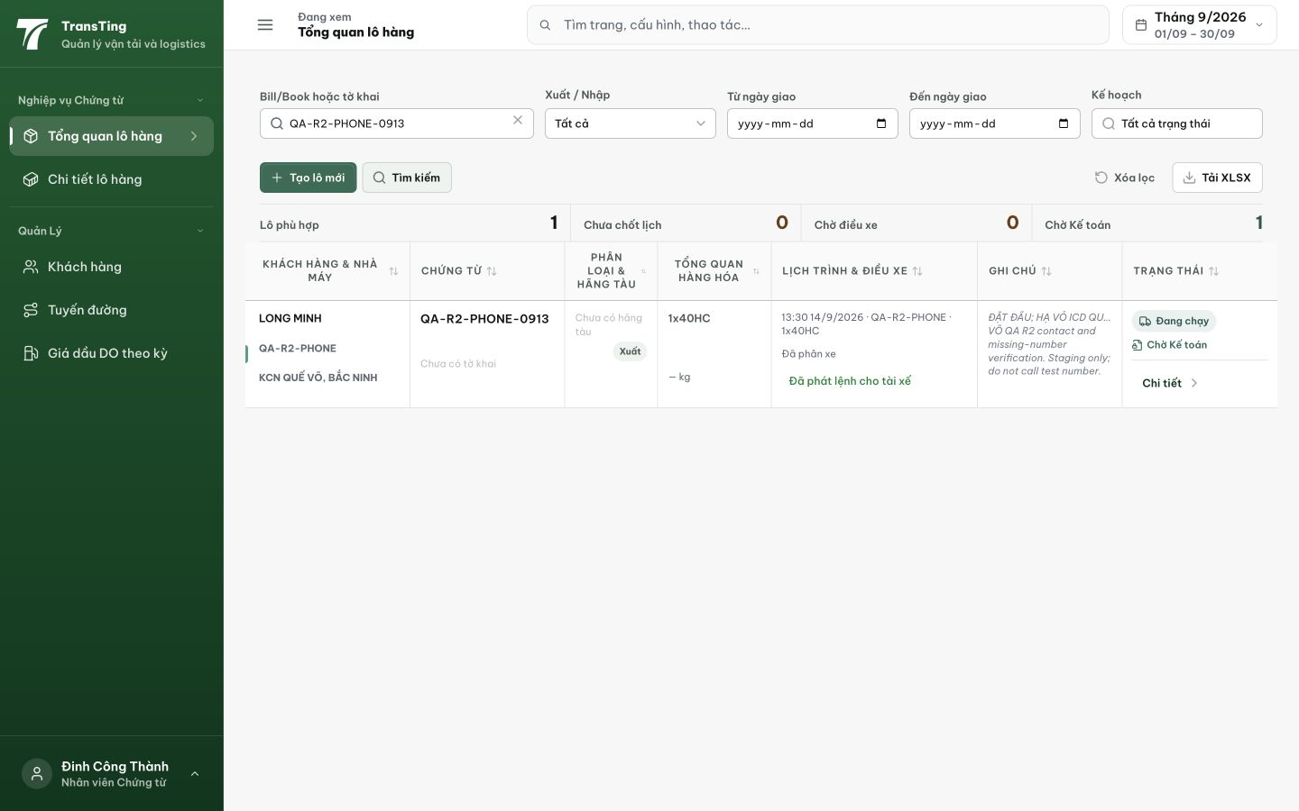
Figure 1. CUS source: QA-R2-PHONE-0913 displays KCN QUẾ VÕ, BẮC NINH, a 13:30 appointment on 14/9/2026 and 1x40HC.

Evidence 2
  - Show the shipment route in the Ops plan
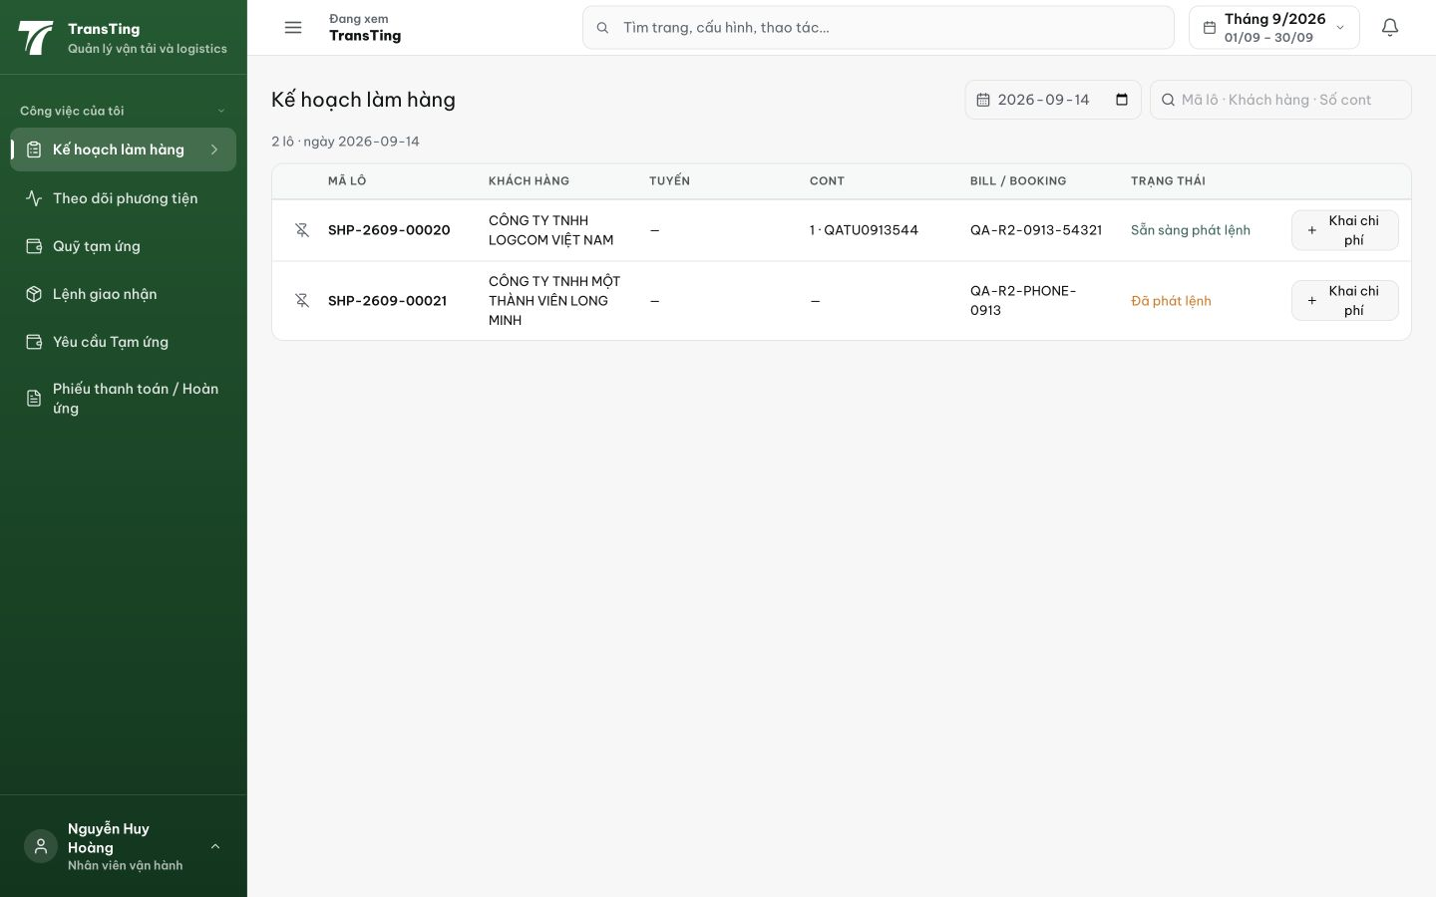
Figure 2. Ops plan for 14/9/2026: SHP-2609-00021 has the same booking and Đã phát lệnh status, but Tuyến shows —. The other row is outside this confirmed comparison.
[2026-09-14] DEV COMPLETED — FCL rows join coalesce(container.routeId, shipment.routeId) (LCL giữ nguyên; shared util + master-plan INNER join không đổi — reviewer xác minh zero row-set change); cell Tuyến: route → destination (muted) → 'Chưa có tuyến đường' tường minh (cùng từ vựng CUS) — không bao giờ dash trơn. Unit 77/77 BE + 47/47 FE (kèm pin argument-order); wire probe + browser 5/5. Fixtures 178396/178397 disclosed. Commit 038e059f. Bằng chứng: 2026-09-14_qa045-ops-plan-route/. Nhánh fulfillment-less còn hở — thẻ riêng 20260914_6.
[2026-09-14] QA PASSED — staging (build ae22ba8b, vòng 3): xác minh đủ tiêu chí — chi tiết trong 2026-09-14_staging3-batch/REPORT.md + dir riêng. (staging: ship 21 fallback + lot 26 explicit label — PARTIAL scope: /ops/orders Tuyến còn '—' → thẻ 20260914_11)

