Link the blocking trip when driver acceptance is rejected
  - QA-047 | P2 | Enhancement | TODO
Environment: Staging https://vantai.tingting.vip
Reviewed: 14 September 2026
Role: Driver dvthuc (Dương Văn Thực); Chrome phone 390 × 844
Page: https://vantai.tingting.vip/my-trips/32; accepted list /my-trips

Existing behaviour
Accepting QATU0914005 correctly reports that the vehicle is running TRP-202609-0001. The retained screen shows only a synchronization-conflict summary and Tải lại để xử lý xung đột. Reload restores acceptance and advises retrying if the vehicle is free; retry correctly rejects the unchanged condition. Đã nhận cards omit TRP codes, so the reported blocker is hard to identify.

Target behaviour
Retain the specific busy-trip reason with an authorized link to the blocking trip and clear next steps. Preserve conditional retry guidance, the acceptance guard and compact sizing.

Impact
The driver loses the concrete blocker identity and must search accepted records to work out the next step.

Cause and investigation
Hypothesis: the persistent conflict view omits the business dependency returned during acceptance. Inspect recovery-state presentation; no datastore cause is established.

Steps to reproduce
1. As dvthuc, open /my-trips/32, container QATU0914005, and click Nhận lệnh vận chuyển while the vehicle has an active trip.
2. Observe the busy-trip toast naming TRP-202609-0001, then the retained reload-only action. Reload and retry: the conflict returns.
3. Open Đã nhận 2 in /my-trips. Neither card shows the reported TRP code.

Acceptance criteria
1. Keep the blocking trip identity and reason visible after the toast expires.
2. Link to the correct authorized active trip; if unavailable, provide a clear dispatcher handoff without exposing unauthorized records.
3. Preserve guidance to complete the active trip through its real workflow and retry when the vehicle is free; recheck current state and retain the guard.
4. Verify compact phone and tablet layouts, including a still-busy retry and recovery after the blocker is resolved.

Requirement reference
Exploratory staging review, 14 September 2026.
User direction: smooth, compact workflows with clear guidance.

Evidence 1
  - Link the blocking trip when driver acceptance is rejected
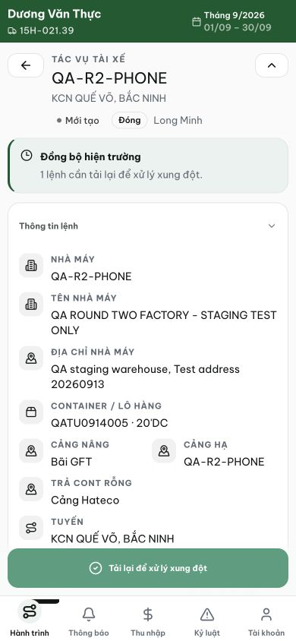
Figure 1. After the rejection, the persistent screen shows a generic synchronization-conflict summary and reload action. The specific busy-trip toast was observed during the interaction and is not visible in this capture.

Evidence 2
  - Link the blocking trip when driver acceptance is rejected
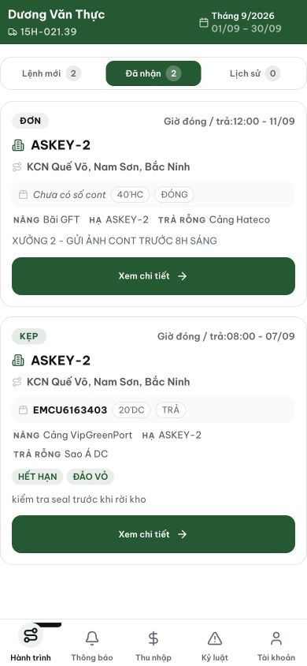
Figure 2. Đã nhận 2: cards identify factory, container, route and date, but neither shows a TRP code to match the blocker named during acceptance.
[2026-09-14] DEV COMPLETED — Sync banner persist verbatim conflict reason (TRP identity sống qua toast); TRP match против driver's OWN board → link 'Mở chuyến TRP-…' authorized; no-match (tàu khác tài xế cùng xe) → handoff 'liên hệ điều vận', không lộ foreign record; conflict-reload + retry giữ nguyên; RUNNING cards có TRP chip compact. Tests 37/22. Self-caught: TRP code YYMM 6 chữ số. Commit 1b8857b9 (pathspec — race-immune sau 2 incident reverted). Browser rung staging.
[2026-09-14] QA PASSED — staging: AC1: blocking-trip identity visible (TRP-260914-8801 in banner); AC2: dispatcher handoff branch verified (banner says "Chuyến này không phải của bạn — liên hệ điều vận"), no foreign record exposure; AC3: guard blocks acceptance; AC4: phone verified — own-trip-link branch untestable in current fixture (dvthuc has 0 accepted trips) Evidence: testplan/qa/evidence/2026-09-14_QA-batch-staging-cut-9/ui/QA-047-conflict-banner-390.png
Trạng thái: QA PASSED — đã xác minh trên staging

