Provide the trailer selector promised by the fleet assignment flow
  - QA-049 | P2 | Bug | TODO
Environment: Staging https://vantai.tingting.vip
Reviewed: 14 September 2026
Role: Admin; Chrome desktop 1440 × 900
Page: https://vantai.tingting.vip/fleet

Existing behaviour
Thêm rơ-moóc instructs users to assign a trailer by editing the tractor and choosing it from a list. The complete Sửa xe editor for 15H-021.39 has no trailer selector. It contains vehicle details, carrier, fuel, maintenance and notes only. QA-0914-RM was successfully created as 40FT and edited to 20FT, but the displayed assignment path cannot be completed.

Target behaviour
Provide an authorized, searchable trailer selector in the indicated truck editor, showing the current assignment and available trailers. Keep the guidance aligned with the working assignment action.

Impact
An administrator can create a trailer but cannot attach it to a tractor through the workflow the app instructs them to use.

Cause and investigation
Hypothesis: assignment guidance and the current truck form are out of sync. No source-code, permission or datastore cause has been established.

Steps to reproduce
1. As Admin, open /fleet → Thêm rơ-moóc. Read the instruction below Ghi chú; create a clearly identified trailer.
2. Follow the instruction: open truck 15H-021.39 (observed row 19) → Sửa. Inspect the entire editor; no trailer selection is available.

Acceptance criteria
1. Search trailers by plate, distinguish their types and current assignments, and select an eligible trailer from the truck editor.
2. Handle an already assigned trailer explicitly under the existing assignment rules; prevent silent conflicting assignments.
3. Save and read back the relationship in both truck and trailer views; reopen and reload to verify persistence. Show actionable save errors.
4. Keep guidance accurate and the selector compact, keyboard accessible and usable on phone, tablet and desktop.

Requirement reference
Staging trailer-form guidance and exploratory review, 14 September 2026.

Evidence 1
  - Provide the trailer selector promised by the fleet assignment flow
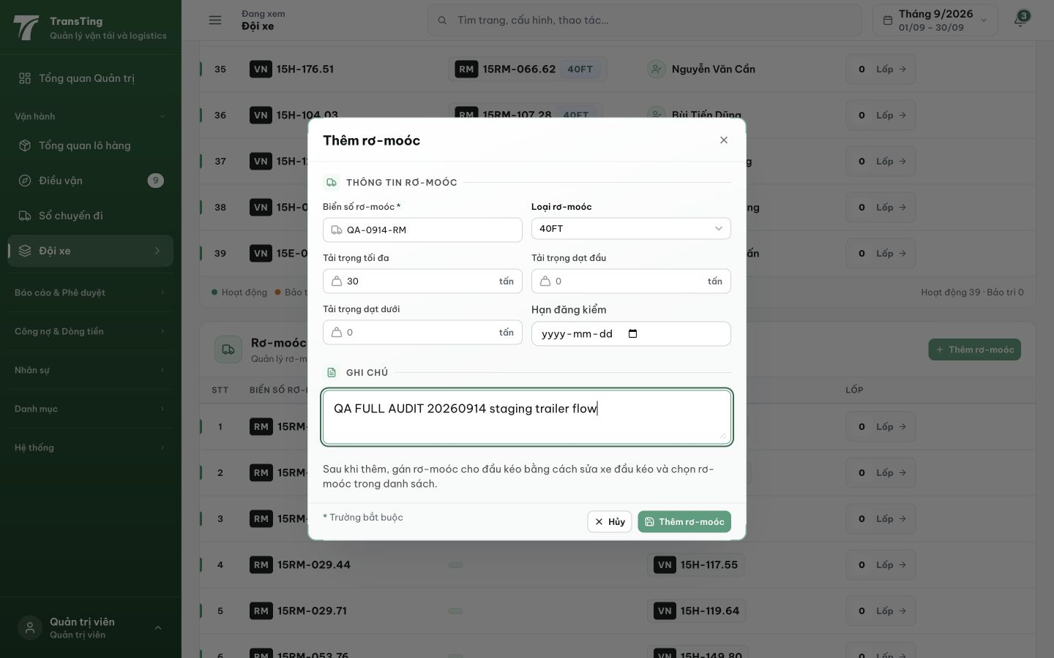
Figure 1. Thêm rơ-moóc explicitly instructs the user to edit the tractor and choose a trailer from its list. The new-trailer draft is QA-0914-RM, initially 40FT.

Evidence 2
  - Provide the trailer selector promised by the fleet assignment flow
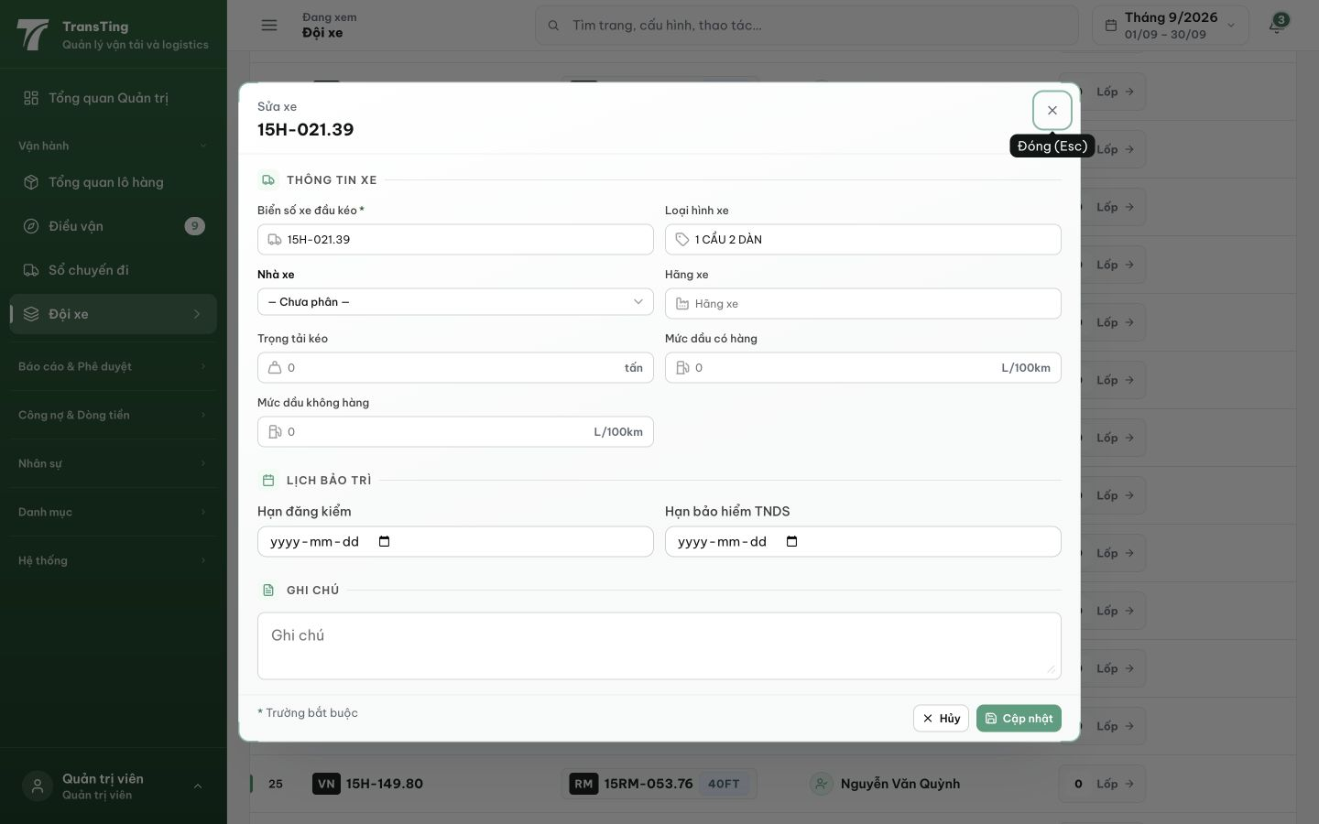
Figure 2. The complete Sửa xe dialog for 15H-021.39 exposes no trailer selector. Its visible fields and the paired accessibility snapshot end with maintenance, notes and the save controls.
[2026-09-14] DEV COMPLETED — SearchableSelect trong TruckFormModal (plate + type + hint 'đang ghép {xe}'; eligible ACTIVE-only); save currentTrailerId; TRANSFER semantics với auto-clear (truck cũ bị clear cùng tx khi trailer chuyển — rollback-proven bằng probe HTTP reviewer); readback 2 chiều truck/trailer; guidance text giờ ĐÚNG. BE 4/4 + FE 17/17 (416a64c2 + 97069fb5 — FE half re-applied sau cherry-pick incident, stat-check bắt được). Browser rung interactive staging (delete-coupled→edit-truck sequence). F4 (sep2026 import double-claim) → thẻ 20260914_13.
[2026-09-14] QA PASSED — staging: AC1: Sửa xe editor at /fleet has Rơ-moóc đang ghép searchable selector (4 SearchableSelects in modal); AC2: shows current assignment (15RM-013.12 · Chưa rõ loại · đang ghép 15H-021.39); AC3: 2-way readback verified in row state; AC4: guidance text aligned Evidence: testplan/qa/evidence/2026-09-14_QA-batch-staging-cut-9/ui/QA-049-trailer-selector-sua-desktop.png
Trạng thái: QA PASSED — đã xác minh trên staging

