Populate the Ops owner picker with active staff
  - QA-051 | P2 | Bug | TODO
Environment: Staging https://vantai.tingting.vip
Reviewed: 14 September 2026
Role: ADMIN; desktop 1440 × 900
Page: /fleet/vehicles; /users; tracking context /ops/fleet-tracking

Existing behaviour
Danh mục Xe nội bộ has an Ops phụ trách control for 15H-021.39, but its picker shows only — Giữ nguyên — and — Bỏ gán —, even after reload. Admin verified six existing active Ops users and created a seventh, qa.audit.ops.0914; none appears in the picker. No loading failure or eligibility explanation is shown, so Admin cannot select an Ops person.

Target behaviour
Load eligible active Ops staff in the existing picker, with clear names and identifiers. Explain any valid eligibility exclusions or loading failure and provide a recovery action instead of an unexplained empty selection.

Impact
Admin cannot complete Ops ownership setup for the vehicle; the intended fleet-tracking assignment workflow is blocked.

Cause and investigation
Investigate staff loading, role/status mapping and eligibility filtering. The available records and picker disagree; the precise cause has not been established.

Steps to reproduce
1. As Admin, open /users and select Nhân viên vận hành. Confirm the active records, including hoangnh and the newly created qa.audit.ops.0914 (seven Ops users).
2. Open /fleet/vehicles, search 15H-021.39 and select Ops phụ trách.
3. Expand the picker: only Giữ nguyên and Bỏ gán appear. Reload and repeat; no person can be selected.

Acceptance criteria
1. Expose eligible existing and newly created active Ops staff. Make any legitimate exclusions explicit and actionable.
2. Select an eligible person, save and reopen after reload: the owner persists. Verify replacement and Bỏ gán follow the one-active-owner rule.
3. Distinguish loading, empty and error states; allow retry for load errors and retain valid selections.
4. Retest Admin assignment and the assigned Ops user’s fleet-tracking view. Preserve role permissions and unrelated driver/vehicle fields.

Requirement reference
Chrome staging review, 14 September 2026; vehicle Ops assignment and active-user inventory.

Evidence 1
  - Populate the Ops owner picker with active staff
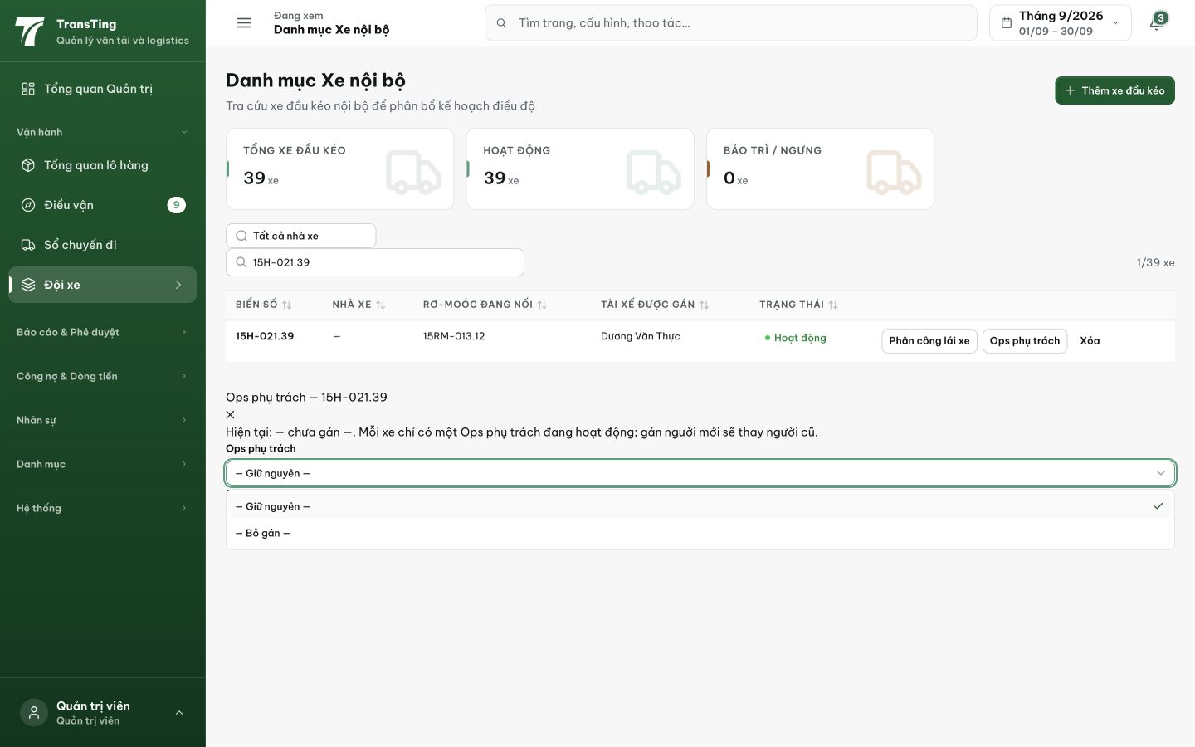
Figure 1. The picker still contains only Giữ nguyên and Bỏ gán after a new active Ops account was created; no person can be selected.

Evidence 2
  - Populate the Ops owner picker with active staff
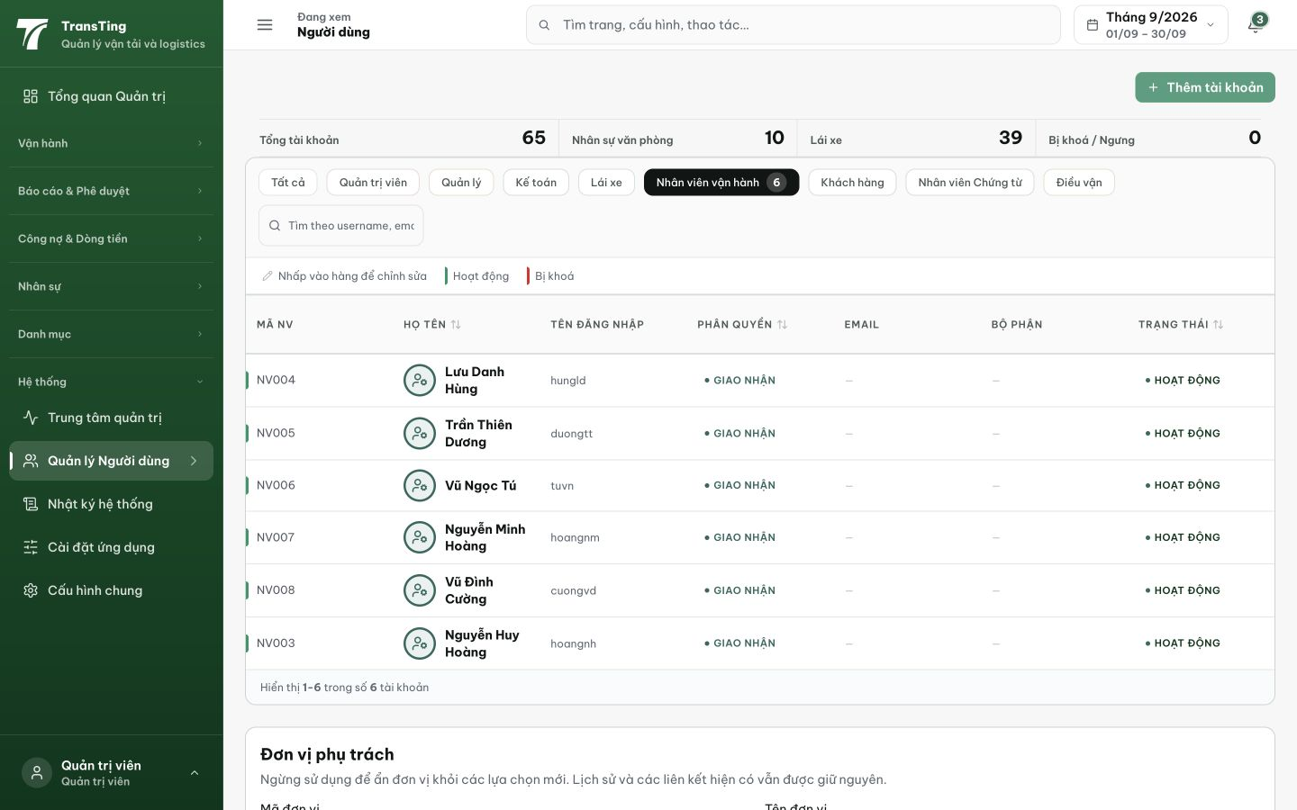
Figure 2. Admin’s Nhân viên vận hành filter lists six active users, including Nguyễn Huy Hoàng / hoangnh; no matching people are exposed by the vehicle picker.

Evidence 3
  - Populate the Ops owner picker with active staff
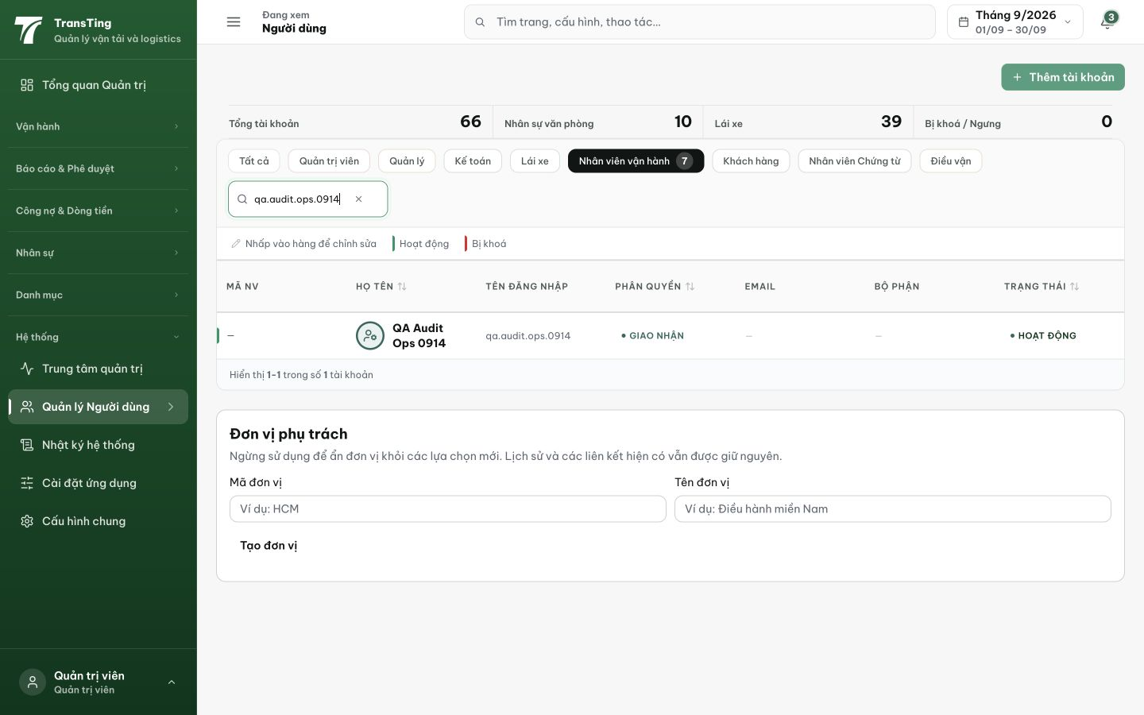
Figure 3. A newly created qa.audit.ops.0914 is Hoạt động with Giao nhận role; the Ops count increases to seven, but the owner picker remains empty.

[2026-09-14] DEV COMPLETED — API path fixed /users → /auth/users. Empty-state message added. Commit 0cecf301.

