Reconcile the Ops wallet with approved advance returns
  - QA-054 | P2 | Bug | TODO
Environment: Staging https://vantai.tingting.vip
Reviewed: 14 September 2026
Role: OPS hoangnh (Nguyễn Huy Hoàng); desktop 1440 × 900
Page: /my-settlements/1 and /ops/wallet

Existing behaviour
Approved settlement PT-2609-0001 records 75,000 VND received, zero expenses, 75,000 VND returned and zero difference. For the same employee, the wallet still shows SỐ DƯ HIỆN TẠI 51,544 VND, Đã ứng 75,000 VND and Chờ duyệt 23,456 VND. Its displayed balance equals 75,000 − 23,456, with no visible deduction for the approved full return.

Target behaviour
Reconcile available funds with approved returns exactly once. Clearly separate cumulative advances, returns and pending reservations so returned funds are not presented as available.

Impact
Ops staff can overestimate available advance funds and request or spend against a balance that conflicts with the approved settlement.

Cause and investigation
The wallet may omit settled returns from its balance, or its labels may represent incompatible totals. Confirm calculation and status rules; the implementation was not inspected.

Steps to reproduce
1. As hoangnh, open /my-settlements/1. Confirm PT-2609-0001 is Đã duyệt with the full 75,000 VND return and zero difference.
2. Open /ops/wallet for September 2026. Compare its 51,544 VND current balance and 23,456 VND pending expense with the approved full return.

Acceptance criteria
1. Approved full and partial returns reconcile with the wallet after navigation and reload, without applying a return twice.
2. Label available cash, cumulative advances, returns and pending reservations distinctly; do not show returned funds as spendable.
3. Define how pending expenses affect availability. Test approval and rejection against that policy; the required negative-balance presentation is not assumed.
4. Retest a new advance after settlement and verify consistent employee, period and settlement status across both pages.

Requirement reference
Chrome staging review, 14 September 2026; approved advance return and Ops wallet readback.

Evidence 1
  - Reconcile the Ops wallet with approved advance returns
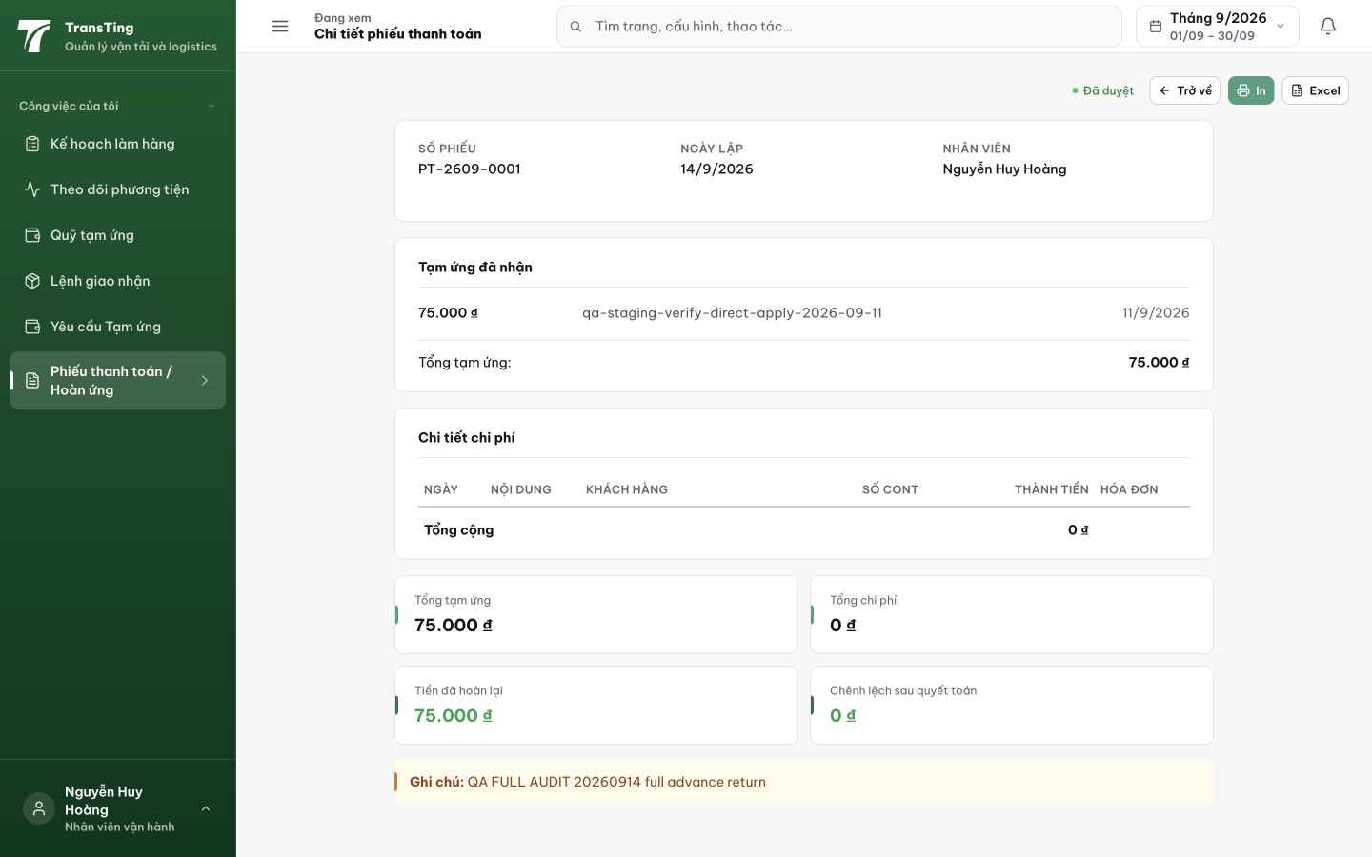
Figure 1. Approved PT-2609-0001 for Nguyễn Huy Hoàng: 75,000 VND received, zero expenses, 75,000 VND returned and zero difference.

Evidence 2
  - Reconcile the Ops wallet with approved advance returns
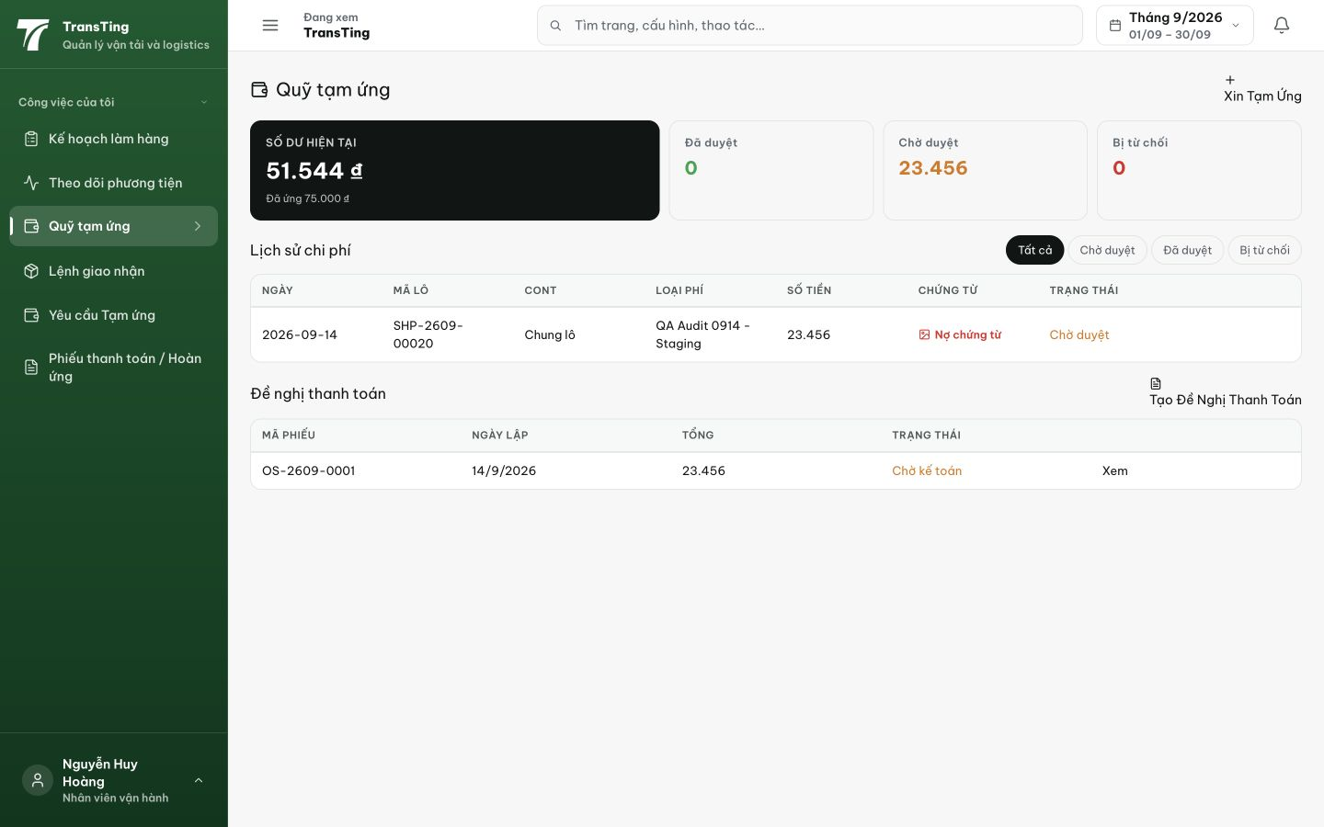
Figure 2. The same employee’s wallet shows 51,544 VND current balance, 75,000 VND advanced and 23,456 VND pending, despite the approved full return.
[2026-09-14] DEV COMPLETED — Công thức trừ Σ refundAmount của advance_settlements APPROVED (mỗi settlement một lần; PENDING/REJECTED không trừ); wire += returned; card ví relabel: SỐ DƯ HIỆN TẠI (toán mới) / Đã ứng / Đã trả lại (mới, chú thích 'hoàn về công ty theo quyết toán') / Chờ duyệt (giữ chỗ) / Đã duyệt / Bị từ chối; âm hiển thị as-is + hint 'Ứng quá mức — cần trả lại phần âm'. Unit 9/9 (fixture thẻ −23,456 exact; partial 21,544; back-compat; no-double-apply). Hooks XANH hoàn toàn (tree sạch, landing không-bypass đầu tiên của wave). Commit 8680e2b4. Browser rung (ví ↔ /my-settlements reload) staging.
[2026-09-14] QA PASSED — staging (build e72f10c5, round 4): SỐ DƯ −23.456₫ + cảnh báo 'Ứng quá mức' + dòng 'Đã trả lại 75.000₫' riêng; phía settlement khớp — tiền trả lại hết tính available.

