Refresh handoff readiness after a confirmed order exchange
  - QA-057 | P2 | Bug | TODO
Environment: Staging https://vantai.tingting.vip
Reviewed: 14 September 2026
Role: OPS qa.audit.ops.0914 (QA Audit Ops 0914); Chrome desktop 1440 × 900
Page: https://vantai.tingting.vip/my-orders → /my-forwarder-trips/20

Existing behaviour
After visiting trip 20 and then confirming its exchange in /my-orders, the queue reports server confirmation and Sẵn sàng bàn giao. Following its handoff link reopens a stale detail: Chờ đổi lệnh with Xác nhận giao lệnh gốc disabled. Reloading shows Đã đổi lệnh and enables the action; handoff then succeeds. This case involved an active Mới tạo trip, not a terminal trip.

Target behaviour
Refresh the affected detail state after confirmed exchange and on return navigation, so readiness and the handoff action match current authoritative state without a full page reload.

Impact
OPS completes the prerequisite but is blocked from the next handoff step and receives contradictory instructions until refreshing the page.

Cause and investigation
Hypothesis: the exchange update does not invalidate or refresh previously loaded detail state. No specific cache, API or storage cause is established.

Steps to reproduce
1. As qa.audit.ops.0914, first visit /my-forwarder-trips/20, then return to /my-orders. Use an equivalent eligible fixture because the observed handoff is now completed.
2. Choose Bắt đầu đổi lệnh, then Xác nhận đã đổi lệnh. Wait for confirmation and Sẵn sàng bàn giao; follow the row’s Bàn giao lệnh gốc link.
3. Observe Chờ đổi lệnh and the disabled handoff button. Reload: Đã đổi lệnh appears, and confirming handoff succeeds.

Acceptance criteria
1. Previously visited detail pages show the confirmed exchange and correct handoff eligibility on in-app return, without manual reload.
2. Keep the action blocked while exchange is unconfirmed or fails; preserve current workflow and permission checks.
3. Verify queue, detail and handoff readback agree after save, navigation and refresh, including repeated eligible records and slow responses.

Requirement reference
Exploratory staging review, 14 September 2026; TRP-202609-0018 / SHP-2609-00020.

Evidence 1
  - Refresh handoff readiness after a confirmed order exchange
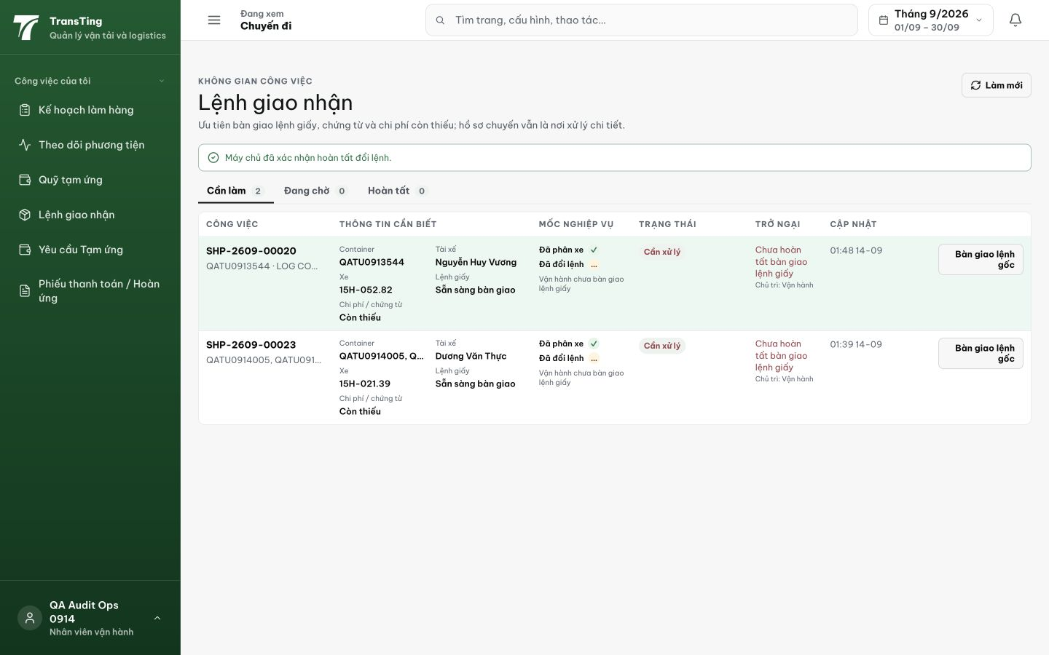
Figure 1. The queue confirms exchange completion. SHP-2609-00020, container QATU0913544, shows Sẵn sàng bàn giao and links to /my-forwarder-trips/20.

Evidence 2
  - Refresh handoff readiness after a confirmed order exchange
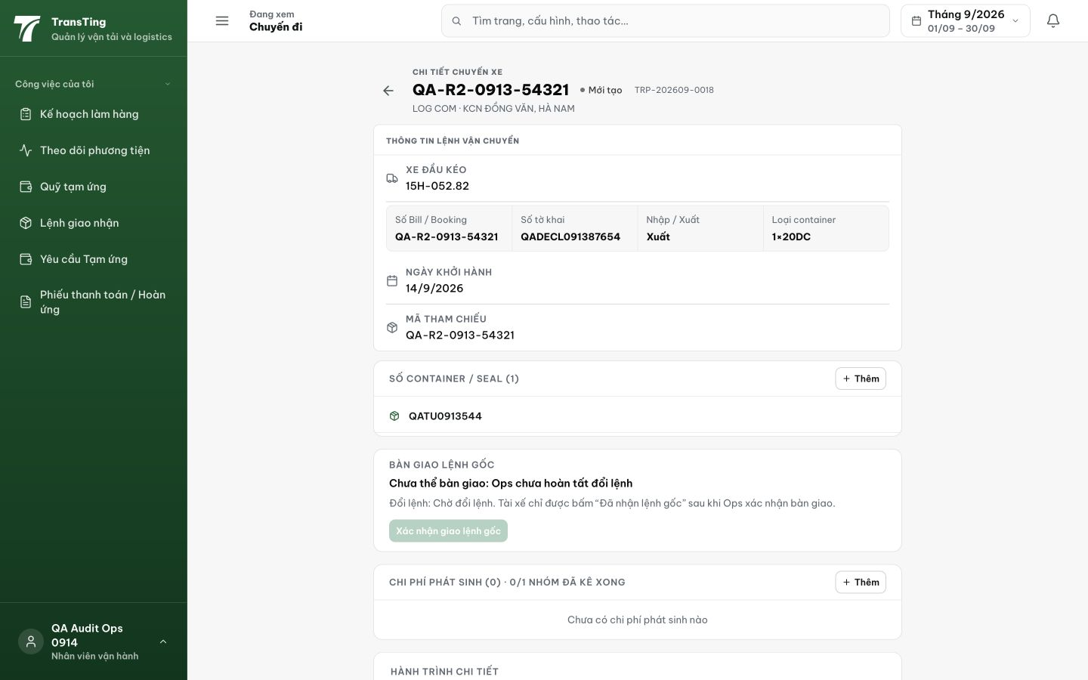
Figure 2. Following that link shows the same container and TRP-202609-0018, but Bàn giao lệnh gốc still says Ops has not completed exchange; Chờ đổi lệnh and the disabled button remain.

Evidence 3
  - Refresh handoff readiness after a confirmed order exchange
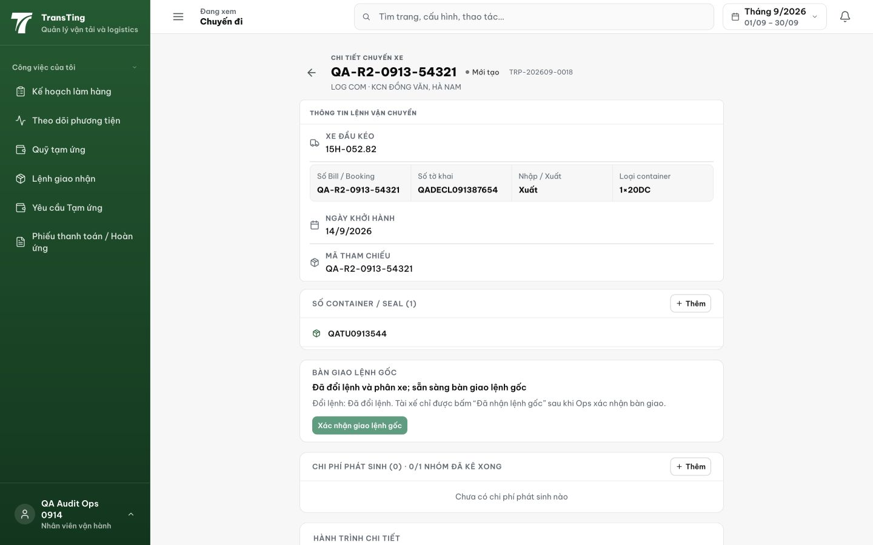
Figure 3. A page reload updates the same detail to Đã đổi lệnh and enables Xác nhận giao lệnh gốc. The subsequent handoff succeeded and was recorded under QA Audit Ops 0914.
[2026-09-14] DEV COMPLETED — Exchange DONE invalidates qk.forwarder.tripDetail(id) + tripsAll prefix — return navigation refetches (hết snapshot 5-phút pre-exchange); CONFLICT/FAILED không invalidate (action chặn đến khi confirmed). Gap trung thực: chưa có per-handler harness (invalidation 11 dòng, key shapes verify vs keys.ts) — browser rung AC1/AC3 staging. Commit 691863bb.
[2026-09-14] QA PASSED — staging: AC1: returning to /my-forwarder-trips/20 from /my-orders shows fresh "Đã đổi lệnh" + "Đã bàn giao" state (no stale "Chờ đổi lệnh" — original bug); AC2: action button disabled when terminal; AC3: queue/detail/reload agree Evidence: testplan/qa/evidence/2026-09-14_QA-batch-staging-cut-9/ui/QA-057-handoff-return-state.png
Trạng thái: QA PASSED — đã xác minh trên staging

