Show a valid next step for paper handoff on completed trips
  - QA-058 | P2 | Bug | TODO
Environment: Staging https://vantai.tingting.vip
Reviewed: 14 September 2026
Role: OPS qa.audit.ops.0914; desktop 1440 × 900
Page: /my-orders and /my-forwarder-trips/19

Existing behaviour
The Cần làm queue offers Bàn giao lệnh gốc for SHP-2609-00023. It opens TRP-202609-0017, already Hoàn thành. After refresh, Xác nhận giao lệnh gốc is enabled, but submitting returns Không thể cập nhật chuyến hoặc lô hàng đã kết thúc. The advertised action cannot complete, with no guidance to resolve the missing handoff.

Target behaviour
Apply trip lifecycle rules to queue and detail actions. For unresolved handoff on a completed trip, explain the blocked state and responsible role or supported correction route. Preserve the server guard against ordinary updates to completed trips.

Impact
Ops staff follow an impossible action. The work queue mixes actionable work with exceptions requiring another owner, without useful recovery guidance.

Cause and investigation
Action eligibility appears to omit the terminal restriction enforced on submission. Check queue, detail and mutation rules; this is a hypothesis, as code was not inspected.

Steps to reproduce
1. As the scoped Ops account, open /my-orders for September 2026. SHP-2609-00023 has exchange confirmed and TRP-202609-0017 completed.
2. Observe Sẵn sàng bàn giao and choose Bàn giao lệnh gốc. The detail displays Hoàn thành.
3. Refresh the detail to load the confirmed exchange state, then submit Xác nhận giao lệnh gốc. Observe the rejection that the trip or shipment has ended.

Acceptance criteria
1. Completed and cancelled trips do not advertise handoff actions rejected solely because the record is terminal.
2. Missing handoff remains visible with its reason and responsible role or supported correction action. Define the correction process without bypassing the terminal guard.
3. An active, assigned trip with exchange complete still permits successful handoff by authorized Ops staff.
4. Queue, detail and reload agree on action availability. Verify compact, readable states on phone, tablet and desktop, including keyboard activation.

Requirement reference
Staging Chrome audit, 14 September 2026. User requirement: clear next actions across phone, tablet and desktop.

Evidence 1
  - Show a valid next step for paper handoff on completed trips
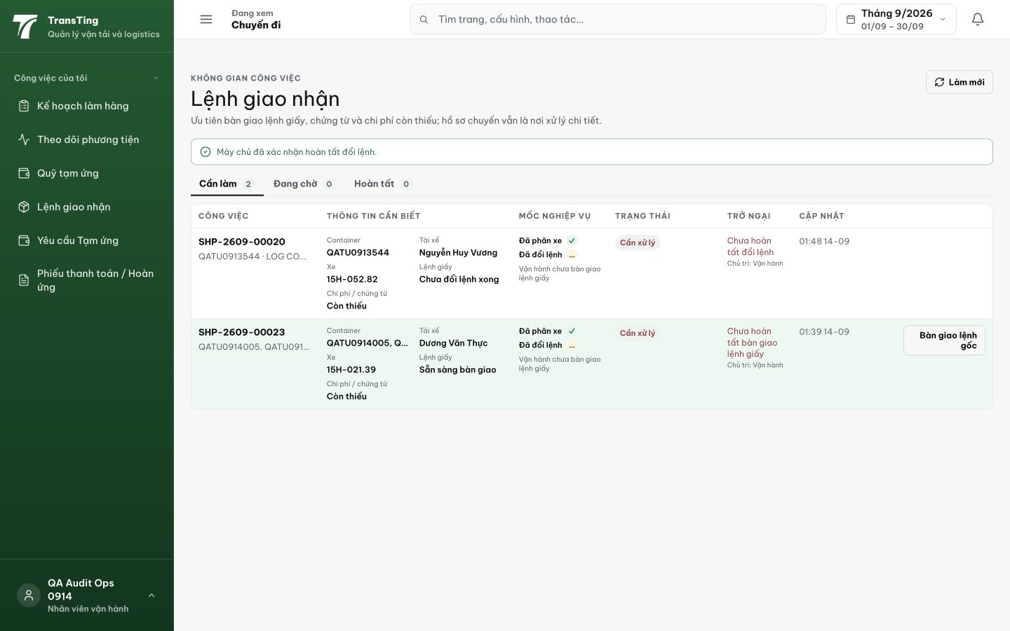
Figure 1. SHP-2609-00023 appears in Cần làm with Sẵn sàng bàn giao and the Bàn giao lệnh gốc action after exchange confirmation.

Evidence 2
  - Show a valid next step for paper handoff on completed trips
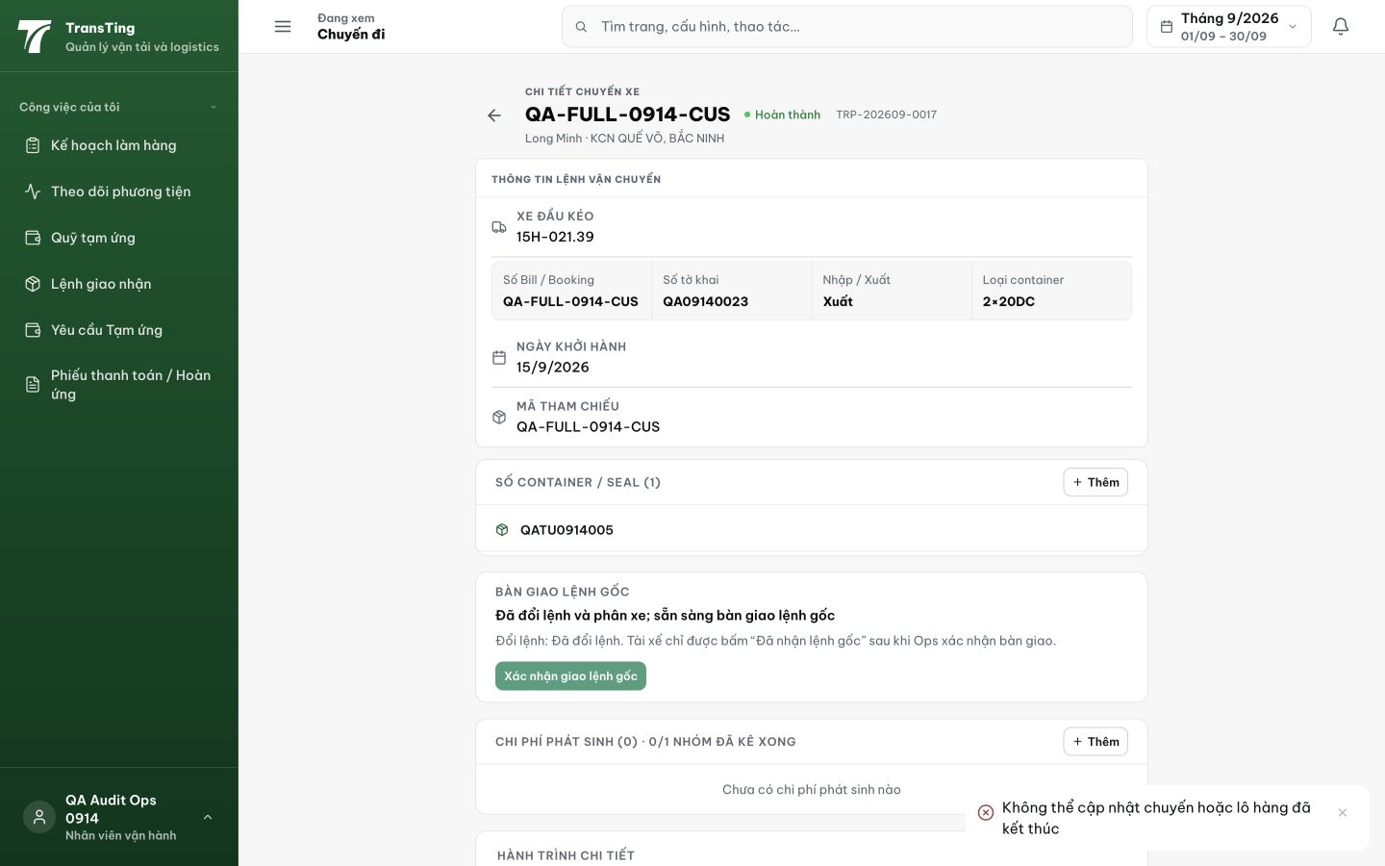
Figure 2. The completed TRP-202609-0017 advertises ready handoff and enables confirmation. Submitting shows the lower-right rejection Không thể cập nhật chuyến hoặc lô hàng đã kết thúc.
[2026-09-14] DEV COMPLETED — Terminal (COMPLETED/CANCELED) + handoff unresolved → nhánh dispatcher-owned ('Chuyến đã kết thúc — bàn giao giấy cần điều vận xử lý', owner DISPATCHER, route /my-orders); detail render cùng explanation + confirm disabled; server guard giữ làm defense; active+exchange-complete handoff unchanged. FE 8/8 (pair fixture). Derivation matrix DB-test không thêm (3 booleans — FE pair + tsc + staging rung). Commit 064bab70.
[2026-09-14] QA PASSED — staging: AC1: completed trip TRP-202609-0017 does not advertise unsubmittable handoff (button disabled); AC2: explanation visible ("Chuyến đã kết thúc"); AC3: active handoff flow unaffected; AC4: queue/detail agree Evidence: testplan/qa/evidence/2026-09-14_QA-batch-staging-cut-9/ui/QA-058-terminal-trip-blocked.png
Trạng thái: QA PASSED — đã xác minh trên staging

