Allow configured Ops categories when saving trip expenses
  - QA-059 | P2 | Bug | TODO
Environment: Staging https://vantai.tingting.vip
Reviewed: 14 September 2026
Role: OPS qa.audit.ops.0914; category created by ADMIN; desktop 1440 × 900
Page: /my-forwarder-trips/20; configuration /config/forwarder-expense-types

Existing behaviour
The form offers QA Audit 0914 - Staging (QA0914), but saving rejects it with “Invalid enum value” and “received 'QA0914' (expenseType)”, listing fixed internal codes. The completed draft stays open; Chi phí phát sinh remains 0 and no expense is created.

Target behaviour
Save selectable configured categories with their correct identity and rules. Explain unusable categories before submission with actionable Vietnamese feedback; retain the draft on errors.

Impact
Ops cannot record the expense using the only offered category, blocking cost completion and its downstream review.

Cause and investigation
Category selection and expenseType validation appear inconsistent. Inspect their mapping and shared rules; the implementation and failing layer are unverified.

Steps to reproduce
1. Confirm QA0914 exists in /config/forwarder-expense-types with no-invoice permission. As qa.audit.ops.0914, open /my-forwarder-trips/20 (TRP-202609-0018).
2. Select QATU0913544 and add an expense. Choose QA Audit 0914 - Staging, buy amount 34,567 VND (sell auto-fills 34,567), Chi hộ tạm ứng, date 2026-09-14, a reason and receiver QA Staging Receiver. Check Phiếu thu / biên nhận / vé lẻ.
3. Select Lưu chi phí. The enum error rejects QA0914; the expense count remains 0.

Acceptance criteria
1. A configured selectable category saves successfully; reload retains the correct category, container, amounts and evidence choice.
2. Verify both configured codes and supported legacy categories. Disabled or ineligible categories cannot be selected without an explanation.
3. Apply the category’s invoice, amount and approval rules consistently; do not bypass them or silently substitute another category.
4. Show a clear field-level Vietnamese error for invalid data, preserve the draft and prevent duplicate entries when corrected and retried.

Requirement reference
Chrome staging review, 14 September 2026; configured forwarder expense category and trip expense submission.

Evidence 1
  - Allow configured Ops categories when saving trip expenses
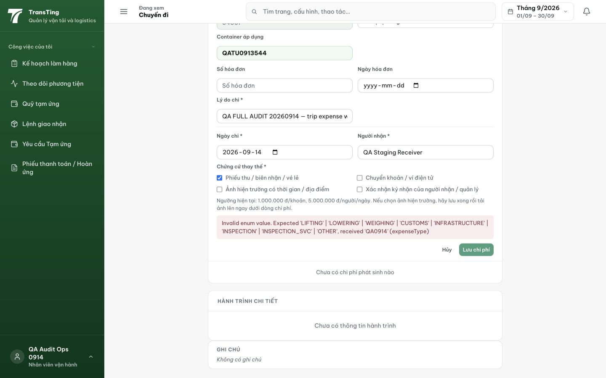
Figure 1. Lưu chi phí returns a raw expenseType enum rejection for QA0914. The completed draft remains visible and no expense row is created.

Evidence 2
  - Allow configured Ops categories when saving trip expenses
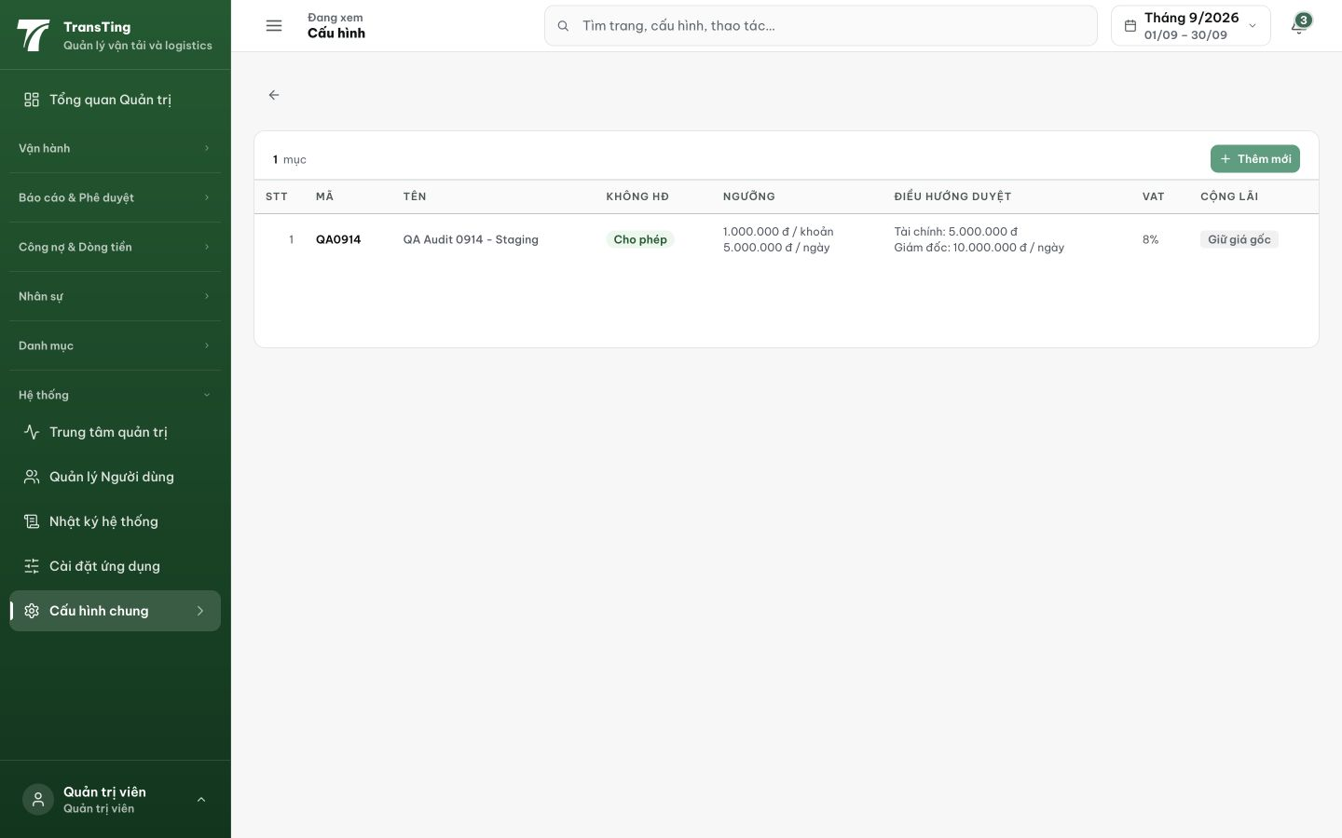
Figure 2. QA0914 / QA Audit 0914 - Staging is saved in the expense-type catalog with no-invoice permission and explicit amount/approval rules.
[2026-09-14] DEV COMPLETED — expenseType shape-only ở shared; gate ngữ nghĩa assertActiveExpenseTypeCode tại CẢ HAI write route (create + PATCH-when-present): ACTIVE catalog row, exact match, không substitution; message VN field-level ('không tồn tại hoặc đã ngừng hiệu lực — chọn lại loại phí') — hết raw enum. FE sweep: 2 select đã catalog-first (static list chỉ fallback vô hại — mọi code legacy là catalog row). Suite 5/5 (ACTIVE/legacy/INACTIVE/garbage/lowercase-reject) + re-run 2+7+12 xanh. Commit e72f10c5. Browser rung (flow TRP-202609-0018) staging.
[2026-09-14] QA PASSED — staging (build e72f10c5, round 4): QA0914 lưu qua native select — hết lớp lỗi 'Invalid enum value'; row 'Đã kê xong'.

