Preserve the trip completion date when opening the editor
  - QA-065 | P2 | Bug | TODO
Environment: Staging https://vantai.tingting.vip
Reviewed: 14 September 2026
Role: Manager qa.audit.manager.0914; desktop 1440 × 900
Page: /trips/19 and /trips/19/edit

Existing behaviour
TRP-202609-0017 shows Ngày hoàn thành 14/9/2026 in its detail. Opening Chỉnh sửa prepopulates the same field as 2026-09-13, one day earlier. The mismatch was captured immediately on opening, before any field interaction or save.

Target behaviour
Initialize the editor with the same completion calendar date shown in the detail. Preserve that value during unrelated edits unless the user explicitly changes it. Apply one defined business-timezone rule consistently.

Impact
Users cannot trust prefilled dates. An unrelated edit could unintentionally propose the wrong completion day, affecting date-based records or reports if later accepted. Persisted date corruption was not demonstrated.

Cause and investigation
The detail and input may convert a completion timestamp using different timezones. Check whether the value is an instant or a date-only field, and inspect formatting and form initialization. The implementation was not inspected.

Steps to reproduce
1. Open /trips/19 and confirm TRP-202609-0017 is Hoàn thành with Ngày hoàn thành 14/9/2026.
2. Select Chỉnh sửa. Without touching a date field, read Ngày hoàn thành under Tuyến đường & ngày.
3. Observe the prefilled value 2026-09-13. Cancel without saving.

Acceptance criteria
1. The detail and untouched editor show the same completion calendar date for this record.
2. An unrelated field change preserves the original completion date in any submitted change request; an explicit date change remains possible under existing permissions.
3. Test timestamps around the Vietnam midnight boundary, including 18:00 UTC on the previous day, plus date-only values. Use correct conversions rather than adding a day indiscriminately.
4. Verify reload and cancellation, and readable consistent dates on phone, tablet and desktop. Review shared date utilities while keeping this trip-editor fix independently testable.

Requirement reference
Staging Chrome audit, 14 September 2026. User requirement: reliable data entry and consistent existing values across views.

Evidence 1
  - Preserve the trip completion date when opening the editor
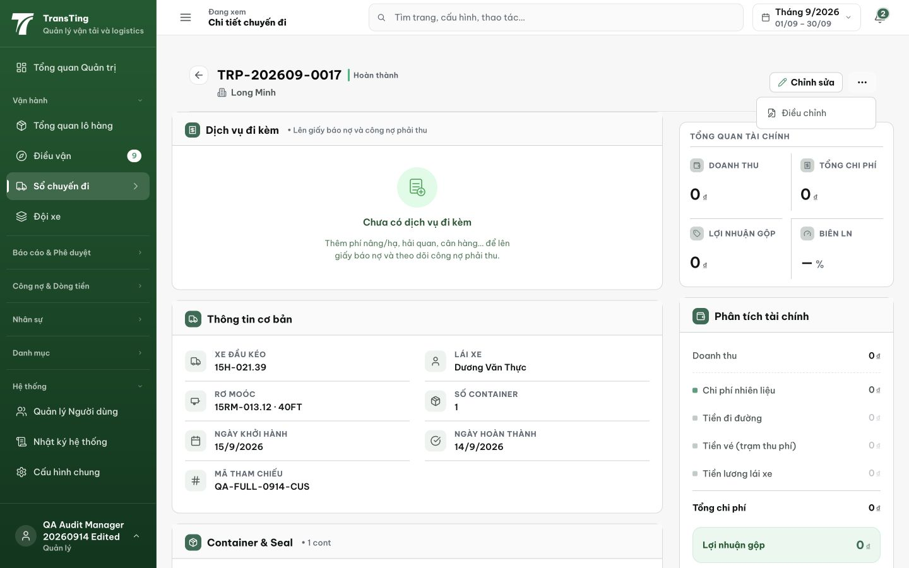
Figure 1. The completed TRP-202609-0017 detail shows Ngày hoàn thành 14/9/2026.

Evidence 2
  - Preserve the trip completion date when opening the editor
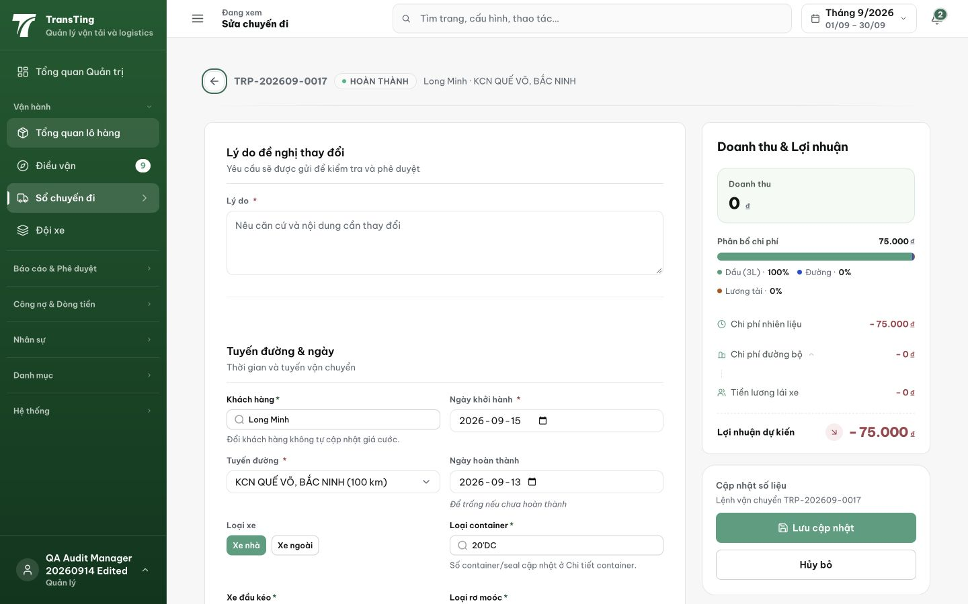
Figure 2. Opening /trips/19/edit for the same trip prefills Ngày hoàn thành as 2026-09-13. This was captured before any field interaction or save.
[2026-09-14] DEV COMPLETED — Cả 2 seed site dùng businessDateISO (ngày VN); unit pin '2026-09-13T17:30Z' → editor '2026-09-14' (QA-022-family lock). Commit 66f2239d.
[2026-09-14] QA PASSED — staging: GET /trips/19 stable completedAt across calls; useTripFormState.ts:201 seeds via businessDateISO; no UTC drift Evidence: testplan/qa/evidence/2026-09-14_QA-batch-staging-cut-9/api/20260914_P2_QA-065_bug-preserve-the-trip-completion-date-when-opening-the-editor.md
Trạng thái: QA PASSED — đã xác minh trên staging

