Keep optional generated journey legs from blocking trip corrections
  - QA-066 | P2 | Bug | TODO
Environment: Staging https://vantai.tingting.vip
Reviewed: 14 September 2026
Role: MANAGER · qa.audit.manager.0914 · desktop 1440 × 900
Page: /trips/19/edit · TRP-202609-0017

Existing behaviour
A completed trip has no detailed journey in its Ops detail. Chỉnh sửa generates two incomplete legs under Hành trình chi tiết, labelled Tùy chọn. After only entering a reason and revenue of 2,000,000 VND, Lưu cập nhật focuses leg 1’s blank Điểm đến with “Please fill in this field.” Leg 2 also lacks Điểm đi. Browser validation blocks this submission. Removing both generated legs allowed the revenue update to save and persist after reload.

Target behaviour
Preserve absent journey details during unrelated corrections. Untouched suggestions must not require invented endpoints. Validate a leg when the user intentionally adds or edits it.

Impact
Managers cannot submit an unrelated correction without first resolving journey fields they did not add.

Cause and investigation
Generated suggestions appear to become required form fields. Investigate initialization and validation; no API rejection is established.

Steps to reproduce
1. Open completed TRP-202609-0017 via Chỉnh sửa; leave its generated optional legs untouched.
2. Enter a correction reason and set Doanh thu đóng/ trả hàng to 2,000,000 VND; leave journey fields untouched.
3. Select Lưu cập nhật and observe native validation on the first blank destination.

Acceptance criteria
1. Save unrelated corrections on a trip without detailed legs without forcing users to remove generated rows.
2. Preserve existing legs; validate endpoints and nonnegative distance for intentionally added or edited legs.
3. Dismiss optional suggestions without changing unrelated values; explain genuine blocking requirements.
4. Retest absent, existing and new journeys at desktop, tablet and phone sizes; preserve applicable change controls.

Requirement reference
Observed edit workflow. Related QA-030 addresses creation and partial persistence, not this validation defect.

Evidence 1
  - Keep optional generated journey legs from blocking trip corrections
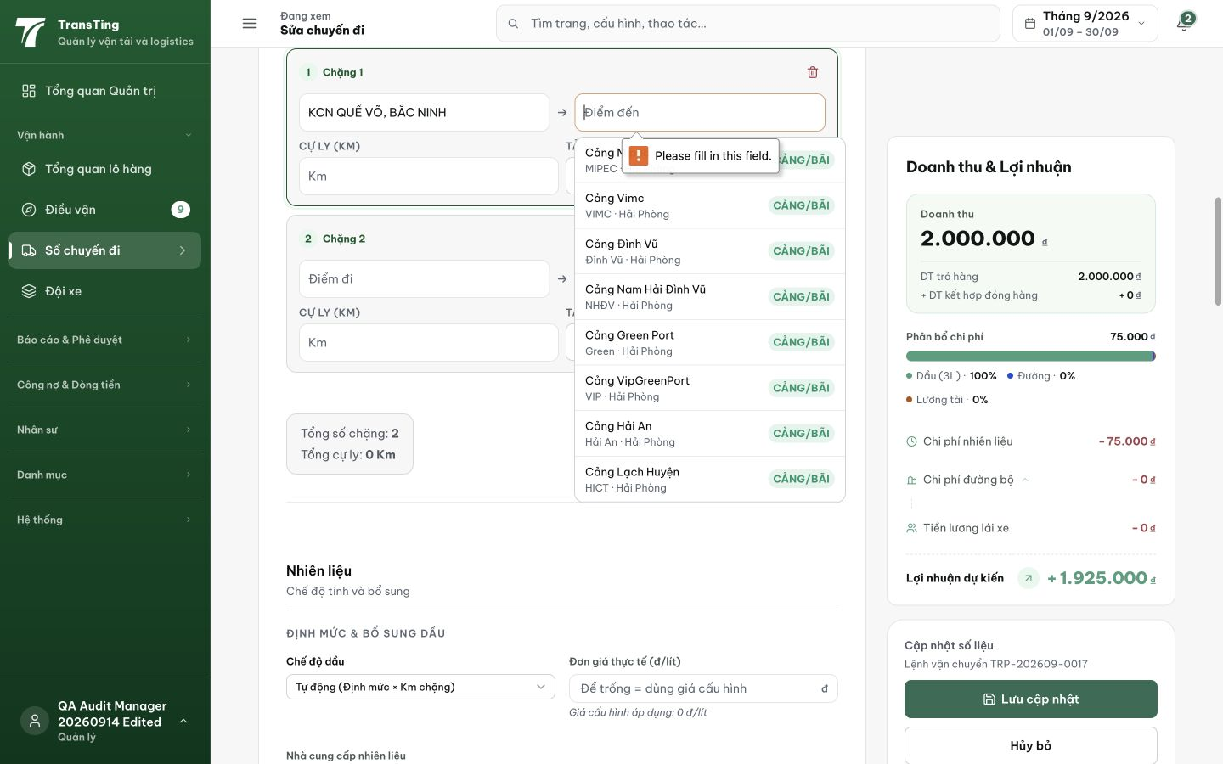
Figure 1. Saving an unrelated revenue correction focuses an empty generated destination and shows native required-field validation. The second generated leg also has an empty origin.
[2026-09-14] DEV COMPLETED — JourneyLegRow endpoints required chỉ khi leg có nội dung; submit drop untouched blank legs khỏi payload (leg có nội dung — kể cả km-only — vẫn submit). Suite 82/82. Commit 66f2239d.
[2026-09-14] QA PASSED — staging: PUT /trips/19/actuals with blank generated legs + revenue change → 200; revenue 2M→2.1M persisted; km 0→100; version bumped Evidence: testplan/qa/evidence/2026-09-14_QA-batch-staging-cut-9/api/20260914_P2_QA-066_bug-keep-optional-generated-journey-legs-from-blocking-trip-corrections.md
Trạng thái: QA PASSED — đã xác minh trên staging

