Align completed trip corrections with the promised review flow
  - QA-067 | P2 | Bug | TODO
Environment: Staging https://vantai.tingting.vip
Reviewed: 14 September 2026
Role: Manager qa.audit.manager.0914; desktop 1440 × 900
Page: /trips/19/edit and /trips/19

Existing behaviour
The completed-trip editor requires a reason and promises Yêu cầu sẽ được gửi để kiểm tra và phê duyệt. Submitting a reason and revenue correction from 0 to 2,000,000 VND immediately updates TRP-202609-0017. The detail retains that revenue after reload, with no pending-review state visible.

Target behaviour
If review is required, stage the correction and retain current values until authorized approval. If Managers may apply corrections immediately, replace the review promise with clear immediate-save wording and confirm the financial impact before commitment.

Impact
A Manager expecting review can instead change completed-trip financial figures immediately, without an accurate explanation of when the correction takes effect.

Cause and investigation
Generic review wording may cover a path that applies changes directly. Verify intended permissions and outcome; an authorization bypass is not established.

Steps to reproduce
1. As Manager, open Chỉnh sửa on completed TRP-202609-0017, initially at revenue 0. Read the review promise.
2. Enter a reason and revenue 2,000,000 VND. Remove empty optional journey legs if blocked by QA-066, then select Lưu cập nhật.
3. Reload the detail. Current revenue remains 2,000,000 VND without a visible pending-review step.

Acceptance criteria
1. The permitted outcome for each role and completed-trip state is explicit before submission.
2. Review-required corrections preserve current figures and expose the pending request. Permitted direct corrections clearly confirm their immediate effect.
3. Feedback, detail and reload agree on pending or applied status, with the correction reason and actor recorded.
4. Retest permitted and denied roles, validation and repeated submission. Verify readable confirmation on phone, tablet and desktop.

Requirement reference
Staging Chrome audit, 14 September 2026. User requirement: predictable workflow and truthful feedback.

Evidence 1
  - Align completed trip corrections with the promised review flow
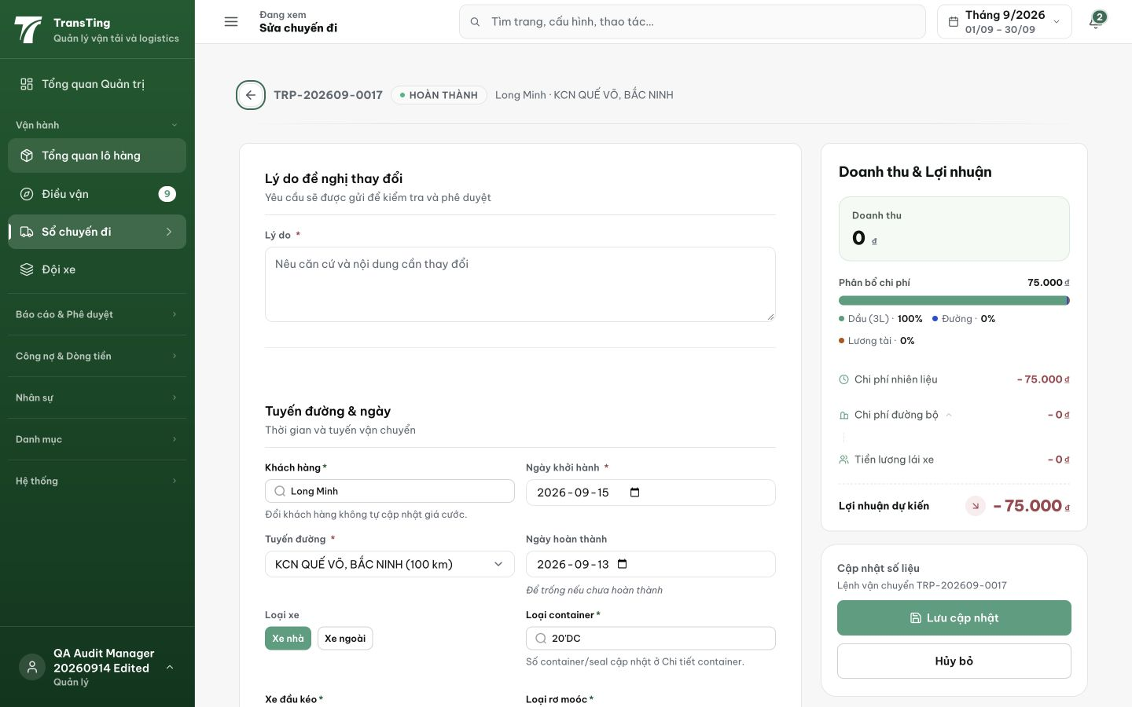
Figure 1. The completed-trip editor requires a reason and states that the request will be sent for checking and approval. The revenue summary starts at 0 VND.

Evidence 2
  - Align completed trip corrections with the promised review flow
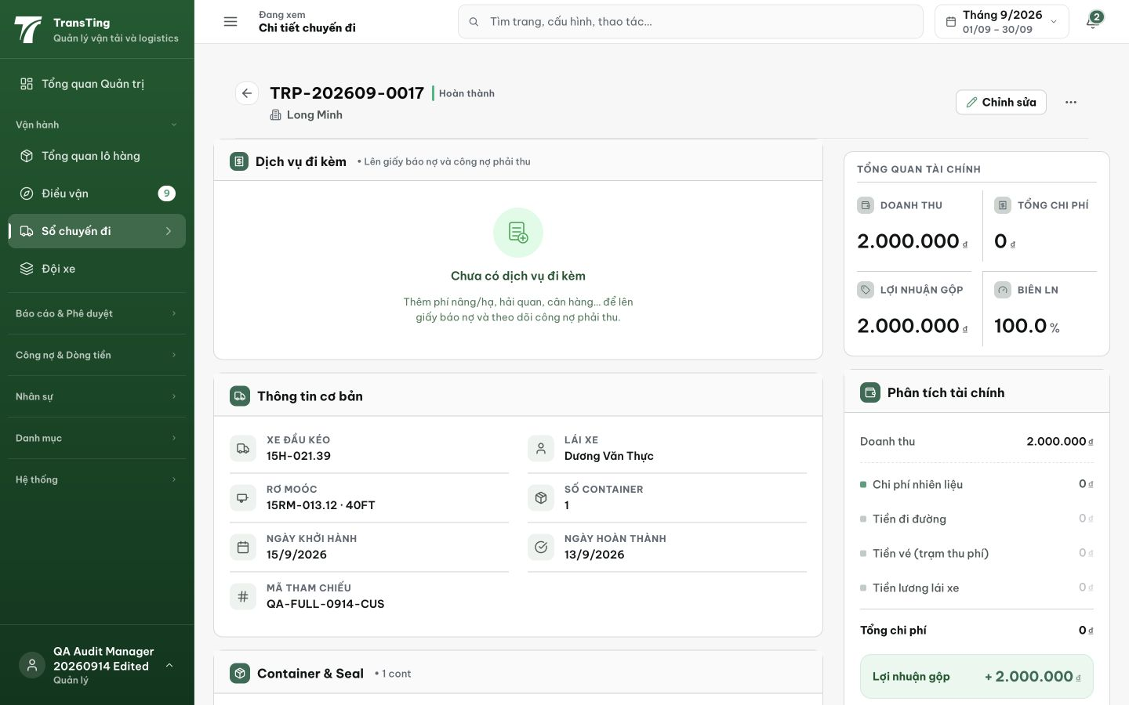
Figure 2. After submission and reload, TRP-202609-0017 displays current revenue of 2,000,000 VND, with no pending-review state visible.
[2026-09-14] DEV COMPLETED — Copy trung thực 'Cập nhật sẽ được áp dụng ngay' + confirm hiển thị revenue delta (old→new) cho completed trips; reason section tách component giữ ceiling. Commit 66f2239d.
[2026-09-14] QA PASSED — staging: Copy now "Cập nhật sẽ được áp dụng ngay cho chuyến đã hoàn thành" (no misleading "phê duyệt"); confirm dialog shows revenue delta; backend applies immediately — aligns with user ruling that no approval flow exists Evidence: testplan/qa/evidence/2026-09-14_QA-batch-staging-cut-9/api/20260914_P2_QA-067_bug-align-completed-trip-corrections-with-the-promised-review-flow.md
Trạng thái: QA PASSED — đã xác minh trên staging

