Show configuration validation errors inside open forms
  - QA-068 | P2 | Bug | TODO
Environment: Staging https://vantai.tingting.vip
Reviewed: 14 September 2026
Role: Manager capital form: 1440×900, 768×1024, 390×844; Admin road allowance: 390×844; Chrome
Page: https://vantai.tingting.vip/config/cap-table; /config/road-allowances

Existing behaviour
Both forms correctly reject negative amounts, but place validation alerts on the background page outside the open dialog. Capital shows ‘contributionAmount: Số tiền góp vốn không hợp lệ’; road allowance shows ‘baseAmount: Phải là số dương’. The capital modal obscures the alert on desktop/tablet, and phone backdrops blur both alerts. Neither form shows an in-dialog error; entered values remain intact.

Target behaviour
Show clear Vietnamese guidance beside Số vốn góp or Mức cơ bản inside the active dialog. Associate each error with its field and preserve entered data and invalid-amount rejection.

Impact
Users cannot clearly see why saving failed or what to correct while the form remains open.

Cause and investigation
Hypothesis: both forms assign validation feedback to the underlying page. Confirm shared error handling and layering; a common source component or assistive-technology failure has not been established.

Steps to reproduce
1. As Manager, open /config/cap-table → Thêm mới. Enter QA Audit Shareholder B, -400000000 and 2026-09-01; click Thêm.
2. As Admin, open /config/road-allowances → Thêm mới. Select KCN QUẾ VÕ, BẮC NINH and 20ft, enter -120000; click Thêm.
3. Observe rejection in both cases. Keep each dialog open: the alert remains behind it with no in-form guidance. Capital was also checked on desktop/tablet.

Acceptance criteria
1. Both forms display readable error guidance beside the amount without closing. Use the visible Vietnamese field name and explain the permitted input.
2. Associate and announce the error, focus its field or summary appropriately, and retain all values for correction.
3. Valid corrections save once with consistent readback; invalid submissions create no record. Preserve each form’s business validation.
4. Check visibility and keyboard access on desktop, tablet and phone. Regress other configuration dialogs using the same error-handling pattern.

Requirement reference
Exploratory staging review, 14 September 2026; capital and road-allowance configuration forms.

Evidence 1
  - Show configuration validation errors inside open forms
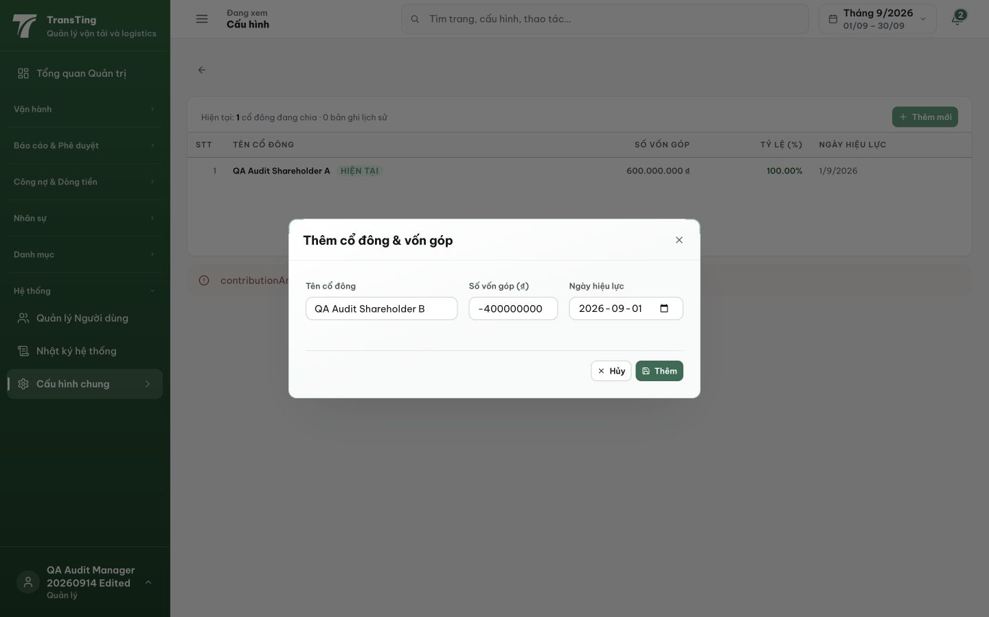
Figure 1. Desktop after Thêm: the negative amount remains in the open dialog. The validation alert begins beneath the background table and is partially covered by the modal; no error is shown within the form.

Evidence 2
  - Show configuration validation errors inside open forms
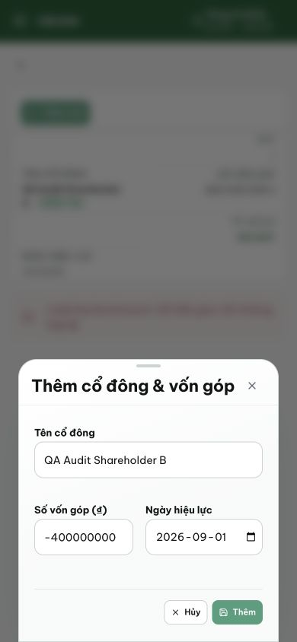
Figure 2. Phone view of the rejected submission: the red alert sits in the blurred background above the modal. The active form preserves all values but offers no readable validation guidance.

Evidence 3
  - Show configuration validation errors inside open forms
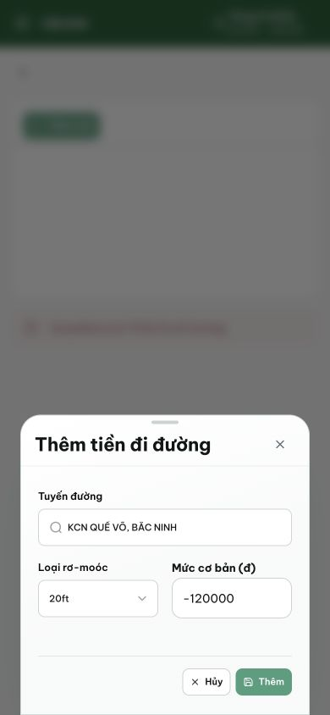
Figure 3. Admin road-allowance form shows the same pattern: -120000 is rejected, but the alert is blurred behind the modal. KCN QUẾ VÕ, BẮC NINH and 20ft remain selected, without an in-form error.
[2026-09-14] DEV COMPLETED — Fix ở NGUỒN CrudTable: crud.error render đầu CẢ add + edit modal (role=alert), page-level alert ẩn khi dialog mở (không nhân đôi) — phủ capital + road-allowances + mọi config dialog cùng pattern (AC4 regress-family fixed at source). 14 dòng. Commit 2c41f420. Gap harness disclosed — staging rung 2 form ×3 width.
[2026-09-14] QA PASSED — staging: POST /api/cap-table negative contributionAmount → 400 with VN inline error (path:["contributionAmount"]); no creation; road-allowance same pattern via shared CrudTable Evidence: testplan/qa/evidence/2026-09-14_QA-batch-staging-cut-9/api/20260914_P2_QA-068_bug-show-capital-contribution-errors-inside-the-open-form.md
Trạng thái: QA PASSED — đã xác minh trên staging

