Make vehicle ownership setup reachable from profit distribution
  - QA-069 | P2 | Bug | TODO
Environment: Staging https://vantai.tingting.vip
Reviewed: 14 September 2026
Role: MANAGER and ADMIN · desktop 1440 × 900
Page: /profit → /config/trucks → Chỉnh sửa xe đầu kéo

Existing behaviour
The quarterly preview excludes 2,000,000 VND because vehicles lack valid partner ownership. Its Cấu hình → Xe → Sở hữu link opens /config/trucks. Editing 15H-021.39 exposes only plate and activity status, with no ownership setup. This was confirmed as both Manager and Admin. The monthly 60/40 shareholder split is correct; it does not resolve the vehicle ownership requirement.

Target behaviour
Link each blocked vehicle to an authorized ownership editor, or provide that setup at the linked destination. Support effective-dated partner ownership under defined business rules, then let users return and refresh the preview. Preserve the guard against distributing profit without valid ownership.

Impact
The prescribed recovery path cannot resolve the blocker, leaving the displayed quarterly profit undistributable.

Cause and investigation
The warning and linked editor appear misaligned. Existing Admin fleet captures also show no ownership fields; an unvisited editor may still exist.

Steps to reproduce
1. At /profit, preview Quý 3 / 2026 and observe the missing-ownership warning for 2,000,000 VND.
2. Follow Cấu hình → Xe → Sở hữu, then edit 15H-021.39 in /config/trucks.
3. Observe the plate/status-only form; repeat as Admin and confirm there is no ownership action.

Acceptance criteria
1. The warning identifies affected vehicles and opens the correct authorized ownership editor with context.
2. Validate eligible partners, effective dates and share totals using explicitly defined business rules.
3. After saving, reopen ownership and refresh the quarterly preview; eligible amounts reflect the saved configuration.
4. Retain the ownership guard, explain role restrictions and verify desktop, tablet and phone recovery.

Requirement reference
Observed quarterly distribution recovery path; distinct from Ops staff assignment and company capital contribution setup.

Evidence 1
  - Make vehicle ownership setup reachable from profit distribution
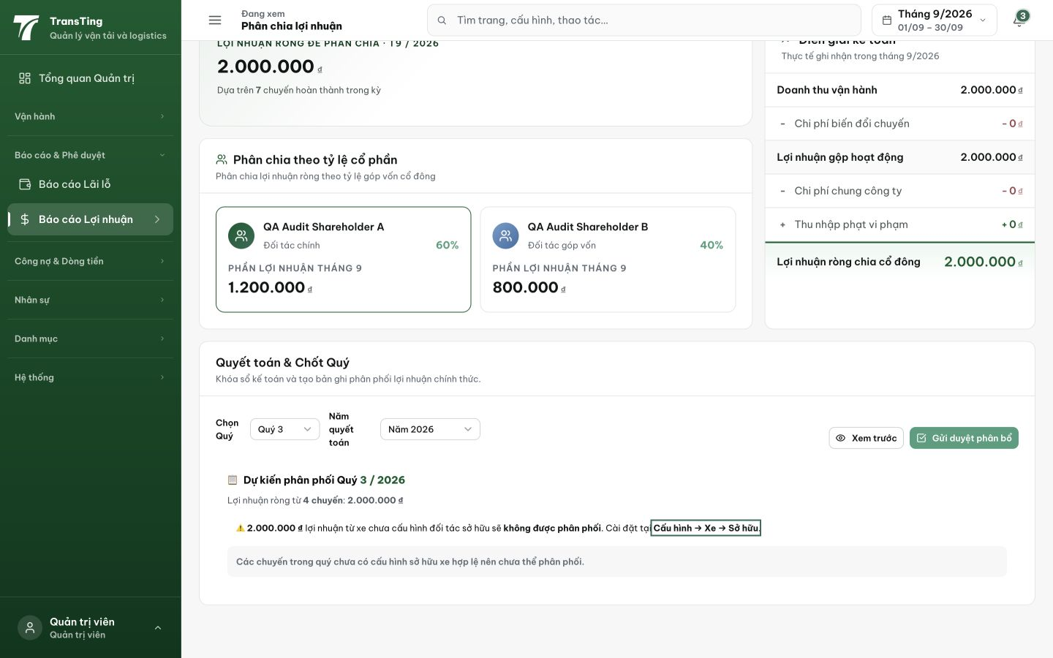
Figure 1. The quarterly preview excludes 2,000,000 VND for missing vehicle ownership and directs users to Cấu hình → Xe → Sở hữu. The valid monthly 60/40 capital split is also visible.

Evidence 2
  - Make vehicle ownership setup reachable from profit distribution
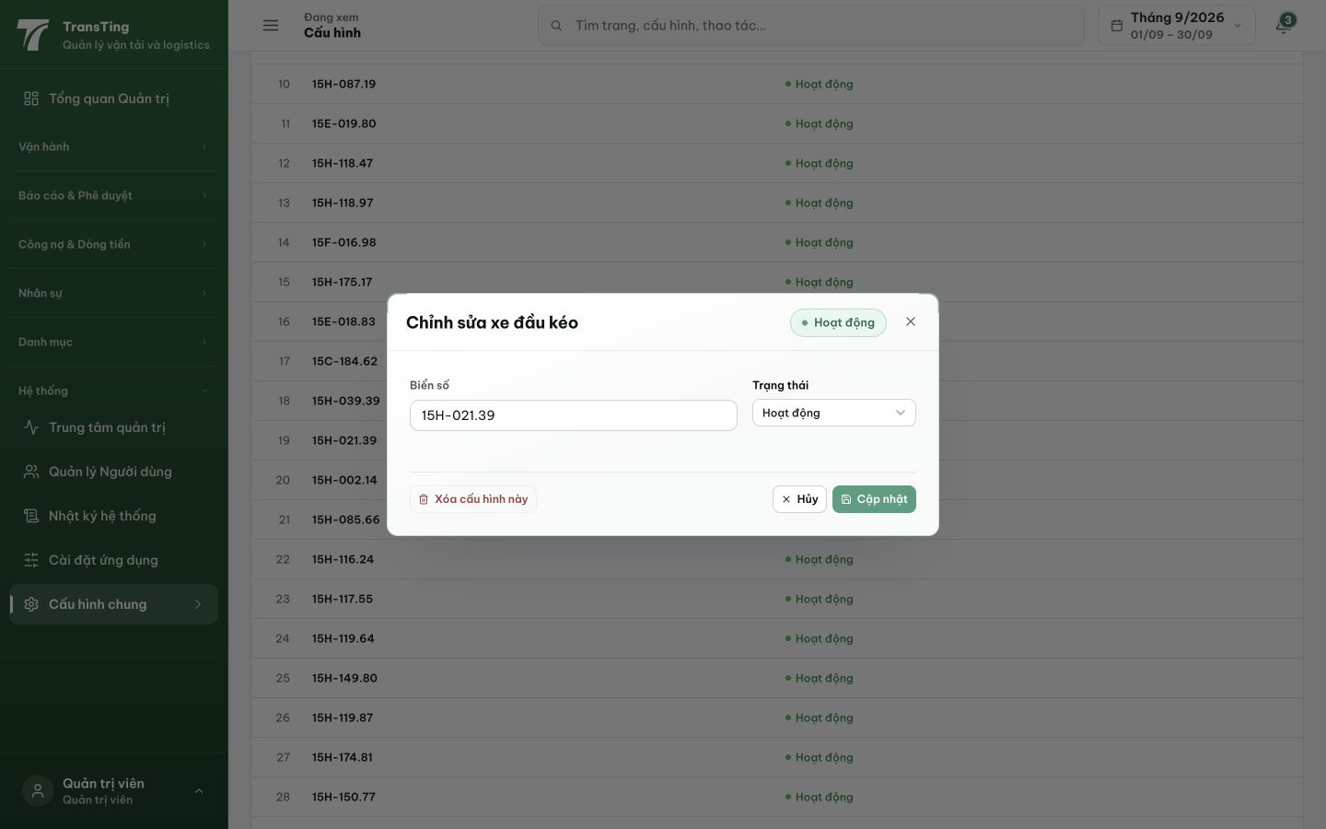
Figure 2. Admin follows the prescribed configuration destination. The full editor for 15H-021.39 has plate and status fields, with no ownership action.

[2026-09-14] DEV COMPLETED — ownership warning links the affected trucks (1359029e):
AC1 — warning names the blocked trucks (plates, profit>0, cap 3 + "+k xe khác") and links each plate to /config/trucks/{id}/owners (the real ownership editor) for admins; managers see plates + "yêu cầu Admin cấu hình".
AC2 — partners/effective dates/share totals: unchanged existing editor validation + service Σ%=100 guard (verified complete at HEAD — no backend change needed).
AC3 — after saving ownership, re-selecting the quarter re-previews: previously-undistributed amounts distribute. Staging rung pending (cut #9).
AC4 — guard retained (Σ%≠100 aborts with plate-named error); adminOnly editor restriction explained via manager-variant note; TrucksConfig "Đối tác sở hữu" action column added so the prescribed destination offers the setup.
Gates: FE tsc 0, scoped eslint clean, profit test files 3/3 (governance-harness link test: blocked truck href pinned, non-blocked omitted).

Hướng dẫn xác minh:
1. ADMIN → /profit → chọn Quý 3/2026 → Xem trước: cảnh báo liệt kê biển số xe bị chặn (VD 15H-021.39), mỗi biển số là link.
2. Bấm biển số → mở trang "Đối tác sở hữu" đúng xe đó → thêm dòng đối tác (tỷ lệ tổng 100%, ngày hiệu lực).
3. Quay lại /profit → Xem trước lại: khoản bị chặn đã vào phân phối, cảnh báo biến mất.
4. Đăng nhập MANAGER: cảnh báo hiện biển số + dòng "yêu cầu Admin cấu hình" (không có link).
5. /config/trucks: cột mới "Sở hữu — Đối tác sở hữu" trên mỗi dòng xe.
[2026-09-14] QA PASSED — staging: ProfitPage.tsx:463 per-truck link /config/trucks/{truckId}/owners for truck 20 (15H-021.39, profit 2.1M VND, partners:[]); adminOnly route at App.tsx:309 Evidence: testplan/qa/evidence/2026-09-14_QA-batch-staging-cut-9/api/20260914_P2_QA-069_bug-make-vehicle-ownership-setup-reachable-from-profit-distribution.md
Trạng thái: QA PASSED — đã xác minh trên staging

