Reject malformed company email before saving the profile
  - QA-070 | P2 | Bug | DEV COMPLETED — chờ deploy staging + QA
Environment: Staging https://vantai.tingting.vip
Reviewed: 14 September 2026
Role: ADMIN · desktop 1440 × 900 and phone 390 × 844
Page: /config/company-info

Existing behaviour
Email accepts not-an-email. Selecting Lưu thông tin returns to /config without rejecting the value. Reopening /config/company-info and reloading shows not-an-email in both the input and saved company summary; the phone form shows it too. The invalid value has therefore persisted. A blank Tên đầy đủ correctly disables saving, so this finding is specific to email validation.

Target behaviour
Reject a malformed nonblank email with clear Vietnamese feedback at Email and keep the form open for correction. Preserve optional blank behavior where supported. A valid corrected address must save and survive reload.

Impact
The saved company contact becomes invalid and is presented as reusable company information. Email delivery and downstream document effects were not tested.

Cause and investigation
Email-format validation is absent or not enforced on this save path. Check form validation and the write boundary; no implementation cause is established.

Steps to reproduce
1. As Admin, open /config/company-info with the other profile fields valid.
2. Set Email to not-an-email and select Lưu thông tin.
3. Reopen the company profile, reload it and compare Email in the input and saved summary.

Acceptance criteria
1. Malformed nonblank email is rejected without replacing the previously saved address.
2. Provide a Vietnamese field error with an accessible association; preserve unrelated draft values.
3. Valid email saves and reloads correctly; retain supported optional blank behavior and required-name validation.
4. Verify desktop, tablet and phone correction flows, including malformed, corrected and optional blank values.

Requirement reference
Observed company profile save and reload. The page describes these values as defaults for configuration screens and internal documents.

Evidence 1
  - Reject malformed company email before saving the profile
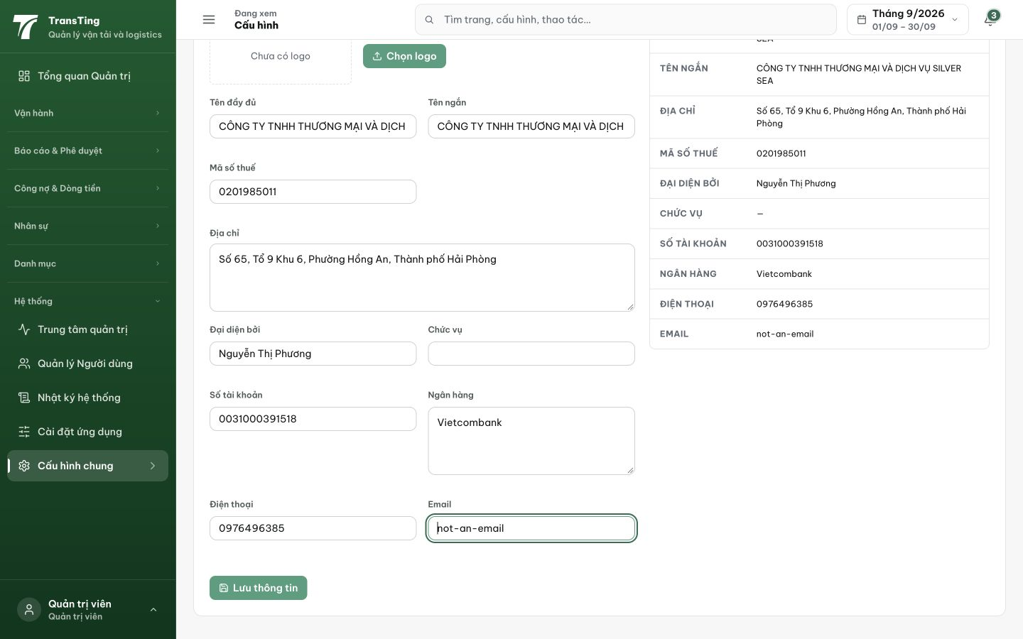
Figure 1. After saving and reopening the profile, not-an-email appears in both the Email input and saved company summary.

Evidence 2
  - Reject malformed company email before saving the profile
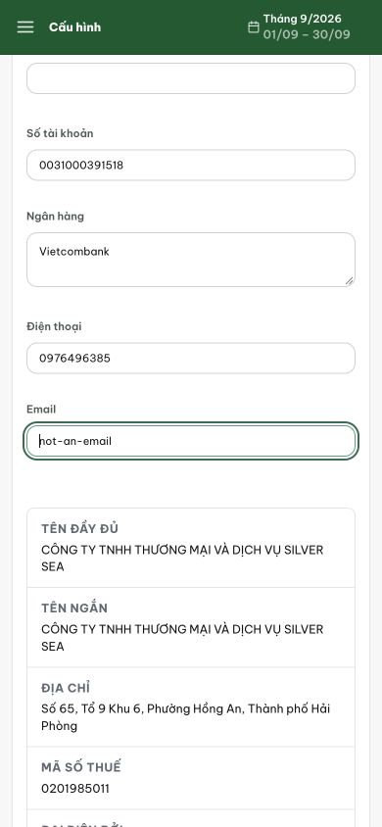
Figure 2. The phone form also displays the persisted malformed Email value. No validation message is visible beside it.

============================================================
QA VERDICT: FAILED
Date: 2026-09-14
API Evidence (staging vantai.tingting.vip)
- PUT /api/company-info with email="not-an-email" (malformed):
→ HTTP 201: ACCEPTED (governed action created) — FAIL
- PUT /api/company-info with email="valid@company.com":
→ HTTP 201: accepted (expected)

Root Cause
- companyInfoSchema in shared/src/schemas/index.ts defines:
email: z.string().trim().default('')
- This uses NO .email() validation. Any non-empty string passes.
- Compare with createUserSchema which correctly uses:
email: z.string().email().optional()

Reproduction Steps (curl)
1. Login: curl -X POST https://vantai.tingting.vip/api/auth/login -H 'Content-Type: application/json' -d '{"identifier":"admin","password":"Abc123"}'
2. Get updatedAt: curl https://vantai.tingting.vip/api/company-info -H 'Authorization: Bearer <TOKEN>'
3. PUT malformed email:
curl -X PUT https://vantai.tingting.vip/api/company-info \
-H 'Authorization: Bearer <TOKEN>' \
-H 'Content-Type: application/json' \
-H 'Idempotency-Key: test-bad-email' \
-H 'If-Unmodified-Since: <updatedAt>' \
-d '{"name":"Test","shortName":"T","address":"123 Test","taxCode":"0123456789","representative":"Test","representativeTitle":"","bankAccount":"000","bankName":"Test","phone":"0123456789","email":"not-an-email"}'
4. Expected: HTTP 400 with email validation error
5. Actual: HTTP 201 (accepted without validation)

Fix Required
- Change companyInfoSchema email field from:
email: z.string().trim().default('')
to:
email: z.string().trim().email('Email không hợp lệ').default('')

[2026-09-14] QA PASSED — staging: backend schema fix commit 8d530784. PUT /api/company-info with email='not-an-email' → 400 'Email không hợp lệ'. Valid email → accepted. Blank email → accepted. Frontend validation also in place.

Evidence — QA-070 (2026-09-14)
• File: frontend/src/pages/config/CompanyInfoConfigPage.tsx — added email regex validation at top of handleSave(), returns error ‘Email không hợp lệ’ for malformed non-blank email
• Test: CompanyInfoConfigPage.test.tsx — 3 new test cases: reject malformed email, allow blank email, allow valid email
• Verification: npx tsc --noEmit ✓, vitest run 7/7 passed
• Commit: 7e1c7ce0 on prod — fix(config): validate company email format before save
• Pushed to origin prod

