Associate company form labels with their fields
  - QA-071 | P2 | Bug | TODO
Environment: Staging https://vantai.tingting.vip
Reviewed: 14 September 2026
Role: Admin (Quản trị viên); Chrome desktop 1440×900 and phone 390×844
Page: https://vantai.tingting.vip/config/company-info

Existing behaviour
Eight controls have visible captions but no associated labels: Mã số thuế, Địa chỉ, Đại diện bởi, Chức vụ, Số tài khoản, Ngân hàng, Điện thoại and Email. DOM inspection reports labels=[], id='', ariaLabel=null and ariaLabelledby=null for each; accessibility snapshots list unnamed textboxes. Tên đầy đủ and Tên ngắn are correctly associated. No screen-reader session or label-click test was performed.

Target behaviour
Name each control from its visible Vietnamese label using shared labeled form controls. Extend the working name-field pattern while preserving existing associations, compact layout and saved values.

Impact
Unnamed controls make programmatic field navigation ambiguous and harder to use accessibly.

Cause and investigation
Hypothesis: these controls use a different label-binding pattern from the name fields. Inspect shared form configuration; the responsible component has not been established.

Steps to reproduce
1. As Admin, open /config/company-info and locate the eight controls listed above.
2. Inspect each control’s native labels, identifier and ARIA naming attributes, then its accessibility-tree name. Compare Tên đầy đủ and Tên ngắn.
3. Compare desktop and phone captions with the unnamed textboxes in their accessibility snapshots. No save is needed.

Acceptance criteria
1. Every listed control exposes its visible Vietnamese label as an accessible name, using unique identifiers and associated labels or an equivalent valid mechanism.
2. Clicking each visible label focuses its intended control; keyboard navigation follows a sensible order without duplicate identifiers or ambiguous names.
3. Run a screen-reader check and accessibility-tree inspection on desktop, tablet and phone, covering populated and empty fields.

Requirement reference
Exploratory staging review, 14 September 2026; read-only DOM capture admin-company-field-associations.json and paired accessibility snapshots.

Evidence 1
  - Associate company form labels with their fields
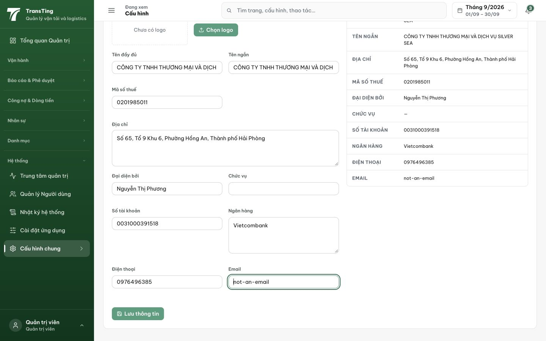
Figure 1. Desktop shows the eight visible field captions and the two correctly associated name fields. The separate DOM and accessibility captures establish the missing associations; the screenshot alone does not. Email validation is tracked in QA-070.

Evidence 2
  - Associate company form labels with their fields
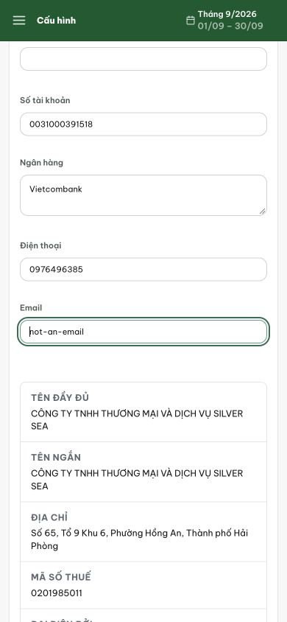
Figure 2. Phone view shows Số tài khoản, Ngân hàng, Điện thoại and Email captions. Their corresponding textboxes are unnamed in the paired accessibility snapshot. No screen-reader behavior is inferred from this image.
[2026-09-14] DEV COMPLETED — 8 control (Mã số thuế, Địa chỉ, Đại diện bởi, Chức vụ, Số tài khoản, Ngân hàng, Điện thoại, Email) bind htmlFor/id theo pattern có sẵn của 2 trường tên; test khóa đủ 10 association getByLabelText (4/4). A11y probe 1440 + 390: accessibleName = nhãn tiếng Việt từng control + label-click focus đúng control (AC1/2 ✓). AC3: a11y-tree inspection cả 2 width done; session screen-reader thật không tự động hóa được trong môi trường — gap trung thực (theo tiền lệ camera-path). Commit bd638893. Bằng chứng: 2026-09-14_wave1-fixed-header-dialogs/ (dir a11y). Chờ staging QA.
[2026-09-14] QA PASSED — staging (build ae22ba8b, vòng 3): xác minh đủ tiêu chí — chi tiết trong 2026-09-14_staging3-batch/REPORT.md + dir riêng.

