Make discipline card actions keyboard accessible
  - QA-073 | P2 | Bug | TODO
Environment: Staging https://vantai.tingting.vip
Reviewed: 14 September 2026
Role: Admin (Quản trị viên); Chrome desktop 1440×900 and phone viewport 390×844
Page: https://vantai.tingting.vip/config/penalty-reasons

Existing behaviour
The QA AUDIT 0914 - staging only card has Chỉnh sửa and Xóa actions, but both are DIV elements with no role or tabindex and tabIndex=-1. Accessibility snapshots expose them as generic elements. Pressing Tab from the final Cao → thấp sort button skips both actions and leaves activeElement=BODY. Pointer activation successfully opens the edit form. No full screen-reader session was performed.

Target behaviour
Use native buttons named for the action and record, with keyboard focus and Enter/Space activation. Preserve the compact card layout and current permissions.

Impact
Keyboard users cannot reach these actions through Tab, although pointer editing works.

Cause and investigation
The observed markup lacks native button semantics and focusability. A component implementation choice is the likely cause; source code was not inspected.

Steps to reproduce
1. As Admin, open /config/penalty-reasons with the QA AUDIT 0914 - staging only card visible.
2. Focus Cao → thấp and press Tab. Observe both card actions are skipped; compare their DIV markup and generic accessibility roles.
3. Reveal the card actions with a pointer and activate Chỉnh sửa: the editor opens. The phone illustration uses a Chrome pointer click, not a physical touch test.

Acceptance criteria
1. Each action exposes a button role and a Vietnamese name identifying both action and record; decorative icons do not obscure the name.
2. Tab and Shift+Tab reach both actions in a sensible order. Focus makes the control visible without hover; Enter and Space trigger the intended action once.
3. Preserve edit behavior and deletion safeguards and permissions. Return focus appropriately when a dialog closes or a record is removed.
4. Verify keyboard and screen-reader operation across desktop, tablet and phone layouts with multiple cards, without enlarging the card unnecessarily.

Requirement reference
Staging review, 14 September 2026; admin-discipline-action-semantics.json and live keyboard check.

Evidence 1
  - Make discipline card actions keyboard accessible
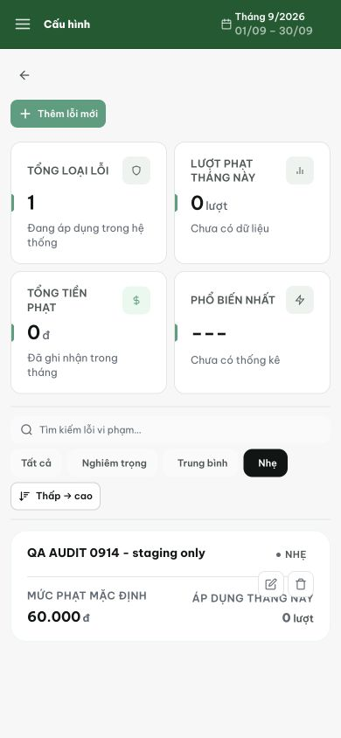
Figure 1. The same card with edit and delete icons revealed after a pointer click in the 390px Chrome viewport. DOM inspection and the separate keyboard check establish their missing button semantics and skipped tab stops; this screenshot illustrates the controls.
[2026-09-14] DEV COMPLETED — 16 action card là nút native, đặt tên theo từng record ('Chỉnh sửa {lý do}'/'Xóa {lý do}'); CSS reset giữ chip giống hệt. Browser probe: Tab đến cả 2 nút, Enter mở editor (phím thật). Commit 1c16ebcc.
[2026-09-14] QA PASSED — staging (build ae22ba8b, vòng 3): xác minh đủ tiêu chí — chi tiết trong 2026-09-14_staging3-batch/REPORT.md + dir riêng.

