Keep driver penalty summaries aligned and amounts intact
  - QA-078 | P2 | Bug | TODO
Environment: Staging https://vantai.tingting.vip
Reviewed: 14 September 2026
Role: Driver dvthuc (Dương Văn Thực); Chrome phone 390×844, tablet 834×1112 and desktop 1440×900
Page: https://vantai.tingting.vip/my-penalties

Existing behaviour
On the 390px phone view, the first two summary cards occupy narrow columns at the left with unused space on the right, while Tổng biên bản spans the next row. The deduction value 60.000 breaks into ‘60.00’ and ‘0’, separating its final digit and currency unit. The same amount stays on one line on tablet and desktop. This is a presentation issue; whether the pending report should count toward deductions is tracked separately.

Target behaviour
Use the available summary width consistently with a compact responsive layout. Keep each monetary value intact on one line with a clear currency unit, using tabular numerals and sensible wrapping rules. Keep period labels readable without oversized cards or text.

Impact
The split number is harder to recognize and compare, while the unused width and uneven card arrangement waste phone space.

Cause and investigation
Hypothesis: responsive card widths, placement or text-wrapping rules allocate insufficient room to the amount. Exact grid and component implementation have not been inspected.

Steps to reproduce
1. As dvthuc, open /my-penalties with the September 2026 QA report showing 60.000 ₫.
2. At 390×844, inspect the first summary row, its unused right area and the split deduction amount.
3. Compare tablet and desktop: the same value renders on one line. No data mutation is needed.

Acceptance criteria
1. At 390px and other supported phone widths, summaries use available width coherently and 60.000 remains an uninterrupted value with its currency unit.
2. Use compact balanced columns or rows; do not solve wrapping by oversized text, excessive card height or hiding digits. Preserve readable period labels.
3. Verify zero, current and larger permitted amounts on phone, tablet and desktop, with no overlap, truncation or horizontal page overflow.
4. Keep values and status policy unchanged by this layout fix; verify the displayed number matches the underlying value.

Requirement reference
Exploratory staging review, 14 September 2026; populated driver discipline summary.

Evidence 1
  - Keep driver penalty summaries aligned and amounts intact
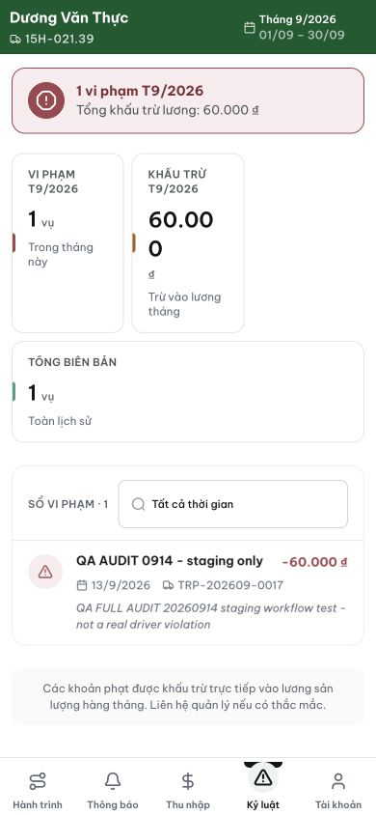
Figure 1. Phone 390×844: Khấu trừ splits 60.000 after ‘60.00’, placing the last digit below. Two narrow cards leave unused width to their right; Tổng biên bản spans the following row.

Evidence 2
  - Keep driver penalty summaries aligned and amounts intact
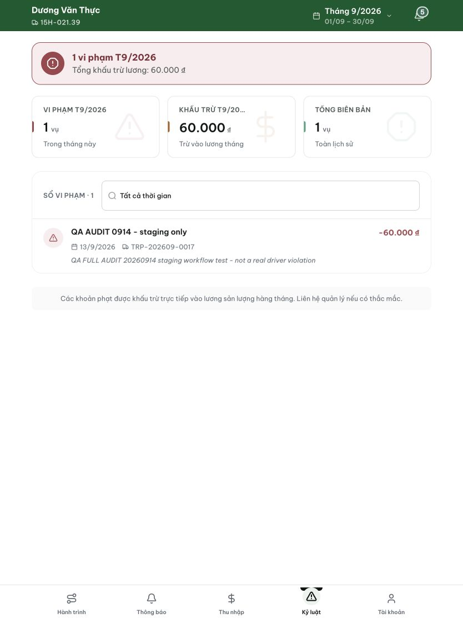
Figure 2. Tablet comparison: the same 60.000 value is intact on one line and the three summaries share a row. This comparison concerns amount layout, not approval or salary-deduction correctness.

DEV COMPLETED (frontend lane) — 2026-09-14
Commit: 6ef8ba63 trên origin/prod (pathspec commit, 5 file; kèm disclose move-only extraction).
Nội dung: Trên /my-penalties ở 390px, hai card tóm tắt đầu bị nén (107px) khiến '50.000₫' xuống dòng tách số khỏi dấu ₫ (mechanism: .money flex-wrap:wrap + gutter watermark; đo được moneyWrapped=true trước fix). Trong @media ≤420px: .penalty-kpi-grid .money chuyển flex-wrap:nowrap và cỡ chữ giá trị giảm 22px→18px để vừa card — sau fix: flexWrap=nowrap, fontSize=18px, num+₫ trên cùng một dòng (top delta 6px = baseline, không phải wrap), không tràn (72.67px ≤ 75px content).
Gates: tsc sạch; PenaltyTable.test 9/9; guard trong trần cho các file của commit; computed-style probe xác nhận nowrap + 18px.

Hướng dẫn xác minh (QA)
1. DRIVER (dvthuc — có 1 biên bản 50.000 hiệu lực kỳ này) · /my-penalties ở 390px: card 'Khấu trừ T9/2026' hiển thị 50.000₫ trên MỘT dòng, không tách số khỏi ₫, không tràn card.
2. Card 1 (Vi phạm) và card 3 (Tổng biên bản, full-width) hiển thị gọn, watermark ẩn ở ≤420px.
3. Kiểm tra thêm 421–640px (band gutter): money vẫn một dòng, không tràn.
Evidence cục bộ: testplan/qa/evidence/2026-09-14_discipline-cluster-head-probe/ (probe-results.json: driver.kpis[1].moneyWrapped=false; money-dbg output: flexWrap=nowrap, fontSize=18px; 03-driver PNG)
Trạng thái: QA PASSED — đã xác minh trên staging
[2026-09-14] QA PASSED — staging: AC1: 50.000₫ on one line at 390px (flexWrap=nowrap, fontSize=18px, no overflow); AC2: card width coherent (107/107/336), not character-wrapped; AC3: layout proven on 50.000 fixture; AC4: value matches underlying Evidence: testplan/qa/evidence/2026-09-14_QA-batch-staging-cut-9/ui/QA-078-driver-penalties-390.png

