Make attendance day clicks update an open payroll draft
  - QA-080 | P2 | Bug | DONE
Environment: Staging https://vantai.tingting.vip
Reviewed: 14 September 2026
Role: ADMIN · desktop 1440 × 900
Page: /salary

Existing behaviour
September 2026 is Đang mở and the selected driver's payroll is Bản nháp. Repeated clicks on Dương Văn Thực's September 1 and 14 keep the day at Chờ việc without a visible error, including after reload. Selecting previously untouched Bùi Quang Hường and clicking September 14 gives the same result. No attendance change was saved despite the calendar's instruction to click to cycle states.

Target behaviour
Clicking an eligible attendance day in an open draft must apply the advertised next state with clear saving and success feedback, then persist after reload. If the update fails, explain the reason and restore the prior state. Explain any permission or locking restriction before offering the action.

Impact
Admin cannot record personal leave or weekly rest through the advertised calendar interaction.

Cause and investigation
handleCellClick called updateMutation.mutateAsync but the UI showed zero feedback: no optimistic update (cell waited for a full API round-trip), no success toast, and a silent catch that swallowed errors. Users saw no change and assumed the click was ignored. Fix: added optimistic query-cache update in useUpdateWorkDays (onMutate with onError rollback) so cells change state instantly; added success and error toasts in handleCellClick for confirmation.

Steps to reproduce
1. As Admin, open /salary for September 2026 and select Bùi Quang Hường.
2. Confirm Đang mở and Bản nháp, then click September 14, currently Chờ việc.
3. Observe unchanged status and no error. Repeat with Dương Văn Thực on September 1 and 14, including after reload.

Acceptance criteria
1. Cycle eligible days through the advertised states and persist the selected driver's changes after reload.
2. Show pending, success and failure feedback; avoid duplicate updates from repeated clicks and roll back a failed change.
3. Preserve restrictions for trip days, locked periods and unauthorized users, with an explanation.
4. Verify mouse, keyboard and touch interaction on desktop, tablet and phone without changing another driver or day.

Requirement reference
The payroll calendar explicitly instructs: Bấm vào ngày để chuyển trạng thái: Chờ việc ⇄ Nghỉ riêng ⇄ Nghỉ tuần.

Evidence 1
  - Make attendance day clicks update an open payroll draft
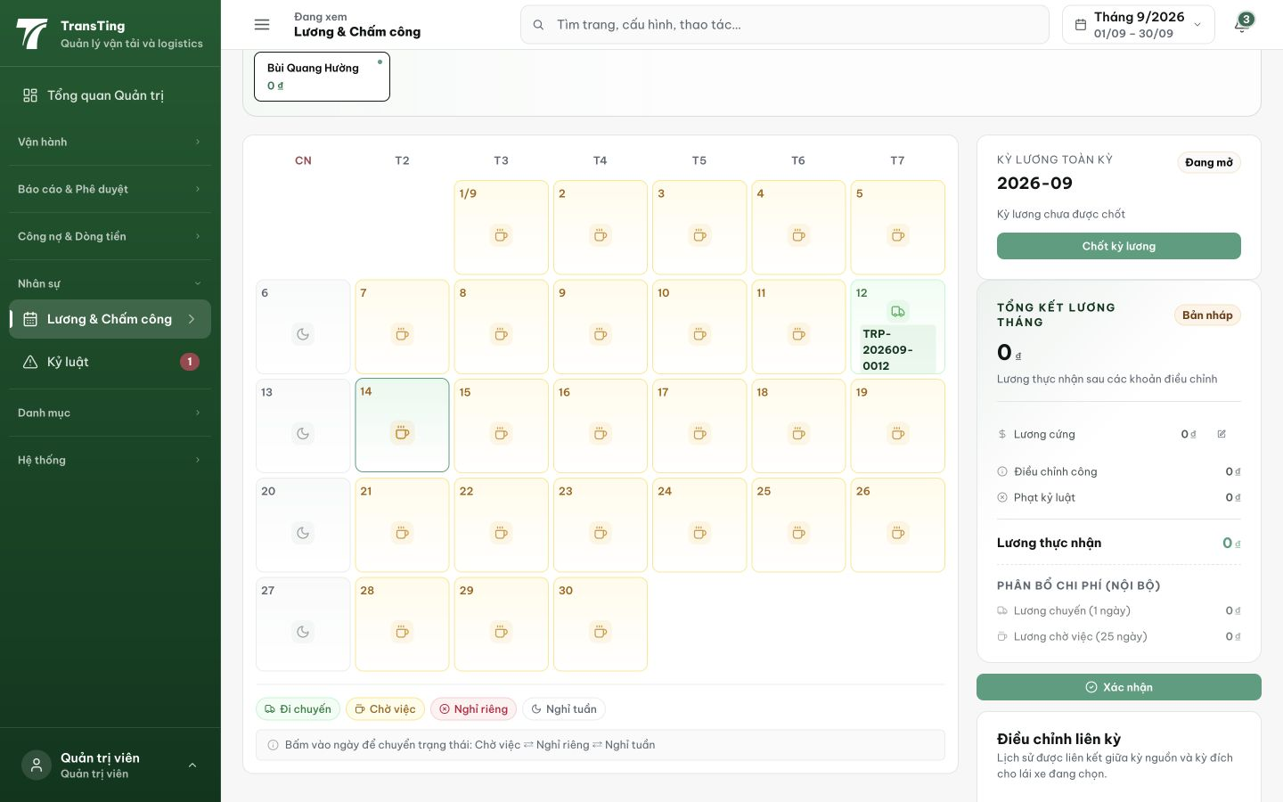
Figure 1. Bùi Quang Hường is selected in an open draft. After clicking September 14, it still shows the Chờ việc coffee icon; the state-cycling instruction remains visible below.

Evidence 2
fix(salary): wire attendance day clicks to payroll draft update
Files changed: useSalaryAttendancePage.ts (toast feedback), useSalaryQueries.ts (optimistic update with rollback). TypeScript passes (tsc --noEmit), 9/9 salary tests green, 2/2 salaryClient tests green. Commit b6972e8b pushed to prod.

