Make payroll attendance days keyboard accessible
  - QA-081 | P2 | Bug | TODO
Environment: Staging https://vantai.tingting.vip
Reviewed: 14 September 2026
Role: Admin (Quản trị viên); Chrome desktop 1440×900
Page: https://vantai.tingting.vip/salary

Existing behaviour
The September calendar advertises day-state changes, but Tab from the filtered Bùi Quang Hường button goes directly to Chốt kỳ lương, skipping the calendar. All 29 inspected non-trip cells are DIVs without role or tabindex (tabIndex=-1); titles contain only attendance state. Accessibility snapshots expose generic entries. No screen-reader session was run; pointer behavior is separate QA-080.

Target behaviour
Make the compact calendar keyboard operable. Expose each full date, attendance state and editability while retaining payroll safeguards.

Impact
Keyboard users cannot reach the advertised attendance actions through the calendar.

Cause and investigation
Observed markup lacks interactive semantics and focusability. Calendar implementation is the likely cause; source code was not inspected.

Steps to reproduce
1. As Admin, open /salary for September 2026 and filter/select Bùi Quang Hường; the period is Đang mở.
2. Focus the filtered driver button and press Tab. Focus moves to Chốt kỳ lương without entering the attendance calendar.
3. Inspect non-trip cells and the accessibility snapshot: generic DIV entries lack focusability despite the day-change helper.

Acceptance criteria
1. Use native buttons or a complete keyboard calendar pattern. Accessible names include full date and state; decorative icons do not replace these names.
2. Tab enters/exits logically; documented arrows may navigate days. Show visible focus and support appropriate Enter/Space activation exactly once.
3. Explain locked/read-only days; preserve permissions and payroll locks. Only offer state changes permitted by current business rules.
4. Verify keyboard and screen-reader operation on desktop, tablet and phone, including open/closed periods. Keep the calendar compact; pointer persistence is QA-080.

Requirement reference
Staging review, 14 September 2026; admin-payroll-calendar-semantics.json and live Tab check.

Evidence 1
  - Make payroll attendance days keyboard accessible
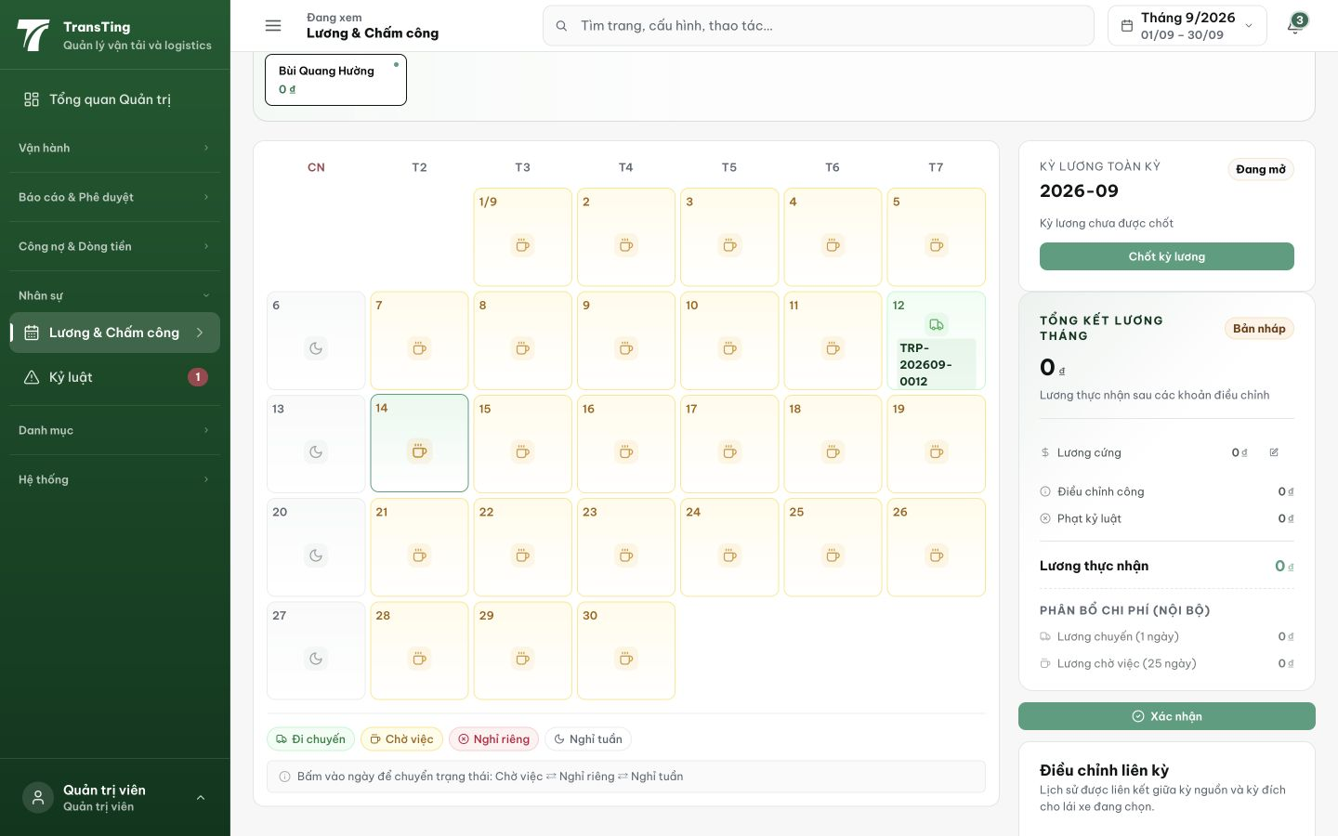
Figure 1. September 2026 calendar for Bùi Quang Hường, with the day-change helper and Chốt kỳ lương control visible. The separate recorded Tab test skips this calendar; DOM inspection establishes missing day-control semantics. This image does not prove pointer updates succeed.
[2026-09-14] DEV COMPLETED — 30 ô ngày = button, aria-label '{dd/mm/yyyy} — {trạng thái}'; spacer inert; aria-disabled + no-op cho locked/trip day (safeguard payroll — code path pin); lịch vào Tab order; Enter đổi trạng thái ô editable (probe thật). Commit 1c16ebcc.
[2026-09-14] QA PASSED — staging (build ae22ba8b, vòng 3): xác minh đủ tiêu chí — chi tiết trong 2026-09-14_staging3-batch/REPORT.md + dir riêng.

